BBRO PROJECT REPORT FORM
Please note the details on page 2 will be used to formulate our Annual Report.
Project Title: Innovative disease monitoring and diagnostics for improved efficiency of crop production (SPOREID)

BBRO project no: | InnovateUK 102104
Project sponsor: | Innovate UK, BBRO, British Sugar plc, Burkhard Instruments
Interim report / Final report (delete as appropriate)

Project lead or student name: | Mark Stevens
Project mentor or supervisors: | Devaki Bhatta (InnovateUK)
Report Date: | 1/4/16 – 31/3/17
Reporting period covered:
(e.g. 1/1/16 - 31/12/16)
Timeline (e.g. Year 1 of 4) | Year 2 of 3
BBRO use only | Date assessed:
Assessors comments
Action required

Project summary (no more than 300 words)
SPOREID is a project designed to minimise the impact of disease on yield of the UK sugar beet crop. The yield potential of the UK sugar beet crop is c.130 t/ha compared to an average yield of 70 t/ha. One of the factors responsible for this yield gap is foliar diseases which can reduce yield by more than 50% and, whilst current practices prevent yield losses of this magnitude, it is estimated that 10% yield is lost to foliar diseases, representing £24M per year. Climate change may lead to increasing pressure from existing or ‘new’ emerging diseases, which require increased crop protection. Improved disease management will allow growers to increase the productivity, sustainability and profitability of the crop. This project brings together novel diagnostic tools, crop disease modelling and yield forecasting to underpin grower decision making and investigate the potential impact of emerging diseases on the crop.

Main Objectives
- To exploit novel diagnostic tools and monitoring systems, crop disease modelling and yield forecasting to improve foliar disease control in sugar beet.

- To provide a new platform that integrates the collection of met data, aphids, mildew and rust spores with rapid DNA-based diagnostics, providing real time information on disease pressure.

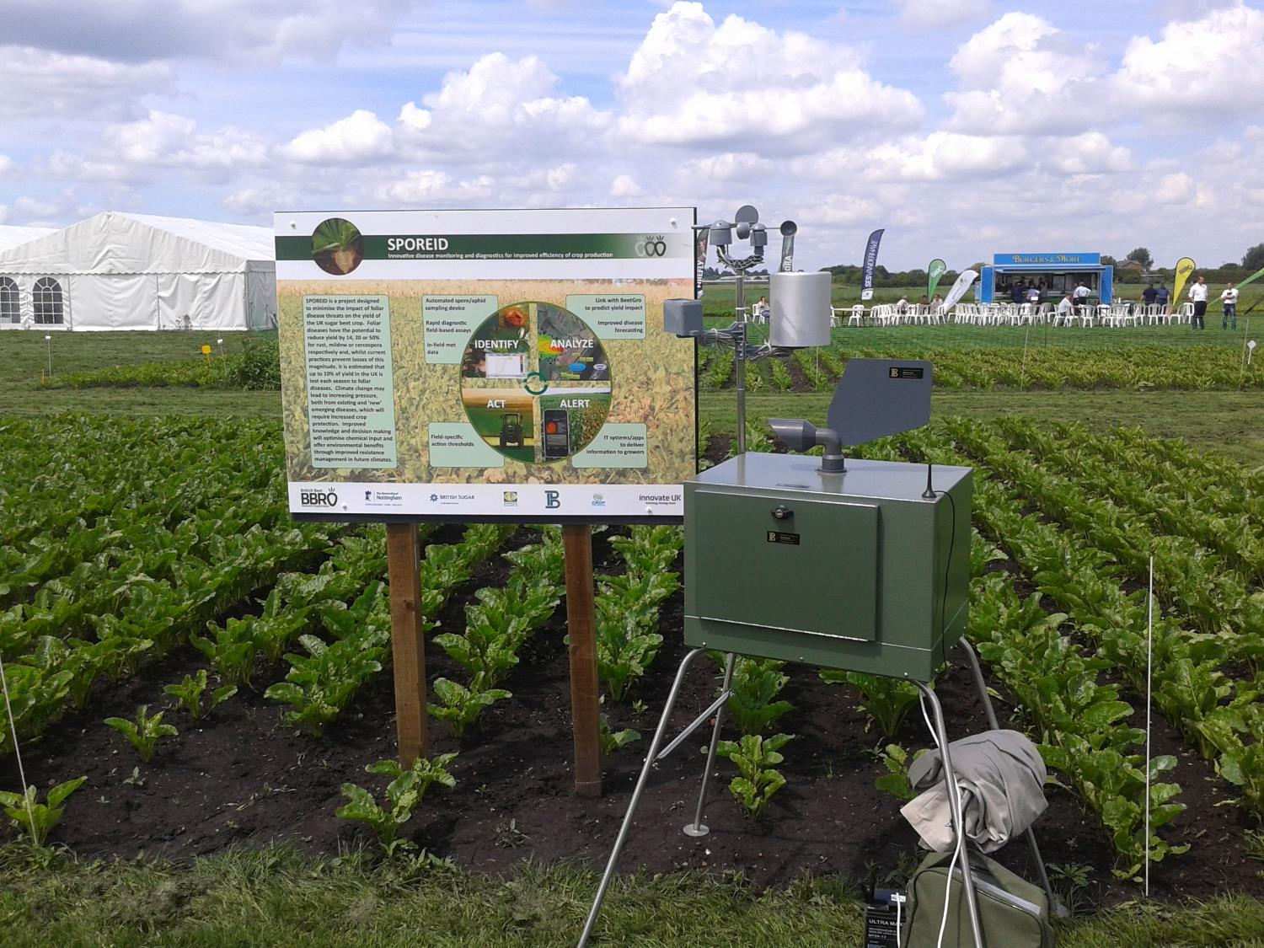  Spore trap prototype presented at BBRO Open Days 2016. |  | 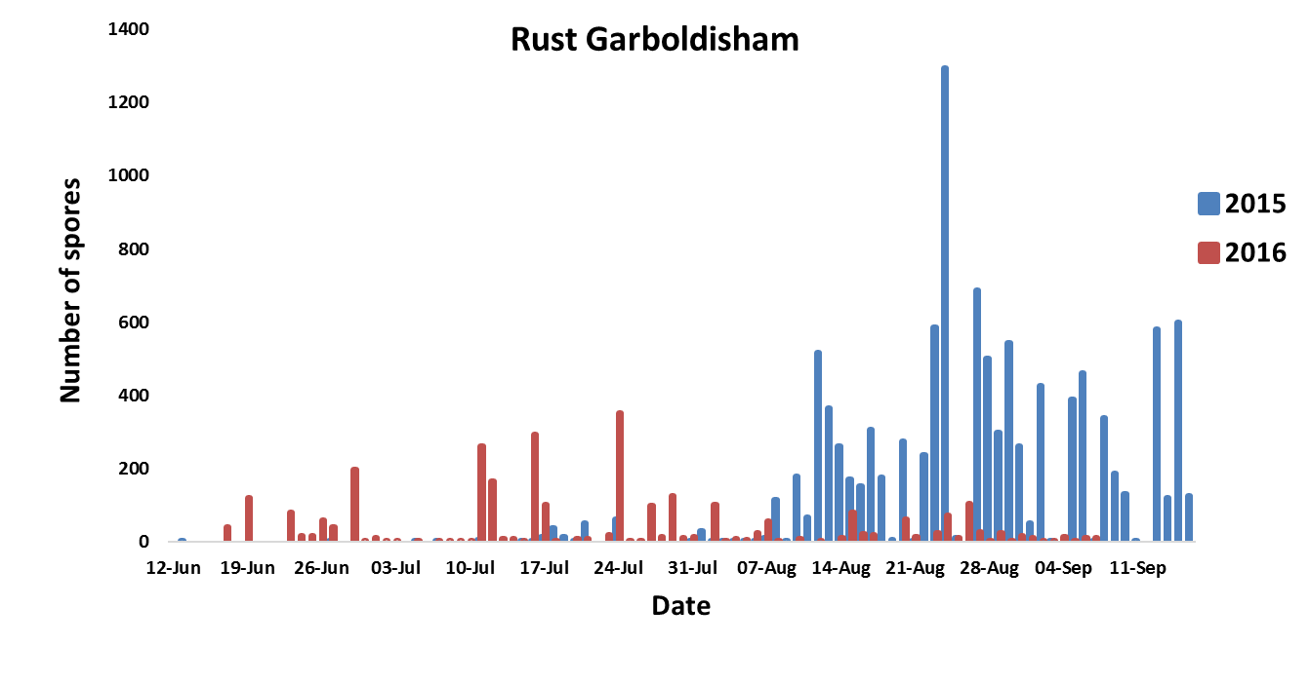  Example of the rust spore data collected over the two years of sampling at Garboldisham fungicide trial.
Main outcomes and achievements
- No evidence of resistance to fungicides was found in British populations of powdery mildew and rust.
- Molecular assays for rapid detection of powdery mildew, rust and cercospora leaf spot were developed.
- Samples collected from in-field spore traps were analysed and provided data of the inoculum presence in 2015 and 2016.
- Prototype of the spore trap with automated DNA extraction and detection was built.
- In 2017, the prototype automated spore trap will be working alongside with the traditional spore traps.

Key messages for growers and industry
Ultimately this project will lead to a new user interface for disease monitoring and prediction and for a more robust approach for the application and benefit of fungicides for the UK crop.

Section 1: To be completed by Project Lead:
Other project objectives (not listed on previous page)
Work Package 1: Determination of sensitivity to fungicides
1.1 Sensitivity index developed
1.2 Identification of resistant isolates
1.3 Sensitivity index developed
1.4 Identification of resistant isolates
Work Package 2: Development of rapid diagnostic assays for use in the field
2.1 DNA extraction method established
2.2 Sequences of relevant genes from Uromyces betae and Erysiphe betae obtained, and primers designed for LAMP assays
2.3 Primers tested and validated against DNA for diagnostic assays for U. betae and E. betae
2.4 Primers validated alongside the chosen DNA release method on spore samples
2.5 Primers developed and validated for Cercospora and Stemphylium
2.6 Specific sensitive DNA based diagnostics optimised for all four pathogens
Work Package 3: Development of an automated spore sampling device
3.1 Source camera
3.2 Automate LAMP assay,
3.3 Combine all steps into first prototype
3.4 Lab test first prototype
Work Package 4: Field testing of the spore trap/diagnostic assays
4.1a Establish field trials with conventional spore traps
4.1b Spore Tape analysis for Powdery Mildew and Rust
4.2 Establish and monitor field network of insect traps
4.3 Assess baseline aphid numbers and infectivity
4.4 Establish field trials to assess fungicide and insecticide timings (to include drilling of untreated seed)
4.5 Field experiments to test unit developed in 3.6
Work Package 5: Evaluation of existing disease models
5.1 Identification of a parameterisable approach appropriate for integration with the BeetGro model
5.2 Evaluation of current disease models for PM, VY and rust
5.3 Model parameterisation appropriate for existing visual approaches – Powdery Mildew
5.3 Model parameterisation appropriate for existing visual approaches - Rust
5.4 Extension of model parameterisation to to incorporate early disease detection developed in WP4
Work Package 6: Development of a disease module for the BeetGro model
6.1 To have made provision to integrate remote sensed crop data into BeetGro model
6.2 Evaluate effects and develop algorithms and modules for BeetGro to describe effect of fungal disease on canopy development
6.3 Evaluate effects and develop algorithms and modules for BeetGro to describe effect of viral disease on canopy development
6.4 Modify fungal disease module based on findings of WP4 Year 1 results
6.5 Modify viral disease module based on findings of WP4 Year 1 results
6.6 Integrate modules into the core BeetGro model, canopy development algorithms
Work Package 7: Developing IT solutions
7.1 Map Evidence of Inoculum: Produce maps that display spatial variability of spores in air at the field and farm scale
7.2 Map Evidence of Disease: Capture disease data to infer spore gradients, thresholds and incubation periods.
Work Package 8: Dissemination and exploitation
8.1 Explain objectives of project at BBRO Open Days in May 2015
8.2 Provide project updates at BBRO winter conference
8.3 Attendance at IIRB winter congress
8.4 Demonstration at BBRO Open Days in May 2016
8.5 Publish article in British Sugar Beet Review
Milestones for current period
Note: mentors will be asked to comment on the status of this project (yellow column) using the scoring system shown below

Milestones | Comments + Any Action required |  | Score  R/A/G
1.1 | Seed/samples/fungicide supplied to RRES for sensitivity assays. |  | G
1.2 | Tests completed with rust and cercospora samples – to be repeated in 2016 |  | G
2.1 | Additional fungicide treatments will also be included (i.e. Armure and Priori Extra from Syngenta). |  | G
2.2 | No resistant isolates were found |  | G
2.1 | TE buffer heated with mechanical disruption. |  | G
2.2 | Sequences of ITS genes from Uromyces betae, Erysiphe betae, Ramularia beticola, Cercospora beticola obtained. |  | G
2.3 | Primers designed for LAMP assay for powdery mildew (beta tubulin) and rust (cytochrome b). |  | G
2.4 | Primers validated with the known amount of spores (slides). Method is being used to analyse the spore tapes samples. |  | G
 |  |  | G
2.5 | C. beticola LAMP assay designed based on tubulin gene |  | G
2.6 | LAMP assay optimised for 3 pathogens (rust, C. beticola and powdery mildew). Ongoing development of the assay for Ramularia detection |  | G
3.1 | Linked to milestone 3.6 |  | G
3.2 | Assay information now delivered. |  | G
3.3 | The prototype is now fully finished and operational. |  | G
3.4 | The prototype testing phase is now completed. |  | G
4.1 and 4.2 | Fungicide trials remained in the ground until January 2017. Untreated seed has been included in drilling. Weather Conditions have prevented aphicide trials taking place in 2016. |  | G
 | Completed analysis of 2015 and 2016 spore tapes data for rust and 2015 for powdery mildew and C. beticola. |  | G
4.3 a | Infectivity tests completed (2,000 aphids).
4.5 a | Dependent upon WP 3
5.1 | Parameterisable approach (June 2015) Identified it will be possible to integrate through both changes in canopy size (loss of green leaf area due to disease) and changes in canopy efficiency (radiation use efficiency). |  | G
5.2 | Current disease models evaluated and used to develop a conceptual approach for integration into Beetgro. |  | G
5.3 a | Model has successfully been parameterised for rust and shows good agreement with observations. |  | G
5.3 b | Insufficient mildew observed to parameterise model for this disease. May need to use historic data sets for mildew. |  | G
5.4 | Available spore data are integrated in the model and improved agreement with observations. |  | G
6.1
6.2
6.3
6.4
6.5
6.6
7.1
7.2
8.2 | BBRO Technical meetings 2-5 February 16 |  | G
8.3 | Poster presented by Agata Kaczmarek at congress 15th – 17th February 2016 |  | G
8.4 | Agata Kaczmarek and Jon West presented prototype of an automated spore trap at four field days in June 16. |  | G
8.5
Status - Mentor’s scoring system for interim reports.
RED | “Major concern - escalate to the next level"  Slippage greater than 10% of remaining time or budget, or quality severely compromised. Corrective Action not in place, or not effective. Unlikely to deliver on time to budget or quality requirements.
AMBER | "Minor concern – being actively managed”  Slippage less than 10% of remaining time or budget, or quality impact is minor. Remedial plan in place.
GREEN | "Normal level of attention"  No material slippage. No additional attention needed

Summary of results (including figures and tables)
Annual report: please provide a 2 page summary of key findings from the reporting year.
Final report: please provide a summary of project findings and outcomes with relevant supporting data.
Field experiments were established on 2 sites, each including untreated crops and those with 1, 2, 3 and 4 fungicide applications, 3 drilling dates and 2 harvests (early and late lift). The crops were scored for disease incidence from June 2016 to September 2016. Final yield, sugar and minerals contents was measured (These data are represented in BBRO project report: Maximising sugar yield via fungicides).

Eight Hirst spore traps were installed in sugar beet fields in 2016, including those with the fungicide experiments. DNA was extracted from the spores collected each week.
Molecular assays for rapid detection of powdery mildew, rust and cercospora leaf spot have been successfully developed at the University of Nottingham. Work is ongoing to develop a robust assay for Ramularia.

Results of the field experiments and spore data analysis have shown that the main disease affecting the crop in both years was rust. Evidence of inoculum was compared between the two seasons (Fig. 1 and 2) and incorporated into BeetGro model to predict the required time between inoculation and the visible symptoms of the infection (Fig. 3). The relationship between disease between weather data and the yield and the disease (rust) was modelled and extended with the dates of spores arrival to the field (Fig. 3 and 4).

Prototype of the spore trap with automated DNA extraction and portable fluorimeter was build and
successfully tested in laboratory conditions alongside with the qPCR system used for DNA analysis (Fig. 5).

Figure 1. Changes in the spore inoculum in the air samples over the sampling period in 2015 and 2016 at the Garboldisham site.

Figure 2. Visual assessments of the rust disease development at the Garboldisham site scored in October 2015 and 2016.

Figure 3. Observed (dots) vs predicted (line) rust development in the field generated by BeetGro model.

Figure 4. Observed (dots) vs predicted (line) sugar yields generated by BeetGro model.

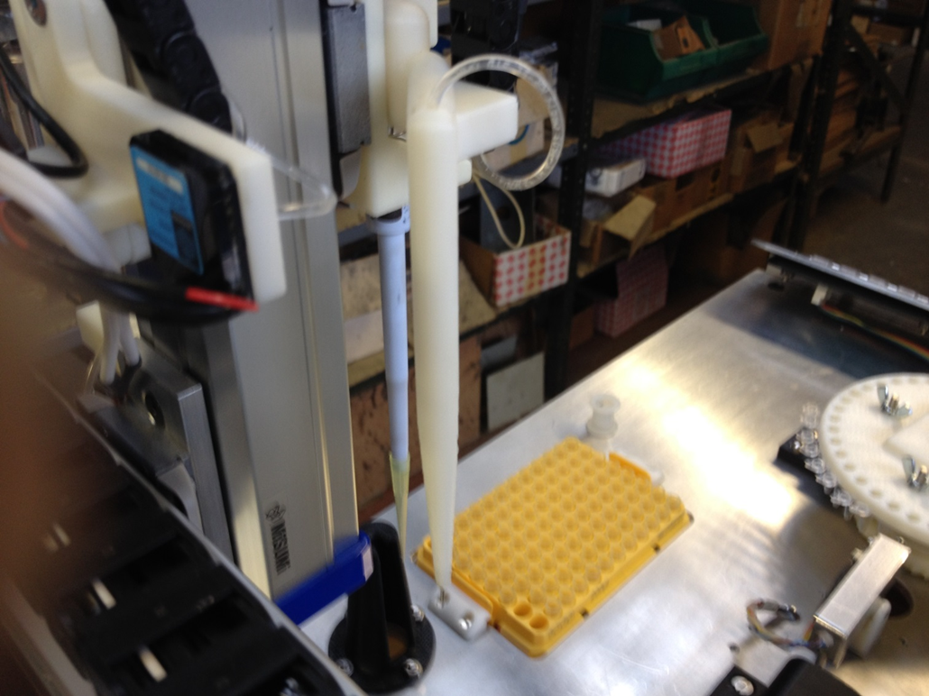
Figure 5. Prototype of the fully automated DNA analyser.

Annual report: Key issues to be addressed next year:

Prototype of fully automated spore trap to be placed in the field.
BeetGro model update that will predict yield in terms of disease development and environmental factors, such as temperature and rainfall.
Web development and communication system between spore trap and server with running BeetGro model.

Publication of results to date/planned publications:
Abstracts submitted for:
- Science Protecting Plant Health Conference
- IIRB meeting

Peer reviewed journal article focusing on Loop-mediated isothermal amplification (LAMP) assay for rapid detection of Uromyces betae (sugar beet rust) and its application to tape trapped field spores.

SporeID introduction to growers published in British Sugar Beet Review.

Section 2: To be completed by project mentor
Is the project on track to meet the stated objectives? (please comment in relation to milestones and the status score awarded in section 1).

Please comment on any proposed changes to milestones.
Are conclusions scientifically robust? (please comment on data analysis/interpretation)
For final reports only:
How would you rate the project against the following criteria (please give a score out of 10, with 10 being highest)
1 ) The project met its original objectives:

2) Contribution to scientific knowledge:

3) Direct relevance to growers:

