BBRO PROJECT REPORT FORM
Please note the details on page 2 will be used to formulate our Annual Report.
Project Title: Virus yellows: aphid monitoring and alternative control strategies using existing/novel insecticides

BBRO project no: | 15/19
Project sponsor: | BBRO
Interim report

Project lead or student name: | Mark Stevens
Project mentor or supervisors: | Ian Bedford
Report Date: | April 2017
Reporting period covered:  (e.g. 1/1/16 - 31/12/16) | 1/4/16 – 31/3/17
Timeline (e.g. Year 1 of 4) | Year 2
BBRO use only | Date assessed:
Assessors comments
Action required

Project summary (no more than 300 words)
Virus yellows is a greater problem in the UK than anywhere else in Europe due to the influence of our maritime climate. Virus threats are accentuated by the ongoing development of insecticide resistance and climate change. An integrated disease management toolkit is required that utilises resistant varieties and accurate disease forecasts to enable timely and appropriate applications of insecticides. This system will slow the development of insecticide resistance in aphid populations, thus prolonging the life of active ingredients, whilst helping to reduce the amount used. This is crucial with the recent appearance of neonicotinoid resistance within mainland Europe. To achieve durable control of the viruses, aphid populations will be monitored and assessed for resistance and virus content in order to allow us to advise growers of risks to their crops. Existing and/or new insecticides will be assessed providing a potential novel approach for controlling these viruses.

Main Objectives
- Annual aphid surveillance and distribution and impact of yellowing viruses (linked/leveraged against the InnovateUK SporeID project).

- Efficacy of existing and novel insecticides for the control of M. persicae.

Insert picture/graph  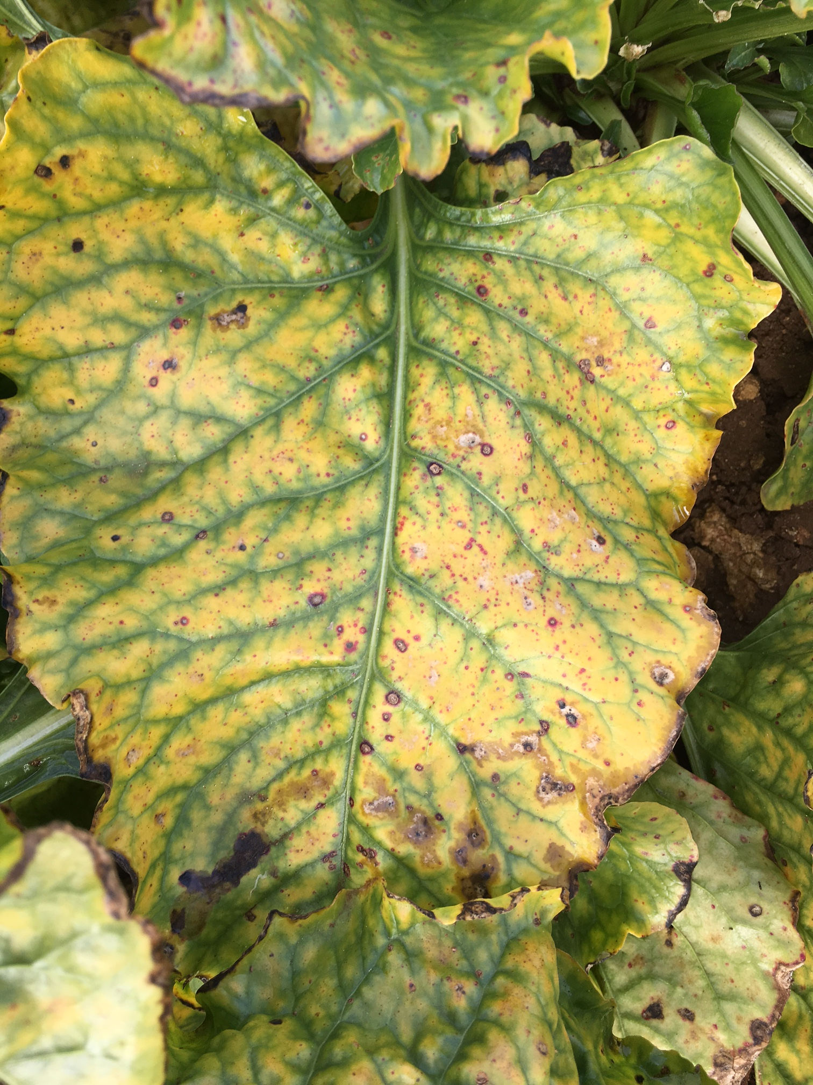 | Insert picture/graph  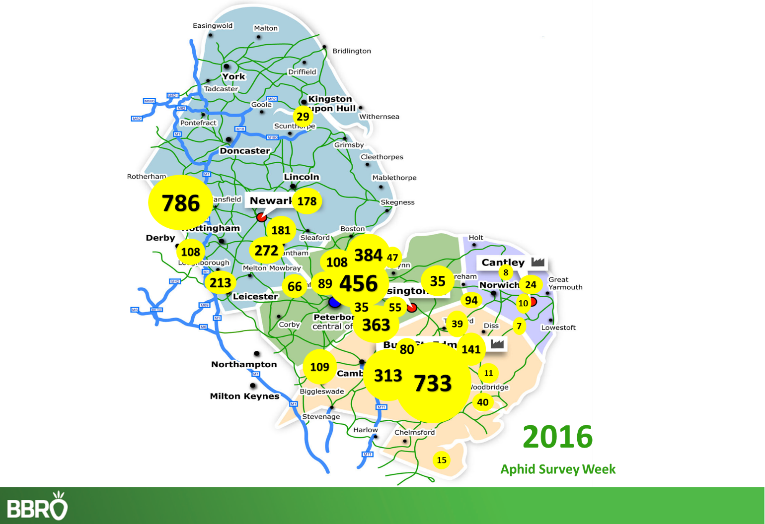
Main outcomes and achievements
- Aphids were caught from the beginning of May, and numbers peaked in early June, before numbers crashed due to predators and the unseasonably wet weather. A total of 4,888 were trapped at the 30 sites and there was significant regional variation in numbers, again influenced by neighbouring oilseed rape and other brassica crops harbouring populations.

- None of the 2000 M. persicae tested were found to be carrying virus.

- Levels of virus in the commercial crop remained below one percent with neonicotinoid seed treatments providing good control of the aphid vectors.

- Although numbers of aphids were too low at field trial sites for insecticide trials, laboratory studies have continued to evaluate new insecticides for the control of M. persicae.

Key messages for growers and industry
Concern remain of the reliance on the neonicotinoid seed treatments for aphid control in sugar beet. Good on-farm hygiene remains critical to limit the range of pests and diseases encountered on farm and 2016 was no different, particularly after the very mild winter period, and when average December temperatures were 6.5ºC higher than normal. Destroying beet remnants and crown material on cleaner load spoil heaps and maus loading sites is essential to reduce the potential threat from aphids and virus yellows.

Section 1: To be completed by Project Lead:
Other project objectives (not listed on previous page)

Milestones for current period
Note: mentors will be asked to comment on the status of this project (yellow column) using the scoring system shown below

Status - Mentor’s scoring system for interim reports.
RED | “Major concern - escalate to the next level"  Slippage greater than 10% of remaining time or budget, or quality severely compromised. Corrective Action not in place, or not effective. Unlikely to deliver on time to budget or quality requirements.
AMBER | "Minor concern – being actively managed”  Slippage less than 10% of remaining time or budget, or quality impact is minor. Remedial plan in place.
GREEN | "Normal level of attention"  No material slippage. No additional attention needed
Milestones | Comments + Any Action required | Status R/A/G

Summary of results (including figures and tables)
Annual report: please provide a 2 page summary of key findings from the reporting year.
Final report: please provide a summary of project findings and outcomes with relevant supporting data.
In January and February 2016, the mean air temperatures from the reference weather stations ranged from 4.9-5.3ºC and so the potential risk from virus yellows infection, in the absence of any control strategies, was high. However, with the use of neonicotinoid treated seed and no evidence to date of neonicotinoid resistant aphids in the UK, this risk is kept to a minimum protecting the crop from significant yield loss.

The BBRO network of yellow water pans were placed in 30 crops across the four factory regions for 12 weeks from the beginning of May to the end of July. These were emptied twice weekly (usually each Monday and Thursday) by British Sugar Area Managers and growers, and samples were sent to BBRO-Norwich for analysis. Aphids are removed from the insect catch, and all Myzus persicae and Macrospiphum euphorbiae recorded.

As a consequence of the warm, settled weather at the beginning of this period, M. persicae were caught from the first week of trapping and early aphid ‘hotspots’ included Swayfield, Lincolnshire and Potton, Bedfordshire. However, due to the particularly wet conditions in June and July this had a negative impact on migration, significantly reducing aphid flight from week seven onwards. For the 12-week trapping period 4,888 M. persicae were caught (see below). This is considerably less than 2015 (8,189 were caught), probably influenced by the cooler, wetter conditions throughout the early summer, although, once again, there was significant regional variation in aphid numbers often influenced by neighbouring oilseed rape and other brassica crops harbouring populations. These data were used as part of the BBRO Industry bulletin service.

Two thousand aphids were tested using a RT-PCR method at Rothamsted Research and none were found to be carrying Beet mild yellowing virus. By the end of September small sporadic patches of virus yellows symptoms could be found in some crops, but levels of virus as recorded by the British Sugar field survey were less than one percent.

Appropriate alternative insecticides are being investigated and it is expected that Teppeki (flonicamid) may gain recommendation for use in sugar beet for 2017 as a foliar treatment following BBRO data supporting registration. Another insecticide, the diamide Verimark (cyantraniliprole) has been identified as a possible PPP for the beet crop, however this is much further from market and is currently under investigation in laboratory studies with Syngenta, although the very latest data are not encouraging for aphid control.

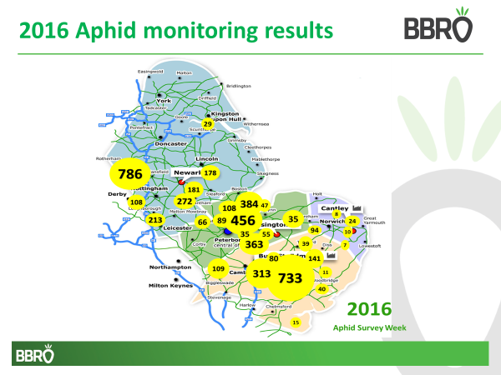

 |  | Week 1 | Week 2 | Week 3 | Week 4 | Week 5 | Week 6 | Week 7 | Week 8 | Week 9 | Week 10 | Week 11 | Week 12
Bury | Fulbourn | 1 | 0 | 229 | 13 | 17 | 6 | 47 | 0 | 0 | 0 | 0 | 0
 | Potton | 50 | 39 | 11 | 8 | 0 | 1 | 0 | 0 | 0 | 0 | 0 | 0
 | Garboldisham | 0 | 1 | 0 | 0 | 5 | 18 | 4 | 1 | 0 | 0 | 0 | 0
 | Hitcham | 6 | 6 | 17 | 29 | 3 | 578 | 89 | 5 | 0 | 0 | 0 | 0
 | Woodbridge | 0 | 0 | 10 | 1 | 0 | 0 | 0 | 0 | 0 | 0 | 0 | 0
 | Great Barton | 2 | 2 | 21 | 5 | 0 | 46 | 4 | 0 | 0 | 0 | 0 | 0
 | Weybread | 1 | 1 | 4 | 0 | 3 | 85 | 43 | 3 | 0 | 1 | 0 | 0
 | Cottenham | 0 | 4 | 5 | 0 | 12 | 4 | 2 | 1 | 0 | 0 | 0 | 0
 | Little Bentley | 1 | 0 | 8 | 3 | 3 | 0 | 0 | 0 | 0 | 0 | 0 | 0
Cantley | Cantley |  | 1 | 5 | 1 | 0 | 2 | 0 | 0 | 0 | 0 | 0 | 0
 | Salhouse | 2 | 2 | 11 | 2 | 0 | 7 | 0 | 0 | 0 | 0 | 0 | 0
 | Frostenden | 0 | 1 | 4 | 0 | 0 | 1 | 1 | 0 | 0 | 0 | 0 | 0
 | North Barningham | 0 | 0 | 3 | 1 | 0 | 2 | 2 | 0 | 0 | 0 | 0 | 0
 | Morley | 4 | 2 | 22 | 10 | 2 | 38 | 11 | 4 | 1 | 0 | 0 | 0
Newark | West Willoughby | 6 | 4 | 13 | 15 | 3 | 138 | 2 | 0 | 0 | 0 | 0 | 0
 | Torworth | 5 | 0 | 0 | 9 | 11 | 166 | 22 | 0 | 0 | 0 | 0 | 0
 | Swayfield | 63 | 8 | 7 | 31 | 5 | 102 | 51 | 4 | 0 | 0 | 0 | 1
 | Stamford | 0 | 8 | 17 | 23 | 1 | 8 | 8 | 0 | 0 | 0 | 0 | 0
 | Barrow on Humber | 0 | 1 | 8 | 4 | 0 | 12 | 2 | 2 | 0 | 0 | 0 | 0
 | Farndon | 0 | 1 | 50 | 30 | 29 | 666 | 7 | 3 | 0 | 0 | 0 | 0
 | Bracebridge Heath | 0 | 0 | 54 | 10 | 1 | 76 | 27 | 10 | 0 | 0 | 0 | 0
 | Wolvey |  | 0 | 0 | 1 | 1 | 40 | 66 | 0 | 0 | 0 | 0 | 0
Wissington | Tinwell | 20 | 8 | 2 | 22 | 4 | 25 | 8 | 0 | 0 | 0 | 0 | 0
 | Ten Mile Bank | 2 | 4 | 7 | 13 | 1 | 6 | 1 | 0 | 0 | 0 | 0 | 0
 | Wretton | 0 | 5 | 31 | 1 | 0 | 0 | 18 | 0 | 0 | 0 | 0 | 0
 | Guyhirn | 12 | 30 | 11 | 5 | 19 | 42 | 337 | 0 | 0 | 0 | 0 | 0
 | Houghton St. Giles | 0 | 2 | 8 | 31 | 34 | 19 | 289 | 1 | 0 | 0 | 0 | 0
 | Holbeach St. Marks | 0 | 1 | 0 | 2 | 0 | 24 | 13 | 4 | 0 | 0 | 0 | 0
 | Feltwell |  | 1 | 40 | 38 | 0 | 279 | 2 | 0 | 0 | 0 | 0 | 0

Annual report: Key issues to be addressed next year:

With a potential withdrawal of neonicotinoid seed treatments evaluation of alternative aphid control will be a priority (both glasshouse and field) in 2017/18.

Publication of results to date/planned publications:
Stevens M. (2017) Pests and diseases update. British Sugar Beet Review 85, 4-8.

Section 2: To be completed by project mentor
Is the project on track to meet the stated objectives? (please comment in relation to milestones and the status score awarded in section 1).

Please comment on any proposed changes to milestones.
Are conclusions scientifically robust? (please comment on data analysis/interpretation)
For final reports only:
How would you rate the project against the following criteria (please give a score out of 10, with 10 being highest)
1 ) The project met its original objectives:

2) Contribution to scientific knowledge:

3) Direct relevance to growers:

