BBRO PROJECT REPORT FORM
Please note the details on page 2 will be used to formulate the BBRO printed Annual Report.
Project Title: Control and monitoring of mangold fly 2017

BBRO project no: | 17-05
Project sponsor: | BBRO
Final report

Project lead or student name: | Dr Sacha White
Project mentor or supervisors:

Report Date: | 31 March 2018
Reporting period covered:  (e.g. 1/1/16 - 31/12/16) | 1/6/17 – 31/7/18
Timeline (e.g. Year 1 of 4) | Year 1 of 1
BBRO use only | Date assessed:
Assessors comments
Action required

Project summary (no more than 300 words)
Mangold fly is currently the most important mid- and late season insect pest of sugar beet. The larvae mine extensively within the leaves, producing characteristic blisters, which reduce green leaf area and plant vigour. Mining also increases sensitivity to herbicides and susceptibility to frosts. Infested crops that experience early frosts can lose considerable areas of canopy with consequent impacts on the autumn potential.

Control of mid- and late season infestations of mangold fly currently relies on targeting the larvae with foliar applications of contact action pyrethroid insecticides. However, the effectiveness of these is variable due to the difficulty in timing sprays. The larvae are only exposed in the time between egg-hatch and when they burrow into the leaf so contact insecticides must be applied to coincide with hatching eggs. Biscaya has also been available in 2015 and 2016 through emergency authorisations. This product is a systemic neonicotinoid so the larvae are susceptible even when inside the leaf, giving growers a wider window of opportunity to control the pest. However, there is uncertainty regarding the efficacy of this treatment and it is unknown whether further emergency authorisations will be granted. Further, from a neonicotinoid resistance management perspective it is not advisable to rely solely on this insecticide in the long-term.

Data from a randomised, replicated field trial in 2015 showed that mangold fly damage reduced yields by 11.2%. This trial experienced moderate levels of infestation so greater yield reductions would be expected from more severe infestations. The overall aim of this project is to reduce these losses by identifying alternative chemical control options and their optimal application timing, and by gaining a better understanding of the patterns of mangold fly emergence and natural enemy activity across the sugar beet growing region.

Short summary of key objectives
- To identify effective chemical control methods and their optimal application timing.
- To improve understanding of mangold fly emergence patterns across the sugar beet growing region and throughout the summer.
- To improve the understanding of natural enemy activity across the sugar beet growing region and throughout the summer.
Figure 1. Total number of mangold fly adults caught in yellow water traps from early May to end of July at three sites in 2016 and 2017. * & ** see Fig. 4 (page 5). | Figure 2. Total numbers of natural enemies caught in yellow water traps from early May to end of July at three sites in 2016 and 2017. Note ‘Parasitic wasps’ includes both those that parasitise aphids and other insects.
Outcomes/Key messages for growers and industry
- Monitoring of mangold fly activity using BBRO’s yellow water trap network found very low numbers of adults in 2017, with numbers were up to 88% lower than in 2016. This was reflected in very few reports of mangold fly damage in crops from June onwards during the 2017 growing season.
- Assessments of natural enemies caught in yellow water traps throughout the summer 2017 found increased activity compared to 2016. This was especially evident in regard to hoverflies (6033% increase) and parasitic wasps (542% increase).
- Due to low mangold fly pressures it was decided, in agreement with BBRO, to defer any field trials until 2018. Waiting for higher pest pressure will provide a more robust test of the candidate insecticides and improve the chances of detecting differences between products.

Section 1: To be completed by Project Lead:
Other project objectives (not listed on previous page)
None

Milestones for current period
Note: mentors will be asked to comment on the status of this project (yellow column) using the scoring system shown below
Obj. no. | Target date | Description
1.1 | 06/2017 | Commence first field trial.
1.2 | 07/2017 | Apply treatments to second mangold fly generation in first field trial.
1.3 | 08/2017 | Commence second field trial.
1.4 | 09/2017 | Apply treatments to third mangold fly generation in both field trials.
1.5 | 01/2018 | Assess yield harvest in both field trials (at BBRO’s discretion).
2.1 | 01/2018 | Assess adult mangold fly numbers in water traps.
2.2 | 03/2018 | Assess natural enemies in water traps.

Status - Mentor’s scoring system for interim reports.
RED | “Major concern - escalate to the next level"  Slippage greater than 10% of remaining time or budget, or quality severely compromised. Corrective Action not in place, or not effective. Unlikely to deliver on time to budget or quality requirements.
AMBER | "Minor concern – being actively managed”  Slippage less than 10% of remaining time or budget, or quality impact is minor. Remedial plan in place.
GREEN | "Normal level of attention"  No material slippage. No additional attention needed
Milestones | Comments + Any Action required | Status R/A/G
1.1-1.5 | Due to low pest pressures, there was considered little benefit in undertaking field trials in 2017 so they were deferred until 2018.
2.1 | Due to low pest pressures, ADAS were asked to assess adult mangold fly at three sites instead of ten sites.
2.2 | Natural enemies have been assessed at three sites as planned.

Summary of results (including figures and tables)
For Project Annual report: please provide a 2 page summary of key findings from the reporting year.
For Project Final report: please provide a summary of project findings and outcomes with relevant supporting data.
Objective 1 - Identifying effective control options
Two field trials were planned for 2017; one starting in June and one starting in August. It was intended to investigate five insecticides (Table 1) in two randomised, replicated field trials for their ability to control mangold fly. Each insecticide was to be applied at three timings; adult emergence (T1), egg laying (T2) and egg hatch (T3). The impact of treatment on the numbers of eggs, larvae and mines, percent leaf area mined and yield at harvest would have been assessed.
Table 1 Planned insecticides for assessment in 2017 field trials.
Treatment | Dose/ha
Untreated control (UTC) | -
Biscaya | 0.4 l/ha
GWN10295 | 0.3 kg/ha
ADAS0306 | 0.75 l/ha
0506ADAS | 0.1875 kg/l
Hallmark Zeon | 0.075 l/ha
Mangold fly eggs and leaf-mining were found in a sugar beet crop at Hibaldstow (Fig. 3). Mature damage was seen in June at the seven leaf stage, suggesting it was due to infestation from the first generation of the pest. As no other reports of significant early mangold fly damage had been received it was decided to conduct the first field trial at this site. Yellow water traps were placed in the crop to monitor for the emergence of the second generation of adults, which usually occurs in June/July. Traps were monitored regularly until end of September and no adult mangold flies were found. Monitoring of the crop over the same period found no eggs or leaf-mining. Further enquiries were made throughout the summer of British Sugar area managers and agronomists across region. These reported no signs of significant mangold fly damage. Following discussions with BBRO it was decided not to begin the planned field trials unless suitable mangold fly numbers were recorded. At the end of September it was agreed with BBRO to defer all mangold fly trials until 2018.
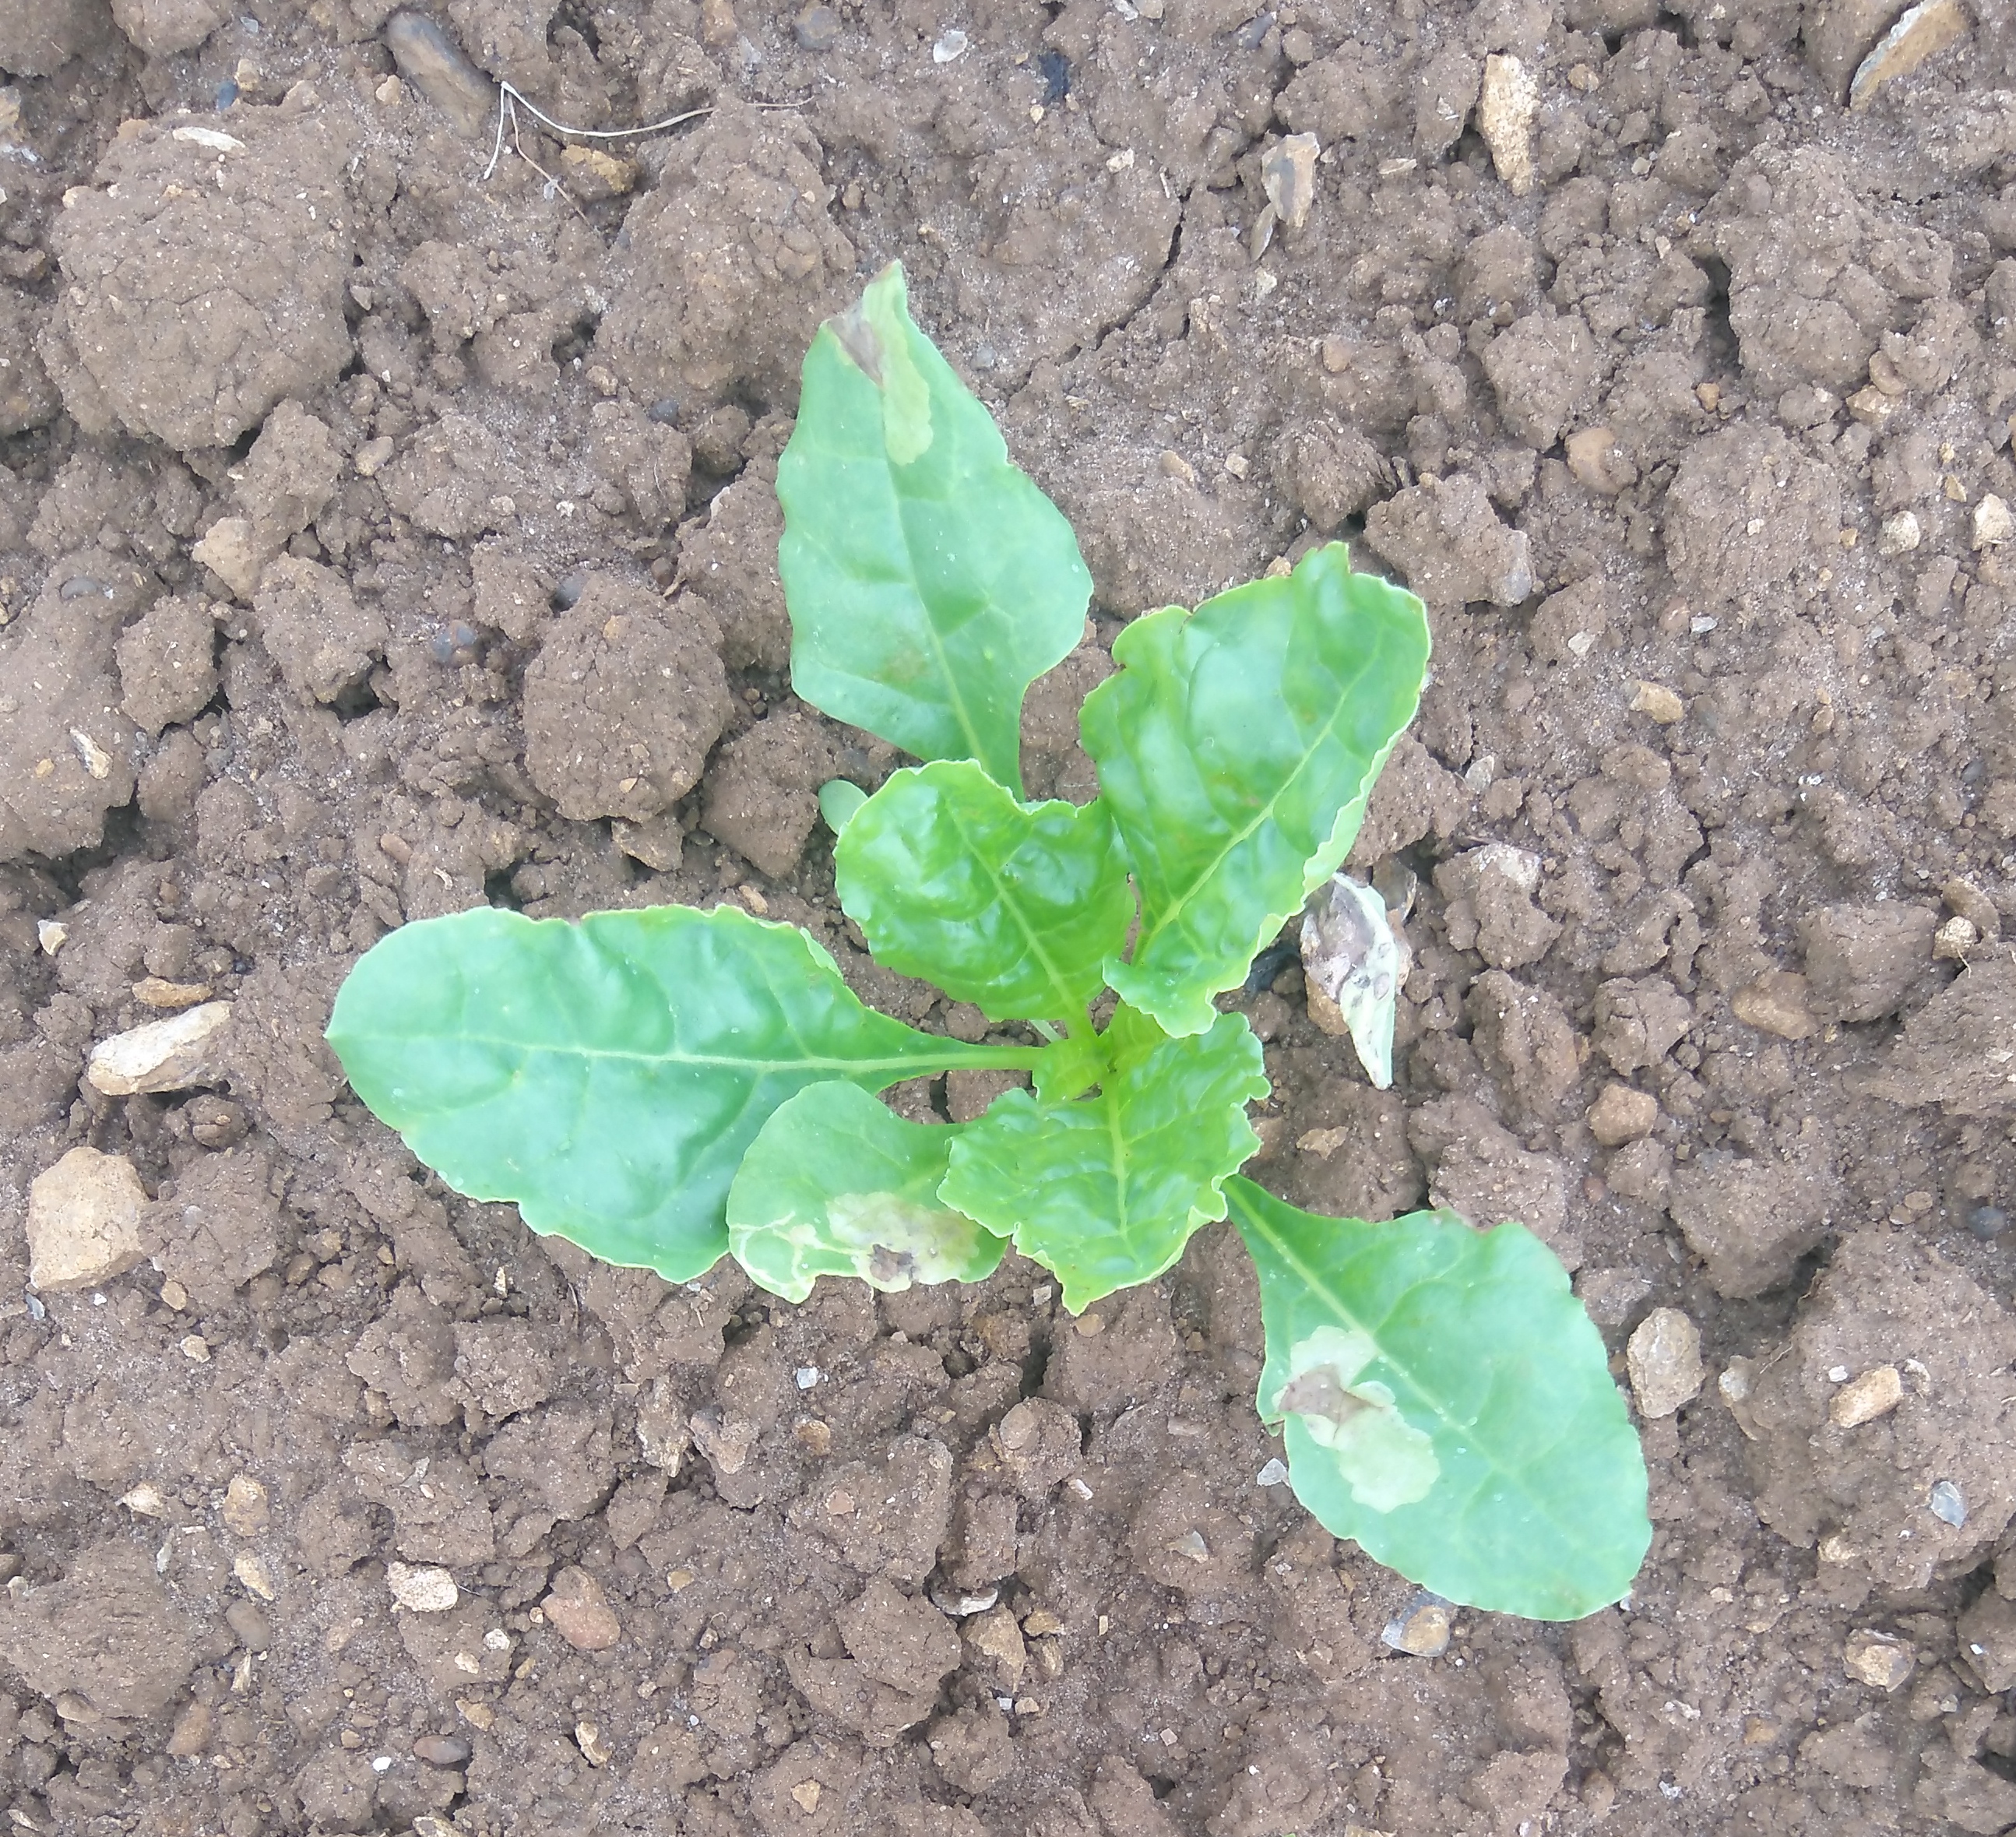
Figure 3. First generation leaf-miner damage in early June at Hibaldstow.
Objective 2 - Understanding adult mangold fly emergence patterns and natural enemy activity in sugar beet crops
Method
Adult mangold fly and natural enemies (NEs) were monitored in BBRO yellow water traps between 4 May and 25 July 2017. Monitoring of adult mangold flies was originally planned to occur at ten sites but due to low levels of damage in crops across the sugar beet region it was decided, in agreement with BBRO, to reduce this to three sites; Barrow upon Humber (North Lincolnshire), Holbeach Hurn (South Lincolnshire) and Woodbridge (Suffolk). These sites were chosen to cover the north-south distribution of sugar beet production, and included a site on the Wash (Holbeach Hurn), a hot-spot for mangold fly in recent years. NE assessments occurred at the same three sites, as planned.
The traps were 27 cm in diameter and 10 cm deep. At each site, three traps were placed across the field at least 15 m apart and at least 15 m from any hedges. Traps were placed just above the top of the crop canopy and their height was adjusted throughout the season as the plants grew. Trap contents were collected at least weekly from May to July by BBRO/British Sugar and sent to ADAS. Where more than one sample was collected from a site in a week, they were combined into a single catch. Where a sample contained a large number of individuals, a proportion was assessed and the total adjusted accordingly.
Adult mangold flies were identified to the Pegomya hyoscyami complex level (Michelsen, 1980), a species complex containing the economically important beet leaf-miners and comprising P. betae (Curtis), P. cunicularia (Rondani), P. exilis (Meigen) and P. hyoscyami (Panzer). Total numbers of adult males, females and those of unknown sex were counted for each site and week. NEs were identified to functional group except for ladybirds, which were recorded separately by BBRO.
Results
A total of 18 mangold flies were caught across the monitoring period, with the greatest number at Holbeach Hurn (total = 8) and Barrow upon Humber (total = 8). In comparison with 2016, total mangold fly numbers caught over the equivalent period in the same areas were 43-88% lower in 2017 (Fig. 4).

Figure 4. Total number of mangold fly adults caught in yellow water traps from early May to end of July at three sites in 2016 and 2017. *Sites monitored differed between 2016 and 2017 at Holbeach. In 2016 monitoring occurred at Holbeach St Marks and in 2017 monitoring occurred at Holbeach Hurn (approx. 3 miles apart). **2016 data for Little Bentley (east Essex) and 2017 data for Woodbridge (south-east Suffolk) (approx. 17 miles apart).
Catch data show no clear pattern in the emergence of the mangold flies, with most caught in May and June and none in July (Fig. 5). Those caught are likely to be the second generation of the pest. The vast majority of mangold flies caught were females (94%).

Figure 5. Numbers of mangold fly caught each week in the summer 2017 at monitoring sites in Suffolk and Lincolnshire.
Numbers of some NE groups (totalled across sites) were considerably higher in 2017 than in 2016 (Fig. 6), especially in regard to hoverflies (6033% increase), parasitic wasps (542% increase) and spiders (133% increase). In other groups reductions were observed compared to 2016, particularly dance flies (62% decrease), soldier beetles (43% decrease) and rove beetles (29% decrease).
Generalists
Aphid specialists
Figure 6. Total numbers of natural enemies caught in yellow water traps from early May to end of July at three sites in 2016 and 2017. Note ‘Parasitic wasps’ includes both those that parasitise aphids and other insects.
Differences in NE activity over time and between sites were evident. For example, hoverflies were abundant at Holbeach Hurn from late June but rare at the other sites (Fig. 7). Parasitic wasps (all types) were abundant at Barrow upon Humber (mid-May and late June) and Holbeach Hurn (from late June) but numbers were considerably lower at Woodbridge (Fig. 7). Prior to mid-June rove beetles were found at all sites (being most common at Holbeach Hurn) but were not observed after 12 June (Fig. 8). Soldier beetles were found throughout the monitoring period at Holbeach Hurn and Woodbridge but were rare at Barrow upon Humber (Fig. 8).

Figure 7. Number of hoverflies (green lines) and parasitic wasps (blue lines) caught by week at Barrow upon Humber (solid lines), Holbeach Hurn (dashed lines) and Woodbridge (dotted lines) monitoring sites.

Figure 8. Number of soldier beetles (blue lines) and rove beetles (orange lines) caught by week at Barrow upon Humber (solid lines), Holbeach Hurn (dashed lines) and Woodbridge (dotted lines) monitoring sites.

Discussion
Low numbers of mangold fly were observed at the sites monitored in 2017, a finding reflected in the scarcity of reports of mangold fly damage in sugar beet crops between June and September 2017 (although the monitoring period does not extend long enough to catch the majority of third generation of adult mangold fly activity). Adult mangold fly numbers were also considerably lower than in 2016 and 2015. Reasons for the reduction in mangold fly pressures after several years of significant localised problems are not clear. In the previous mangold fly project a trend for a year-on-year northern shift in the focus of the problem was noted, so to check whether this had happened in 2017 agronomists advising beet growers (primarily fodder beet) north of the Humber were contacted but no reports of problems were received. Other reasons for the reduction in pressures could be weather-related or control by natural enemies. The mean temperature in May and June 2017 was warmer than previous years in which mangold fly has been a problem (2013-16) (Met Office, 2018) and it is possible that this may have detrimentally affected the pest. Further research is required to better understand the effect of environmental conditions on mangold fly development and activity.
In contrast to mangold fly numbers, the monitoring work found large increases in NE activity in 2017 compared to 2016, which may in part explain the reduction in mangold fly pressure. Increased activity of hoverflies, parasitic wasps and spiders was particularly evident, although moderate reductions in some NE groups were also seen (e.g. soldier beetles and dance flies). However, it should be noted that yellow water traps are not necessarily ideal for monitoring some insects, especially epigeal groups such as ground beetles. Warmer conditions from April to June 2017 compared to 2016 (Met Office, 2018) would undoubtedly have helped NE populations increase in response to prey populations at the beginning of the growing season. However, large variation in NE populations between sites show that site-specific factors also have a strong influence on the diversity and abundance of NEs. For example, the much higher hoverfly populations found at Holbeach Hurn than the other sites suggests this site had conditions more suitable for these insects. To maintain populations of this natural enemy, aphid prey and other food sources (e.g. pollen and nectar) are needed (AHDB, 2014). Hoverflies can be encouraged by providing flower-rich habitats, such as field margin flower strips containing coriander, buckwheat, phacelia and alyssum (AHDB, 2014), and it would be beneficial to know whether these were present at Holbeach Hurn and whether the addition of such habitats at other sites would result in increased hoverfly activity. To further understand the between site variation in populations of this valuable beneficial and the impact they are having on pest control, it would be useful to also know the between site differences in aphid populations. Hoverfly larvae are voracious aphid predators, with a single larvae capable of consuming up 1200 aphids during their life span, which added to their mobility and short generation time, makes them highly effective at controlling at aphid infestations (AHDB, 2014).
A number of approaches are also known to encourage other NE populations and improve their activity. For example, parasitoid wasps are NEs of many crop pests, including aphids and leaf-miners, and are important for maintaining pest populations at low levels. Parasitoids can be encouraged by planting simple open flowers, which provide nectar supplies, and minimising insecticide use (AHDB, 2014). Ground beetles are important predators of pest stages that spend time on or in the soil, which includes mangold fly pupae. Including tussock-forming grasses in field margins, reducing insecticide use, minimising cultivation intensity and introducing beetle banks are all means of encouraging ground beetle activity (AHDB, 2014).
The contribution of NEs to pest control will become increasingly important as the availability of effective insecticides decrease, either due to resistance or regulation. Currently there are concerns over the future availability of neonicotinoid seed treatments in sugar beet. On 28 February 2018, The European Food Standards Agency updated its risk assessment on neonicotinoids, concluding that most uses of the insecticides represent a risk to honeybees and wild bees (EFSA, 2018). A decision from the European Commission on whether further restrictions to neonicotinoids are needed is likely this year. If the restrictions are extended to sugar beet then the protection they provide for the first generation of mangold fly will be lost. The damage from the first generation of the pest usually occurs in April and May when crops are at their most susceptible. A further issue with these early infestations is that leaf-miner damage also increases crop sensitivity to herbicides, many of which are applied during this period. Finding effective monitoring methods and alternative control treatments will therefore become more important.
Reference:
AHDB (2014). Encyclopaedia of pests and natural enemies in field crops. Agriculture and Horticulture Development Board.
EFSA (2018). Neonicotinoids: risks to bees confirmed. Date accessed: 27 March 2018. Available from: https://www.efsa.europa.eu/en/press/news/180228.
Met Office (2018). UK actual and anomaly maps [online]. Date accessed: 22 March 2018. Available from: http://www.metoffice.gov.uk/climate/uk/summaries/anomacts.
Michelsen, V. (1980). A revision of the beet leaf-miner complex, Pegomya hyoscyami s. lat. (Diptera: Anthomyiidae). Entomologica Scandinavica, 11, 297-309.

Annual report: Key issues to be addressed next year:

Publication of results to date/planned publications:
Section 2: To be completed by project mentor
Is the project on track to meet the stated objectives? (please comment in relation to milestones and the status score awarded in section 1).

Please comment on any proposed changes to milestones.
Are conclusions scientifically robust? (please comment on data analysis/interpretation)
For final reports only:
How would you rate the project against the following criteria (please give a score out of 10, with 10 being highest)
1 ) The project met its original objectives:

2) Contribution to scientific knowledge:

3) Direct relevance to growers:

