

Integrated disease management of sugar beet, Beta vulgaris
Angharad Hughes
Sponsors report – 2022
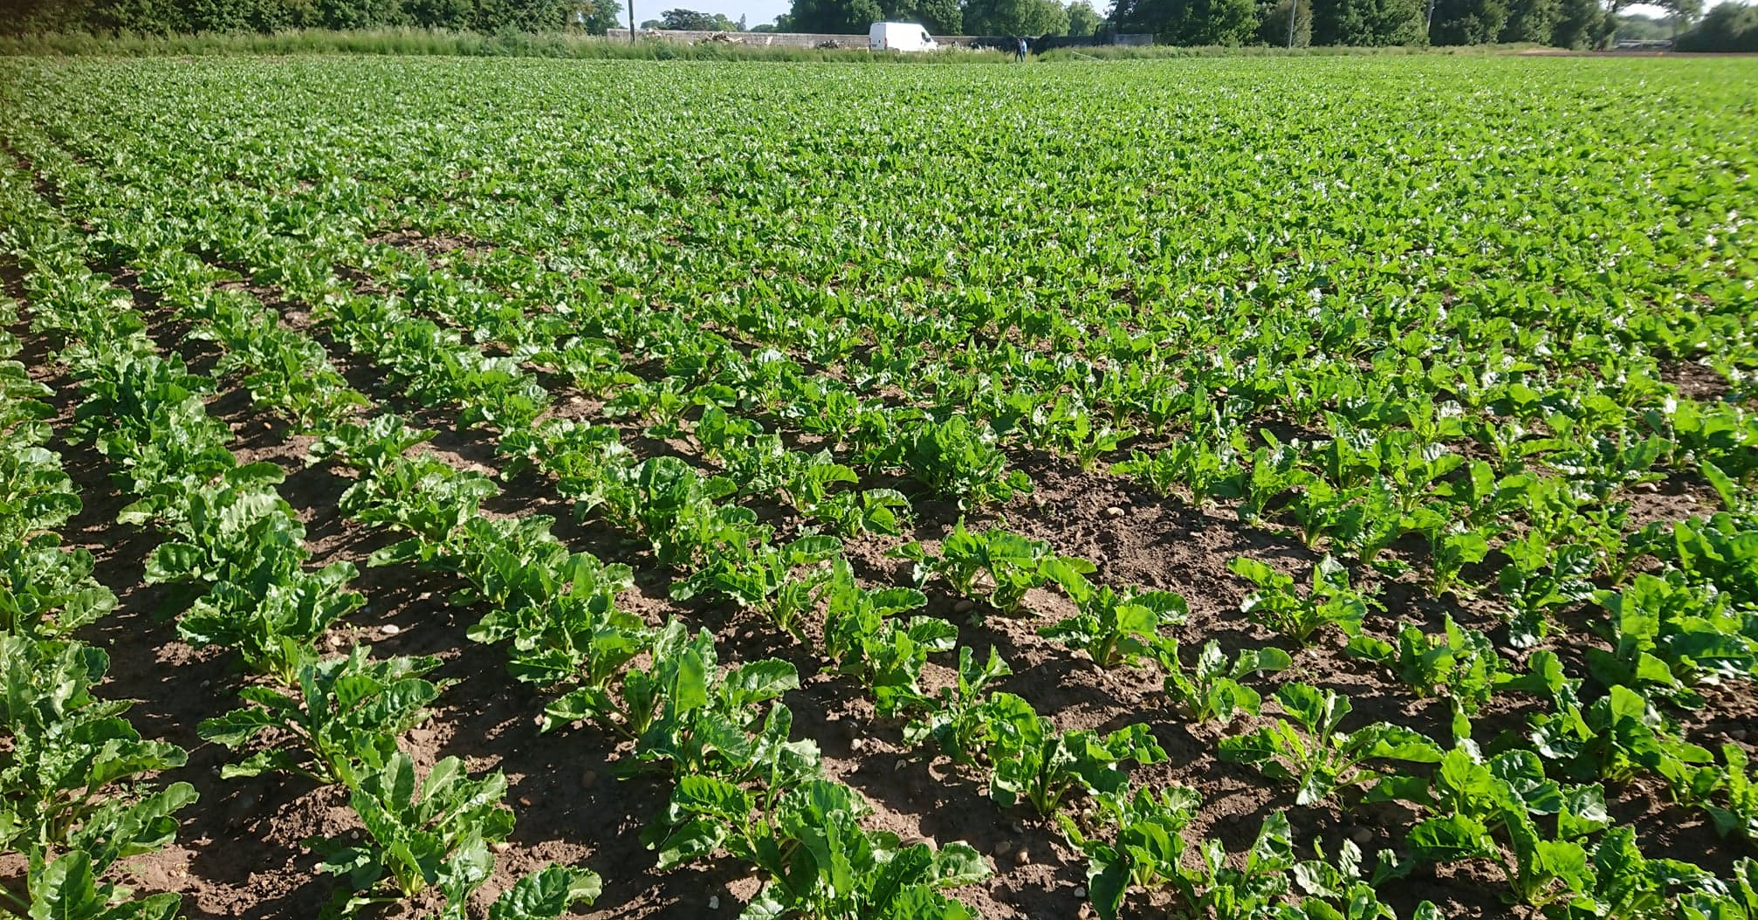
Supervisors: Debbie Sparkes & Mark Stevens
Internal assessor: Erik Murchie





Contents

1. Introduction 4
1.2 Foliar diseases 5
1.2.1 Cercospora 5
1.2.2 Rust 5
1.2.3 Powdery mildew 5
1.3 Disease control methods 5
1.3.1 Varietal resistance/ tolerance 5
1.3.2 Alternate rows/ mixed planting 6
1.4 Fungicides 6
1.4.1 Triazoles 6
1.4.2 Strobilurins 7
1.4.3 SDHIs 7
1.4.4 Fungicide resistance 7
1.5 Remote sensing 7
1.6 Summary 8
1.7 Research questions 9
2. Polytunnel trial- Source sink manipulation 9
2.1 Introduction/ aim 9
2.3 Trial layout 9
2.4 Treatments 10
2.4.1 Control (unshaded) 10
2.4.2 Whole plant shading 10
2.4.3 Individual leaf shading (2 leaves shaded) 10
2.4.4 Individual leaf shading (4 leaves shaded) 10
2.5 Nitrogen and manganese applications 10
2.6 Measurements 10
2.6.1 Pre-treatment measurements 10
2.6.2 SPAD 11
2.6.3 Field Spec 11
2.6.4 Disease scoring 11
2.6.5 Post-harvest measurements 11
2.7 Results to date 11
2.7.1 SPAD 11
2.7.2 Disease scoring 12
2.7.3 Harvest measurements 12
2.9 Conclusion/ further work 15
3. Field trial 15
3.1 Experimental design 15
3.2 Virus yellow control 16
3.3 Measurements 16
3.3.1 Canopy cover 16
3.3.2 Disease scoring 17
3.3.3 SPAD 17
3.3.4 Remote and proximal sensing. 17
3.3.5 Harvest processing 17
3.4 Statistics 17
4. Results to date 19
4.1 Canopy cover 19
4.2 Disease scoring 20
4.2.1 Powdery mildew 20
4.2.2 Rust 21
4.2.3 Cercospora 22
4.3 SPAD 23
4.4 Remote and proximal sensing 24
5. Discussion 24
5.1 Canopy cover 24
5.2 Disease scoring 24
5.3 SPAD 25
6. Future work 25
6. References 26

1. Introduction
Sugar beet, Beta vulgaris, is a globally important crop utilised for sugar production (Draycott, 2006). Between 1945 and 2000 sugar production globally from sugar beet rose from approximately 6 to 40 million tonnes, 75% of which is produced in Europe (Draycott, 2006). Sugar beet is a biennial species, harvested after one year to maximise sugar yields before resources are diverted from vegetative to reproductive growth. The sugar beet root is comprised of a series of concentric rings of secondary cambia which originate in the primary taproot pericycle. Six to seven of these rings are laid down during early seedling development and form the bulk of the harvest becoming thicker from continual cell production and cell expansion. Each sugar beet contains approximately ten of these rings in total (Schnepel and Hoffmann, 2016). On average the sugar content of a sugar beet is 17%.
1.1 Photosynthesis, light interception, and yield
The sugar accumulated in the beet root storage organ is produced through photosynthesis (Duraisam et al, 2017). In optimal conditions there is a direct, linear relationship between radiation intercepted by the canopy and sugar yield (Figure 2). Radiation use efficiency (RUE) of a crop is the dry matter increase per unit of photosynthetically active radiation absorbed. The RUE of sugar beet is estimated as 1.72g of dry matter for each MJ of intercepted radiation (Werker and Jaggard, 1998). As harvest occurs prior to productive growth in sugar beet this linear relationship is also true for yield (Cooke & Scott, 1993) (Figure 2), as accumulated resources have not yet been diverted to reproduction.
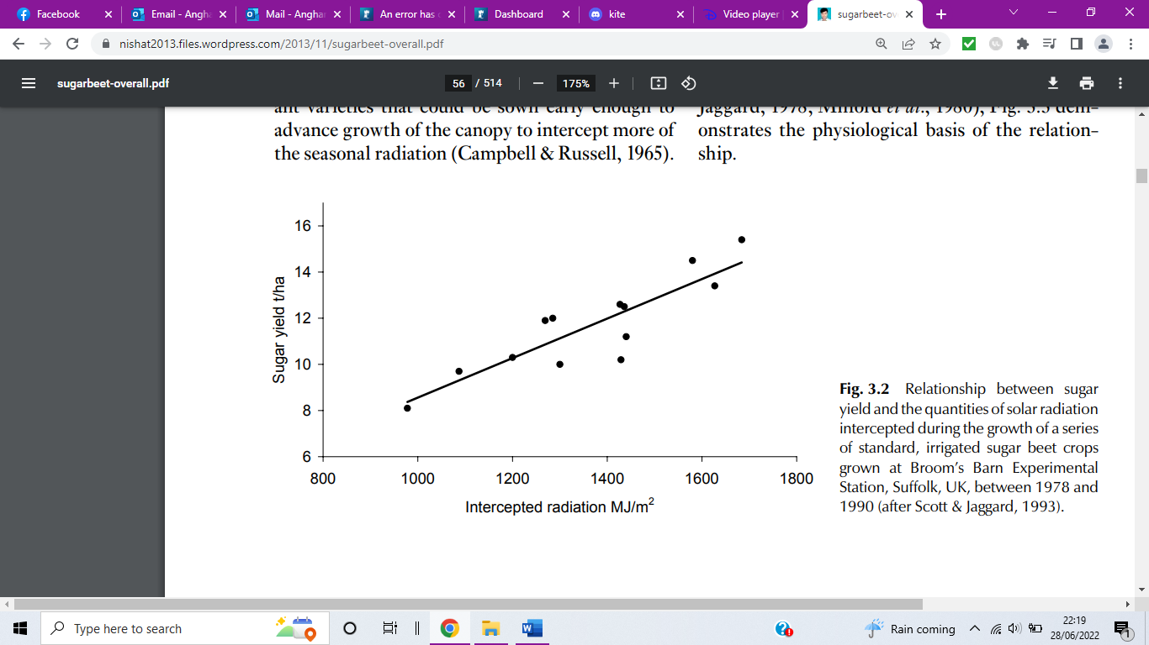
Figure 2: The relationship between sugar beet yield and RUE (Cooke & Scott, 1993)
The relationship between light interception and yield which causes particular concern in relation to foliar diseases. Leaf spots and necrosis caused by disease reduce healthy leaf area thereby limiting the crops’ ability to absorb solar radiation, reducing potential yields. Additionally, photosynthetic processes may also be disrupted by disease infection thus reducing RUE.

1.2 Foliar diseases
There are number of fungal foliar diseases which pose a threat to UK beet crop and yield. 13% of samples sent to the BBRO 2021/2022 plant clinic (BBRO,2022c) were identified as foliar disease (Figure 3). The most significant in the UK are rust, powdery mildew and cercospora

1.2.1 Cercospora
Although historically not a major risk in the UK, in recent years, as the climate warms, cercospora has become a major concern to the UK beet industry. Cercospora is a threat between mid-July to October in hot humid conditions (Steddom et al, 2005). Symptoms appear as tan/light brown spots with darker edges and often a central black dot which coalesce resulting in defoliation (Asher & Hanson, 2006). Conidia may persist in leaf debris for 1-2 months however, pseudostromata can survive up to 2 years. Possible control methods include crop debris removal, 3-year rotations, resistant cultivars, cultural measures (Asher & Hanson, 2006) and fungicide usage. Yield loss is attributed to defoliation reducing photosynthetic capacity and energy expenditure from leaf replacement, sugar impurities like sodium and potassium may increase (Holtschulte, 2000).

1.2.2 Rust
Rust, caused by Uromyces beticola (Kristoffersen et al, 2018), occurs in damp conditions between 15-22ºC from mid-July causing losses of 10-14% (BBRO, 2022b). 1-2mm orange/brown pustules often with a yellow halo resulting in epidermis rupture (Asher & Hanson, 2006) arise on seed stalks, petioles and leaf surfaces. Teliospores persist on leaf detritus and weeds in spring spreading sporidia onto young plants (Asher & Hanson, 2006). Control methods include resistant cultivars and fungicides.

1.2.3 Powdery mildew
Powdery mildew (Erysiphe betae) is a grey mould which appears first on older leaves and rapidly spreads across leaf surfaces from July in dry warm conditions (BBRO, 2022b). It gives a dusty appearance causing chlorosis. It’s considered as one of the most potentially damaging foliar diseases to UK beet accounting for 20% reductions in yield of infected crops (BBRO, 2022b). Partially resistant cultivars and fungicide application are current control methods (BBRO, 2022b).

1.3 Disease control methods

1.3.1 Varietal resistance/ tolerance
Disease susceptibility is where a variety shows full disease symptoms and consequent yield loss when infected, whereas tolerance is a plant’s ability to maintain performance under disease pressure (Ney et al, 2013), in sugar beet this would be seen by a lower-than-expected yield losses. Resistance may vary from partial to complete resistance whereby a variety is unaffected by a pathogen (BBRO, 2022b). In some cases, resistance may have been bred into a variety at the cost of agronomic traits such as yield (Vyska et al, 2016). Whilst resistant varieties may outyield their susceptible counterparts in high disease years, there is often a yield penalty in low pressure years where resistant varieties are outperformed (Vyska et al, 2016). For instance, many root and crown rot resistant beet cultivars have a yield penalty under low disease pressure and a higher bolting risk (Buhre et al, 2009). Consequently, growers must balance the cost of each variety with disease risk and potential yields.

1.3.2 Alternate rows/ mixed planting
The advantages of growing mixed varieties or species for disease control have been recognised in several species including wheat (Cox et al, 2004) potatoes (Phillips et al, 2005) winter triticale (Boligłowa et al, 2018), and rice (Mundt, 2002). For example, an 87% reduction in potato late blight severity was found in the susceptible cultivar Cara when grown with the resistant cultivar Appel rather than as monocrop (Philips et al, 2005). Mixed cropping prevents disease through; resistance induction, where avirulent spores delay or block the spread of virulent spores, barrier effects where resistant plants block spread and dilution, which decreases the distance between susceptible individuals delaying spread (Phillips et al, 2005).
Despite successes in disease control through cultivar mixing very little research has been done in sugar beet. Harveson and Rush (2002) investigated cultivar mixing for control of soil borne pathogens but found no benefit compared with monocrop. This is possibly due to the difference in spread mechanisms between soil and air borne pathogens. The only foliar diseases investigated with beet cultivar mixing were curly top and cercospora (Finkner, 1976; Harveson and Rush, 2002). The results indicated a reduction in disease incidence, but this was not consistent, possibly due to small sample sizes, and further research on a larger scale is needed (Finkner, 1976).
A higher importance is sometimes placed on susceptible varieties with agronomically important traits such as drought resistance or high yield potential than resistant varieties which may have yield penalties (Mundt, 2002). Mixed planting therefore allows grower to take advantage of desirable traits in both varieties. Furthermore, where there is pressure from multiple diseases, for example rust and cercospora in sugar beet, it may be possible to have a mixed crop with two varieties each resistant to one disease giving the overall crop improved resistance to both.

1.4 Fungicides
Fungicide usage protects sugar beet from many diseases that are detrimental to yield, however, continual research and development is needed to ensure that fungicides remain an effective control measure. In the UK, triazoles and strobilurins are used on sugar beet, SDHIs used on other crops are currently being evaluated for sugar beet usage.

1.4.1 Triazoles
Triazoles are 14-demethylase inhibitors (DMIs) a key component in ergosterol biosynthesis (Kristoffersen et al, 2018). Ergosterol is required for cell wall development and membrane structural components, consequently, ergosterol inhibition results in abnormal growth and fungal death (Mueller, 2006).

1.4.2 Strobilurins
Strobilurins function through inhibition of mitochondrial respiration by binding to the Qo site of cytochrome b located in the mitochondrial membrane (Bartlett et al, 2002). This halts electron transfer within the cytochrome bc₁ complex limiting ATP production (Bartlett et al, 2002).

1.4.3 SDHIs
SDHIs are succinate dehydrogenase inhibitors which disrupt fungal respiration and energy production through disruption of the mitochondrial complex II by blocking Ubiquinone-binding sites (McKay et al, 2011).

1.4.4 Fungicide resistance
Though fungicides are an effective tool against disease, fungal pathogens are able to develop resistance, thereby reducing efficacy. In cercospora, triazoles target the Cyp51 gene. Muellender et al (2021) identified three resistant C.beticola strains which had a nucleotide 1391-point mutation of Cyp51 resulting in the production of a serine rather than tyrosine, thus decreasing the binding affinity of the triazole. Additionally, upregulation of the Cyp51 gene was identified in these strains in the presence of fungicide which combined provides increased resistance. However, resistance has not yet been found in U. beticola (Kristoffersen et al, 2018).

1.5 Remote sensing
Remote sensing (RS) utilises imaging, and reflectance sensors to determine physiological characteristics of vegetation for pest and disease identification. RS can identify predation, visual disease symptoms such as leaf spots and pigment destruction and wilting (Zhang et al, 2019). RS detects the wavelength of reflected light from the target which varies depending on physiological structures. Typically, leaf pigments are associated with visible light reflected, cell structure with near infrared and water content and leaf biochemical with shortwave infrared (Figure 1).
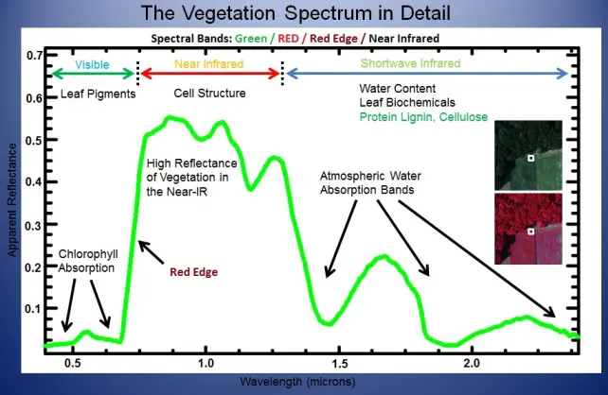
Figure 1: The vegetation spectrum (Corrigan, 2020)

Spectral vegetation indices (SVIs) are calculated from reflectance data to determine characteristics like chlorophyll content (Steddom et al, 2003) (Figure 6) which can indicate disease. For example, Normalized Difference Vegetation Index (NDVI) associated with biomass and leaf area has been used for powdery mildew detection in wheat (Yaun et al, 2014). The SVI mNDblue was developed (Jay et al, 2017) for chlorophyll detection in sugar beet, and may be an effective tool for disease identification.
Sensing can be performed at canopy or leaf scale for instance through drone or leaf clip (Steddom et al, 2005, Mahlein, 2011). Typically, ‘remote sensing’ refers to both canopy and leaf level sensing. For clarity, in the remainder of this document, canopy and leaf sensing will be referred to as remote and proximal sensing respectively.
The lag phases between disease onset and visual symptoms for cercospora, rust and powdery mildew are 8, 10 and 15 day respectively (Mahlein, 2011). It may be possible for remote/proximal sensing to detect disease prior to onset of visual symptoms allowing fungicide application to be optimised. Steddom et al, (2005) successfully used RS to monitor visual symptoms of cercospora. Furthermore, Mahlein, (2011) utilised RS to monitor cercospora, rust and powdery mildew on sugar beet when visual symptoms were present. However, accuracy was limited at low disease severity consequently may not be suitable for pre-symptomatic disease detection.

1.6 Summary
The UK sugar beet industry currently faces threat from fungal foliar diseases, notably cercospora, rust and powdery mildew reducing sugar yield and quality. Current control methods rely on varietal resistance and tolerance, and fungicide application. This study aims to address knowledge gaps in the use of alternate rows, and interactions between varietal resistance/ tolerances and fungicide applications. In addition, the use of remote sensing techniques to identify and monitor foliar disease of sugar beet will be investigated.

1.7 Research questions
- Are varietal mixtures an effective means for fungal disease control in sugar beet thus reducing fungicide requirement?
- Can fungicide programmes be tailored according to varietal susceptibility to disease to limit unnecessary application?
- Can remote or proximal sensing detect disease infection prior to visual symptoms?

2. Polytunnel trial- Source sink manipulation

2.1 Introduction/ aim
In recent years the widely held belief that sugar beet is source limited with a direct linear relationship between intercepted radiation and dry matter (sugar yield) has been challenged with the suggestion that there is a sink limitation at play (Manderscheid et al, 2010, Schnepel, & Hoffmann, 2016).
Understanding the source/sink relationship in sugar beet is important for understanding yield formation. Source limitation is of particular importance to my project as foliar damage from diseases such as rust is a form of source limitation. This trial aims to determine whether sugar beet yield is source limited by using shading to manipulate source availability which will be indicated through reduced yield as shading increases.

2.3 Trial layout
The variety BTS1140 was used in this trial. Three seeds were sown in 5L pots on 28 April. Post gemination they were thinned leaving one per pot 23 May. On 26 July the plants were arranged into blocks of similar sized plants and treatments applied.
The trial contained four blocks each with two plants per treatment within each block, (Figure 2).
 | Block 1 |  |  |  | Block 2 |  |  |  | Block 3 |  |  |  | Block 4
 | 0 |  | 3 |  | 2 |  | 0 |  | 3 |  | 1 |  | 0 |  | 2
 | 0 |  | 3 |  | 2 |  | 0 |  | 3 |  | 1 |  | 0 |  | 2
 | 1 |  | 2 |  | 3 |  | 1 |  | 2 |  | 0 |  | 1 |  | 3
 | 1 |  | 2 |  | 3 |  | 1 |  | 2 |  | 0 |  | 1 |  | 3
Figure 2: Layout of source/sink trial. Treatments: 0=control, 1= 4 leaf shading, 2= 2 leaf shading, 3= full shading with frame.

2.4 Treatments

2.4.1 Control (unshaded)
Plants had no shading.

2.4.2 Whole plant shading
Whole plant shaded with shade netting held in place by frame. 57% of available light blocked by artificial shading.

2.4.3 Individual leaf shading (2 leaves shaded)
Leaf bags formed of shade netting placed on leaf 10 and 12. Each bag blocks 47% of available light. At trial onset the average leaf number was 21 as such the overall amount of light blocked by artificial shading is 4.5%
During high winds pegs were used to hold bags in place.

2.4.4 Individual leaf shading (4 leaves shaded)
Leaf bags formed of shade netting placed on leaf 6, 8, 10 and 12. Each bag blocks 47% of available light. At trial onset the average leaf number was 21 as such the overall amount of light blocked by artificial shading is 9%.
During high winds pegs were used to hold bags in place.
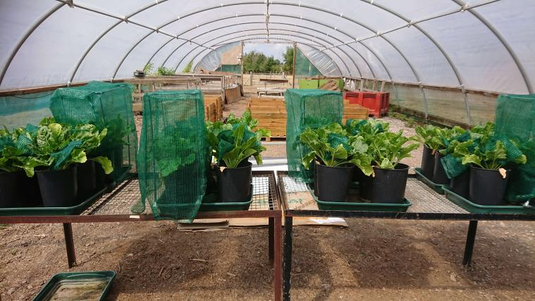
Figure 3: Polytunnel source manipulation trial 2022.

2.5 Nitrogen and manganese applications
Nitrogen was applied on 17 June and 1 July at a rate of 50kg/ha N in the form of ammonium nitrate and a further 20kg/ha on 8 September.
Manganese was applied on the 9 September at a rate of 5L/ha using opt E-Man.

2.6 Measurements

2.6.1 Pre-treatment measurements
Plant height, leaf number, leaf 12 length, leaf 12 width, leaf number and dead leaf number measurements were taken.

2.6.2 SPAD
Weekly SPAD measurements were taken on two leaves per plant. On those plants with leaf bags one bagged and one non-bagged leaf was measured.

2.6.3 Field Spec
Unfortunately, due to a fault in the equipment the only Field Spec measurement was performed the week preceding the treatment application as opposed to the proposed fortnightly readings.

2.6.4 Disease scoring
This was performed according to the BBRO protocol upon sighting of Powdery mildew on 1/09/2022.

2.6.5 Post-harvest measurements
Harvest was performed on 27 October. Following harvest, the fresh weight of dead leaves, green leaves, root and petiole was measured for each plant. Leaf area was measured using a Licor leaf area meter. A 5mm root slice was taken at the widest point and imaged, ImageJ software was used to obtain average root diameter and cambium ring number counted. The samples were then dried in an oven at 70% to obtain dry weights. Following drying the samples will be sent for ICPMS analysis to confirm suspected manganese deficiency.

2.7 Results to date

2.7.1 SPAD
There was no significant difference in leaf greenness, as measured by SPAD, between the different shading treatments (Figure 4).

Figure 4: Average SPAD of sugar beet grown under shade treatments. Treatments: Control= no shading, 2 leaves shaded, 4 leaves shaded and whole plant shaded. Error bar shows LSD^{5%}

2.7.2 Disease scoring
Powdery mildew levels were recorded on 1/09/2022 and averaged at 27.5% coverage across the trial, there was no significant differences between the treatments.

2.7.3 Harvest measurements
The control plants had a significantly lower leaf area than the shaded plants (Figure 5). Specific leaf area, an indication of leaf thickness, is significantly lower in the whole plant shading treatment that the control and 2 & 4 leaf shaded treatments (Figure 6). Therefore, the leaves increased in size and decreased in thickness as shading increased.

Figure 5: Leaf area of sugar beet grown under shade treatments. Error bar shows LSD^{5%}

Figure 6: Specific leaf area of sugar beet grown under shade treatments. Error bar shows LSD^{5%}
The whole plant dry weight and root dry weight of the plants decreased with shading (Figure 7 & 9). The unshaded control plants had significantly higher whole plant and root dry weights than the 4 leaf and fully shaded treatments, additionally the fully shaded plants were significantly smaller than the other treatments. Contrastingly there were no significant differences in leaf dry weight (Figure ).
There was no significant difference in cambium ring number across the treatments, with all plants containing between 10 and 13 rings.

Figure 7: Whole plant dry weight of sugar beet grown under shade treatments. Error bar shows LSD^{5%}

Figure 8: Leaf dry weight of sugar beet grown under shade treatments. Error bar shows LSD^{5%}

Figure 9: Root dry weight of sugar beet grown under shade treatments. Error bar shows LSD^{5%}
The average root diameter reduced as shading increased with whole plant shading being significantly smaller than unshaded and 2 leaf shaded treatments (Figure 10).

Figure 10: Average root diameter at widest point sugar beet grown under shade treatments. Error bar shows LSD^{5%}

2.8 Discussion
The cambium ring number remained largely constant across the treatments, supporting findings by Schnepel & Hoffmann (2016) indicating that cambium ring number is more dependent upon genetics than environmental factors and that differences in yield may be attributed to ring thickness and cell size, not ring number.
The lower leaf area seen in the unshaded plants and lower specific leaf area of the whole shaded plants may be a result of stress caused by shading whereby the more shaded leaves have thinned and become slightly larger in an attempt to maximise intercepted light for photosynthesis. This increase in leaf area under shading was also noted by Manderscheid, (2010) whilst investigating elevated CO₂ and N levels.
Dry root weight and root diameter both significantly decreased as shading levels increased across the treatments. Root weight decreased by approximately 62.4% from unshaded to plants grown under 57% shading. Similar results were found by Wang et al, (2014) when investigating the effect of shading on sweet potato yields. This yield reduction indicates that there is a source limitation acting on the sugar beet. Additionally, as there was no significant difference between treatments for leaf and petiole weight, this indicates that the source reduction was attributed to shading not canopy size difference. However, this study only considers dry matter yield, further investigation is needed to confirm a source limitation on sugar accumulation
Whilst under restricted source conditions these beet demonstrate source limitation. This, however, contradicts findings of Manderscheid et al, (2010) who when investigating shading in conjunction with raised N and CO₂ levels concluded that the major limitation of sugar beet yield was sink strength. Therefore, there may be some circumstances where sink limitation becomes important.

2.9 Conclusion/ further work
This study indicates source limitation acting on sugar beet when under shaded conditions. Further work is needed to confirm these results at a larger scale and over a longer duration. Additionally, sugar yield should be investigated alongside dry matter yield.

3. Field trial

3.1 Experimental design
The first field experiment included three varieties and an alternate row combination. The varieties used are Kortessa, BTS1140 and Advena which have a high, medium and low resistance to rust and powdery mildew respectively (BBRO, 2022a). The alternate row treatment combines Kortessa and Advena (Table 1). Six fungicide treatments were selected (Table 2). Two azole and strobilurin combinations have were used in order to provide a comparison between the currently available active ingredients and those which have been removed from use. Fungicide applications were applied on 29/07/2022 following observation of mildew infection in the field, with a second and third application on 07/09/2022 and 14/10/2022 respectively.

Table 1: Varieties selected for the 2022 field experiment.
Variety | Kortessa | BTS1140 | Advena
Potential yield (% control) | 99.9 | 100 | 99.8
Rust resistance | 7.7 | 5.4 | 3
Mildew resistance | 5.7 | 4.6 | 3.8
Alternate row - Kortessa + Advena

Table 2: Fungicide treatments for 2022 trial.
Treatment | Fungicide
0 | Control
1 | Azole
2 | SDHI
3 | Azole+ SDHI
4 | Azole+ Strobilurin
5 | Azole+ Strobilurin

The experiment was arranged as a randomised complete block design with four replicate blocks.

3.2 Virus yellow control
In order to control virus yellows within the trial, as part of the BBRO Aphid survey three yellow water pan traps were set across the field and 20 plants were marked and inspected for aphids twice weekly from April to June. This aphid monitoring allowed for the timely application of foliar aphicide once threshold was reached. The threshold for early development is one aphid per four plants and, once plants reach the 12-leaf stage the threshold increases to one aphid per plant. Insecticides were applied on 10/05/2022 (acetamiprid) and 19/05/2055 (flonicamid).

3.3 Measurements

3.3.1 Canopy cover
A tractor mounted camera (Canon 1100D) with a wide-angle lens set at 10mm was used to image the plots from above fortnightly at a height of 1.2m, 2.5m from the plot edge. Two images were taken of each plot each covering 36% of the plot, ImageJ software was then used to threshold the images and calculate an average % canopy cover for each plot

3.3.2 Disease scoring
The disease scoring was performed via visual assessment in accordance with the BBRO protocol. Due to the subjective nature of visual assessment, there is an inherent inaccuracy (Steddom et al, 2005) due to human error and external factors like weather. However, alternatives including leaf tagging and photographic assessment of individual leaves (Ghazal & Hajjdiab, 2015) are impractical and time consuming for a field setting and may also be subject to bias.
Disease scoring was performed fortnightly from 11th July and increased to weekly in October when disease levels began to rise significantly.

3.3.3 SPAD
SPAD measurements were be taken fortnightly weather permitting. For each plot four leaves were measured with three readings taken on different positions on each leaf.

3.3.4 Remote and proximal sensing.
Proximal sensing a FieldSpec using a leaf clip was used to measure reflectance between 350nm to 2000nm of four leaves per plot to calculate SVIs described in Figure 6. Remote sensing was performed using a tractor mounted Crop Circle a remote sensor which measures red and near infrared wavelengths (670-760nm). From this NDVI, NDRE and MnDBlue were calculated. Both forms of sensing were performed fortnightly.

3.3.5 Harvest processing
A hand harvest was performed taking a sample from each plot on 28th November. 10 plants were lifted from each plot in total across row 5 and 6 to ensure plants from both varieties in alternate row plots were measured. Upon harvest the fresh weight of root, petioles and leaves was measured (rows 2,3,4 were saved for final harvest by the BBRO plot harvester). The sample was then sub sampled and five plants were randomly selected, and oven dried to obtain dry weights. The remaining plants will be harvested by the BBRO team in January for and sent to the BBRO tare house for root weight, sugar content, and amino nitrogen (AN), sodium (Na) and potassium (K) content analysis.

3.4 Statistics
Statistical analysis will be performed in GenStat. ANOVA and repeated measures ANOVA will be used to investigate data across the season followed by the post hoc Duncan’s test. Scatter plots and correlation matrices will be used to investigate the relationship between spectral indices and disease seen in the field.
Figure 11: Remote sensing spectral vegetation indices, associated traits and equations.
Spectral Vegetation Indices | Trait | Equation | Reference
Normalized difference Vegetation Index (NDVI) | Biomass leaf area | (R760 – R710)/(R760 + R710) | (Steddom et al, 2005), (Mahlein, 2011)
Green normalized difference vegetative index (GNDVI) | Canopy greenness | (R810 – [(R510 + R561) / 2])/(R810 + [(R510 + R561)/2]) | (Steddom et al, 2005)
Visible atmospherically resistant index (VARI) | Chlorophyll content | (R559 – R661)/(R559 + R661 – R460) | (Steddom et al, 2005)
Difference vegetation index (DVI) | Chlorophyll Content | R810 – ([R610 + R661]/2) | (Steddom et al, 2005)
Renormalised difference vegetation index (RDVI) | Chlorophyll content | sqrt (NDVI * DVI) | (Steddom et al, 2005)
Simple ratio (SR) | Green biomass | R800/R670 | (Mahlein, 2011)
Normalized difference index (ND) | Chlorophyll content | (R750 − R705) / (R750 + R705) | (Mahlein, 2011)
Modified normalized difference index (mND) | Chlorophyll content | (R750−R705)/(R750+R705−2 · R445) | (Mahlein, 2011)
Photochemical reflection index (PRI) | Pigment variation | (R531 − 570) / (R531 + R570) | (Mahlein, 2011) , (Zhang et al, 2019).
Structure insensitive pigment index (SIPI) | Carotenoid: chlorophyll a ratio | (R800 − R445) / (R800 + R680) | (Mahlein, 2011)
Pigment specific simple ratio (PSSRa) | Chlorophyll a | R800/R680 | (Mahlein, 2011)
Pigment specific simple ratio (PSSRb) | Chlorophyll b | R800/R635 | (Mahlein, 2011)
Pigment specific simple ratio (PSSRc) | Carotenoid | R800/R470 | (Mahlein, 2011)
Pigment specific normalized difference (PSNDa) | Chlorophyll a | (R800 − R680) / (R800 + R680) | (Mahlein, 2011)
Pigment specific normalized difference (PSNDb) | Chlorophyll b | (R800 − R635) / (R800 + R635) | (Mahlein, 2011)
Pigment specific normalized difference (PSNDc) | Carotenoid | (R800 − R470) / (R800 + R470) | (Mahlein, 2011)
Anthocyanin reflectance index (ARI) | Anthocyanin | 1/R550 − 1/R700 | (Mahlein, 2011)
Modified chlorophyll absorption integral (mCAI) | Chlorophyll content | (R545 + R752)/2 × (752 − 545) − (∑545 − 752 (1.158 × R)) | (Mahlein, 2011)
Red edge position (REP) | Inflection point red edge | 700 + ((40 · (RRE−R700))/(R740- R700) | (Mahlein, 2011)
Plant sensecence index (PSRI) | Plant senescence | (R680 − R500) /R750 | (Mahlein, 2011)
Water index (WI) | Water content | R900/R970 | (Mahlein, 2011)
Optimized soil adjusted vegetation index (OSAVI) | Biomass with soil adjustment factor | ((1+0.169) · (R800−R670))/( R800+R670+0.16) | (Mahlein, 2011)
Modified chlorophyll absorption reflectance index (MCARI) | Chlorophyll content | [(R700-R670)-0.2(R700-R550)*(R700/R670) | (Mahlein, 2011)
SumGREEN index (SG) | Green reflectance | av R500 : R600 | (Mahlein, 2011)
SumVIS index (SV) | VIS reflectance | av 400 : R600 | (Mahlein, 2011)
Blue/Green index (BIG2) | Chlorophyll content | R450/R550 | (Mahlein, 2011)
(mNDblue) | Chlorophyll content | (R450-R730)/(R450+R850) | (Jay et al, 2017)

4. Results to date

4.1 Canopy cover
Canopy images were taken fortnightly, however in some cases weather or equipment problems prevented data collection. From 1 June through to 28 June there was a continual increase in canopy cover as the plants established. A significant loss in canopy occurred from the end of June due to the drought conditions seen from June to early August. For example, July and August saw a combined rainfall of 44.8 mm compared to the 103.8 mm of the previous year recorded by the onsite met office station. Canopy recovery has occurred since the 19 August and has continued to date. To date there has been no significant differences between canopy cover for variety or treatment.

Figure 12: Canopy cover of Sutton Bonington field trial plots June-October 2022.

4.2 Disease scoring
Disease scoring identified powdery mildew, rust and cercospora in the trial.

4.2.1 Powdery mildew
Powdery mildew was present in the field from 27 July, this declined and was absent by September due to leaf loss caused by drought (Figure 12). There was no significant difference between treatment and variety.
Figure 13: Powdery Mildew levels across variety in Sutton Bonington field trial 2022.
Figure 14: Powdery Mildew levels across treatments in Sutton Bonington field trial 2022. Treatments: 0= control, 1= Azole, 2= SDHI, 3= Azole+ SDHI, 4= Azole+ Strobilurin, 5= Azole+ Strobilurin.

4.2.2 Rust
Rust was first seen in the field on 8 August and has increased since (Figures 15 & 16). From 11 October, the control plots had higher levels of rust than the treated plots (Figure 15). Differences between varieties became significant from 17 October with BTS1140 showing higher levels than the Advena, Kortessa and alternate varieties (Figure 16). There was a significant interaction between treatment and variety on the 24 October where the plots with both BTS1140 and no fungicide treatment were significantly higher in rust levels than other combinations.

Figure 15: Rust levels across varieties in Sutton Bonington field trial 2022. Error bar shows LSD^{5%}
Figure 16: Rust levels across treatments in Sutton Bonington field trial 2022. Treatments: 0= control, 1= Azole, 2= SDHI, 3= Azole+ SDHI, 4= Azole+ Strobilurin, 5= Azole+ Strobilurin. Error bar shows LSD^{5%}

4.2.3 Cercospora
Cercospora was identified in the trial on 13 August. From 27 September BTS1140 had significantly higher cercospora levels than the other varieties excluding the 3 October, (Figure 17). The control treatment had significantly higher levels on 17 October and 3 November with no significant interaction between treatment and variety.

Figure 17: Cercospora levels across varieties in Sutton Bonington field trial 2022. Error bar shows LSD^{5%}
Figure 18: Cercospora levels across treatments in Sutton Bonington field trial 2022. Treatments: 0= control, 1= Azole, 2= SDHI, 3= Azole+ SDHI, 4= Azole+ Strobilurin, 5= Azole+ Strobilurin. Error bar shows LSD^{5%}

4.3 SPAD
While there were significant differences in leaf greenness, measured by SPAD, on some dates, the differences between treatments were not significant and a repeated measures ANOVA across the season shows only variety to be significant with BTS1140 lower the other varieties which were not significantly different from each other. A repeated measures ANOVA across the season shows only variety to be significant with BTS1140 lower the other varieties which were not significantly different from each other.

Figure 19: Average SPAD values for fungicide treatments on Sutton Bonington field trial plots June-November 2022. Treatments: 0= control, 1= Azole, 2= SDHI, 3= Azole+ SDHI, 4= Azole+ Strobilurin, 5= Azole+ Strobilurin. Error bar shows LSD^{5%}

Figure 20: Average SPAD values for variety on Sutton Bonington field trial plots June-November 2022. Error bar shows LSD^{5%}

4.4 Remote and proximal sensing
Due to a fault with the Field Spec data was only collected on 7 July, 20 July and 4 August.
The Crop Circle has been used throughout the growing period on the same dates canopy cover images were taken (Figure 12), with the exception of 1 June, 8 July and 27 July due to equipment faults.
The processing and analysis of both Field Spec and Crop Circle data is ongoing.

5. Discussion

5.1 Canopy cover
The lack of significant differences in canopy cover between variety and treatment indicates that all varieties have a similar drought tolerance as lack of rainfall from June and August was the major cause of canopy decline. Thus far canopy cover has given no indication of disease presence however, this may change before the final harvest in January.

5.2 Disease scoring
Powdery mildew, rust and cercospora have been present within the field trial. Unfortunately mildew infected leaves were lost during the drought and reinfection didn’t occur as such this study has focuses on cercospora and rust.
Across the season BTS1140 has had significantly higher rust levels that the other varieties which were grouped. This was unexpected as Advena was the most susceptible variety with BTS1140 as the intermediate. This may be due to reduction in varietal performance this hypothesis is supported when comparing the BBRO recommended lists of 2022 and 2023 where the rust score for BTS1140 reduces from 9 to 7.7 where 1 is classified as high leaf infection and 9 as very low leaf infection. (BBRO, 2022a, BBRO, 2022d) Similarly, to rust BTS1140 has the highest level of cercospora across the varieties. Though unavailable at the onset of this trial the BBRO 2023 (BBRO, 2022d) recommended list indicates BTS1140 to be the most susceptible to cercospora of the varieties used so this result was expected. Furthermore, due to the close grouping of Advena and Kortessa in rust and cercospora levels, it has not yet been possible to determine if alternate rows are an effective means for disease control.
For both rust and cercospora there has been no significant difference between fungicide treatments with only the untreated control showing significantly higher infection levels. This may be because of relatively low levels of disease across the trial not being significant to demonstrate differences which may occur under high pressure years.

5.3 SPAD
A SPAD meter measures the specific wavelengths 650 nm and 940 nm in order to give an indication of chlorophyll content (Zhang et al, 2021). Across the season SPAD levels gradually increased, following an initial drop in July, this drop may be attributed to severe drought and leaf loss. Zhang et al, (2021) also noted a rise in SPAD levels in sugar beet during the leaf and sugar growth stages, in this case however, SPAD levels reduced during the main sugar accumulation stage. In our study SPAD levels may have continued to rise across the season due to rapid leaf regeneration induced via drought conditions.
Whilst Advena, Kortessa and the alternating varieties were grouped BTS1140 demonstrated a significantly lower SPAD across the season. This may be attributed to differences in genetics between varieties however, the significantly higher levels of disease in the BTS1140 plots may account for the lower SPAD values as disease symptoms damaged photosynthetic systems.
5.4 Remote and Proximal sensing
The processing and analysis of this data is ongoing.

6. Future work

Future work will investigate fungicide application timing and number of applications in order to optimise usage and investigate tailoring of fungicide treatments to varietal disease resistance. For example, by extending the period between applications.
Investigation into the use of remote sensing for pre-symptomatic disease detection will also be continued as data collection was limited this year.

6. References

Asher, M.J. and Hanson, L.E., (2006). Fungal and bacterial diseases. Sugar beet, pp.286-315.
Bartlett, D.W., Clough, J.M., Godwin, J.R., Hall, A.A., Hamer, M. and Parr‐Dobrzanski, B., (2002). The strobilurin fungicides. Pest Management Science: formerly Pesticide Science, 58(7), pp.649-662.
BBRO, (2022a) RECOMMENDED LIST OF SUGAR BEET VARIETIES 2022 (Based on trials from 2018-2020) Available at: https://bbro.co.uk/media/50483/22-treated-rl-3years-data.pdf
BBRO, (2022b) 2022 Sugar Beet Reference Book-Featuring the latest advice on crop protection
BBRO, (2022c) Plant clinic. Available at: https://bbro.co.uk/bbro-research/plant-clinic/ (accessed on: 12/11/2022)
BBRO, (2022d) Recommended List 2023. Avaliable at: https://bbro.co.uk/sugar-beet-varieties/recommended-list/ (accessed on 13/12/2022)
Boligłowa, E., Gleń-Karolczyk, K., Klimek-Kopyra, A. and Zając, T., (2018). Condition of winter triticale in pure and mixed sowing. Journal of Research and Applications in Agricultural Engineering, 63(2).
Buhre, C., Kluth, C., Bürcky, K., Märländer, B. and Varrelmann, M., (2009). Integrated control of root and crown rot in sugar beet: combined effects of cultivar, crop rotation, and soil tillage. Plant Disease, 93(2), pp.155-161.
Cooke & Scott (1993) The Sugar Beet Crop. Science into practice. Chapman & Hall
Corrigan (2020) Multispectral Imaging Camera Drones In Farming Yield Big Benefits. Available at: https://www.dronezon.com/learn-about-drones-quadcopters/multispectral-sensor-drones-in-farming-yield-big-benefits/ (accessed on: 11/11/2022)
Cox, C.M., Garrett, K.A., Bowden, R.L., Fritz, A.K., Dendy, S.P. and Heer, W.F., (2004). Cultivar mixtures for the simultaneous management of multiple diseases: tan spot and leaf rust of wheat. Phytopathology, 94(9), pp.961-969.
Draycott (2006), ‘Introduction’ in Draycott Sugar Beet, Blackwell Publishing pp 1-8
Duraisam, R., Salelgn, K. and Berekete, A.K., (2017). Production of beet sugar and bio-ethanol from sugar beet and it bagasse: a review. Int J Eng Trends Technol, 43(4), pp.222-233.
Finkner, R.E., (1976). Cultivar blends for buffering against curly top and leafspot diseases of sugarbeet. Journal of the American Society of Sugar Beet Technologists, 19(1), pp.74-82.
Ghazal, M. and Hajjdiab, H., (2015), February. Leaf spot area index: A nondestructive mangrove leaf spot estimation technique. In 2015 IEEE International Conference on Signal Processing, Informatics, Communication and Energy Systems (SPICES) (pp. 1-5). IEEE.
Harveson, R.M. and Rush, C.M., (2002). The influence of irrigation frequency and cultivar blends on the severity of multiple root diseases in sugar beets. Plant disease, 86(8), pp.901-908.
Holtschulte, B., (2000). Cercospora beticola–worldwide distribution and incidence. Cercospora beticola, pp.5-16.
Jay, S., Gorretta, N., Morel, J., Maupas, F., Bendoula, R., Rabatel, G., Dutartre, D., Comar, A. and Baret, F., (2017). Estimating leaf chlorophyll content in sugar beet canopies using millimeter-to centimeter-scale reflectance imagery. Remote Sensing of Environment, 198, pp.173-186.
Kristoffersen, R., Hansen, A.L., Munk, L., Cedergreen, N. and Jørgensen, L.N., (2018). Management of beet rust in accordance with IPM principles. Crop Protection, 111, pp.6-16.
Mahlein, A.K., (2011). Detection, identification, and quantification of fungal diseases of sugar beet leaves using imaging and non-imaging hyperspectral techniques. Rheinischen Friedrich-Wilhelms-Universität Bonn. https://doi. org/10.1, 1, p.4184.
Manderscheid, R., Pacholski, A. and Weigel, H.J., (2010). Effect of free air carbon dioxide enrichment combined with two nitrogen levels on growth, yield and yield quality of sugar beet: Evidence for a sink limitation of beet growth under elevated CO2. European Journal of Agronomy, 32(3), pp.228-239.
McKay, A.H., Hagerty, G.C., Follas, G.B., Moore, M.S., Christie, M.S. and Beresford, R.M., (2011). Succinate dehydrogenase inhibitor (SDHI) fungicide resistance prevention strategy. New Zealand Plant Protection, 64, pp.119-124.
Muellender, M.M., Mahlein, A.K., Stammler, G. and Varrelmann, M., (2021) Evidence for the association of target‐site resistance in cyp51 with reduced DMI sensitivity in European Cercospora beticola field isolates. Pest Management Science, 77(4), pp.1765-1774.
Mueller, D.S., (2006). Fungicides: triazoles.
Mundt, C.C., (2002). Use of multiline cultivars and cultivar mixtures for disease management. Annual review of phytopathology, 40(1), pp.381-410.
Ney, B., Bancal, M.O., Bancal, P., Bingham, I.J., Foulkes, J., Gouache, D., Paveley, N. and Smith, J., (2013). Crop architecture and crop tolerance to fungal diseases and insect herbivory. Mechanisms to limit crop losses. European Journal of Plant Pathology, 135(3), pp.561-580.
Phillips, S.L., Shaw, M.W. and Wolfe, M.S., (2005). The effect of potato variety mixtures on epidemics of late blight in relation to plot size and level of resistance. Annals of Applied Biology, 147(3), pp.245-252.
Schnepel, K. and Hoffmann, C.M., (2016). Effect of extending the growing period on yield formation of sugar beet. Journal of Agronomy and Crop Science, 202(6), pp.530-541.
Steddom, K., Bredehoeft, M.W., Khan, M. and Rush, C.M., (2005). Comparison of visual and multispectral radiometric disease evaluations of Cercospora leaf spot of sugar beet. Plant Disease, 89(2), pp.153-158.
Steddom, K., Heidel, G., Jones, D. and Rush, C.M., (2003). Remote detection of rhizomania in sugar beets. Phytopathology, 93(6), pp.720-726.
Vyska, M., Cunniffe, N. and Gilligan, C., (2016). Trade-off between disease resistance and crop yield: a landscape-scale mathematical modelling perspective. Journal of the Royal Society Interface, 13(123), p.20160451.
Wang, Q., Hou, F., Dong, S., Xie, B., Li, A., Zhang, H. and Zhang, L., (2014). Effects of shading on the photosynthetic capacity, endogenous hormones and root yield in purple-fleshed sweet potato (Ipomoea batatas (L.) Lam). Plant Growth Regulation, 72(2), pp.113-122.
Werker, A.R., Jaggard, K.W., (1998). Dependence of sugar beet yield on light interception and evapotranspiration. Agricultural and Forest Meteorology 89, 229– 240
Yuan, L., Zhang, J., Shi, Y., Nie, C., Wei, L. and Wang, J., (2014). Damage mapping of powdery mildew in winter wheat with high-resolution satellite image. Remote sensing, 6(5), pp.3611-3623.
Zhang, J., Huang, Y., Pu, R., Gonzalez-Moreno, P., Yuan, L., Wu, K. and Huang, W., (2019). Monitoring plant diseases and pests through remote sensing technology: A review. Computers and Electronics in Agriculture, 165, p.104943.
Zhang, J., Tian, H., Wang, D., Li, H. and Mouazen, A.M., (2021). A novel spectral index for estimation of relative chlorophyll content of sugar beet. Computers and Electronics in Agriculture, 184, p.106088.

