Interpreting and managing intra-field variation in sugar beet yield

Objective:
To investigate the causes and effects of intra-field variation in sugar beet by mapping spatial variability and identifying the main associated environmental variables.
To assess how growers may be able to manage sugar beet fields more precisely in terms of soil preparation, drilling and application of inputs.
Short Summary:
- The effect of headlands on sugar beet yields has been estimated by Sparkes et al (1998) showing that the headlands yielded 19–41% less than the central area, with a mean reduction of 26%. However, the variation in the center of the field has been less well investigated although a recent report showed that the average variation in root fresh weight yields in three field at Brooms Barn was +/- 65t/ha and this was positively correlated with plant population, soil moisture and organic matter and negatively correlated with weed density and canopy temperature (Mahmood & Murdoch, 2017)
- During 2017, BBRO started two projects on intra-field variation 1) the BYC to assess the impact of variable crops on lost yield potential and 2) a long-term monitoring on intra-field performance with the Morley Agricultural Foundation.
- The BYC used aerial photography to identified fields showed patchy canopy development. Photographs were taken during July.
- The uniformity of crops (excluding headlands) was assessed in three categories 1) uniform and good canopy development across most of the field 2) some areas of thin canopy development and 3) significant areas of poor canopy development. Examples of categories 1 & 3 are shown below:

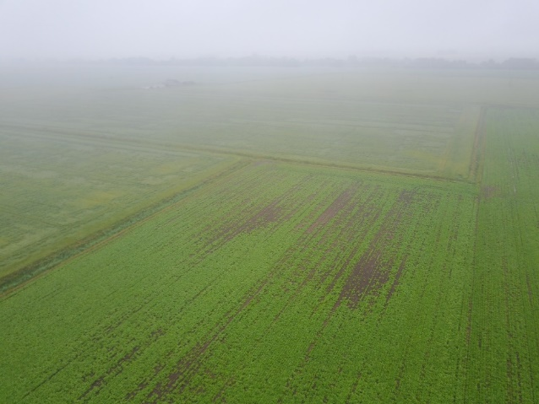
- Category 3 field 2. Category 3 field
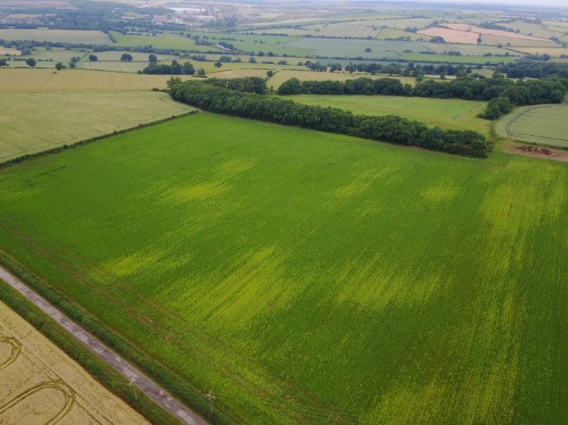

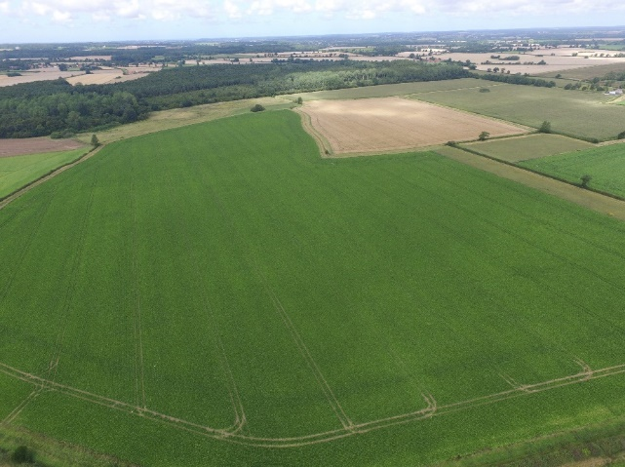
- Category 1 field 4. Category 1 field
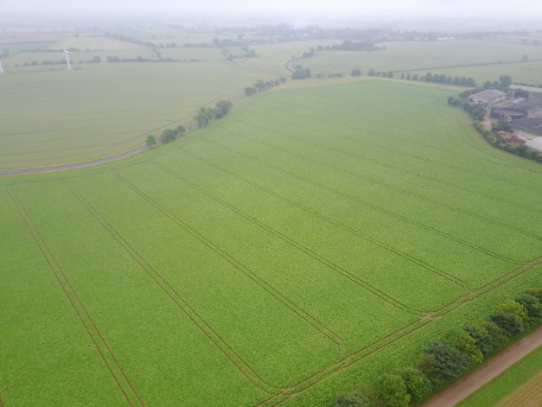
- The average proportion of the potential yield achieved (estimated by the BeetGro model) for each category was calculated and showed that overall fields in categories 2&3 achieved on average 14% less of their potential yield. It was not possible for the data to explain the small difference between categories 2 & 3.
Uniformity category | Average % of yield potential achieved
1 | 77%
2 | 61%
3 | 65%

- There were several explanations for the variability, but the most common cause was variable germination and establishment due to dry soils. In some cases, this was related to the variation in the underlying soil type and in other fields, factors such as legacy effect of wheelings, soil compaction were the cause. Areas of weed growth also accounted for the variation in a few fields.
- Long term monitoring of fields at Morley was established during the autumn of 2017. Detailed soil sampling of four fields commenced to establish a baseline for the monitoring of crop performance across the rotation. Two fields were due to be drilled with sugar beet in 2018. A range of soil chemical, physical and biological assessments taken form 0.5ha blocks and will be related to crop performance in these blocks. The need for more detailed sample will be based on analysis of the 20187/18 data.
- A programme of aerial images will be used to help with the analysis. The two images below show the two adjacent sugar beet field just before drilling and then in June. In June, the two fields, despite being adjacent to one another and broadly of a similar soil type show very different levels of variability.

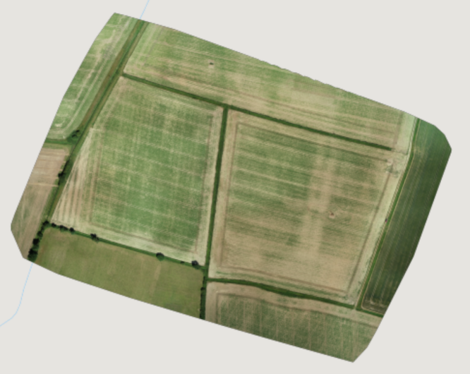
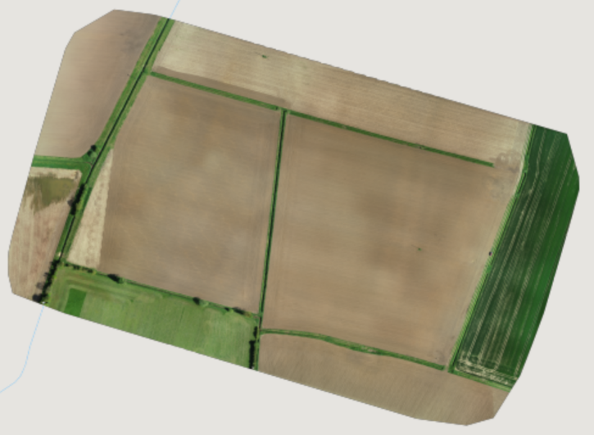

Outcomes/key messages for growers

- Initial data indicated that sugar beet crops loose considerable yield potential due to intra-field variation and identifying and quantifying these losses will provide a basis for making decisions about the value on interventions and/or precision management of fields.
- In some fields, variable performance will be largest accounted for by differenced in soil type with little scope for remedial action.
- Growers are encouraged to assess and map fields in terms of their intra-field performance
- Targeted application of organic manures, liming materials, fertilisers and soil cultivations mat be options to reduce variation within fields. The use of variable seed rates could also be deployed to improve the establishment of target plant populations. Further data will be valuable to validating the potential of these approaches.

