Project summary
This project is focusing on sugar beet radiation use efficiency (RUE) which is examining radiation (sunlight) interception by the canopy and measuring its resulting biomass across the season. In recent years, breeders have released sugar beet varieties which differ widely in canopy architecture. Some have a very prostrate canopy whilst others have a much more upright growth habit. A direct relationship exists between radiation interception by sugar beet and sugar yield. Therefore, rapid canopy expansion and closure is vital to maximising yield, which would suggest that a more prostrate canopy would be beneficial. However, in other crops, such as rice and wheat, more upright leaf angles are desirable due to better light distribution through the canopy which leads to higher radiation use efficiency. The aim is to investigate whether a more upright canopy increases the radiation use efficiency and subsequent yield of sugar beet.

Key objectives
- To investigate to what extent canopy characteristics (leaf development, angle and area) differ between sugar beet varieties.
- To assess whether these differing canopy traits affect radiation interception, radiation use efficiency and yield.

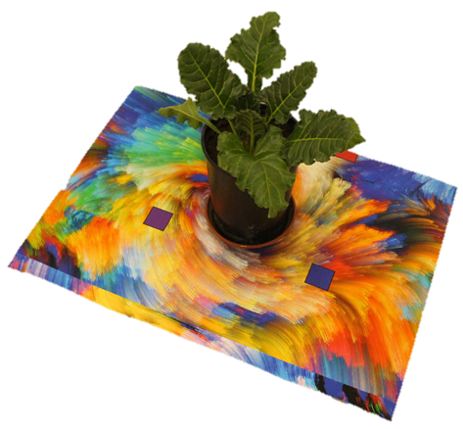
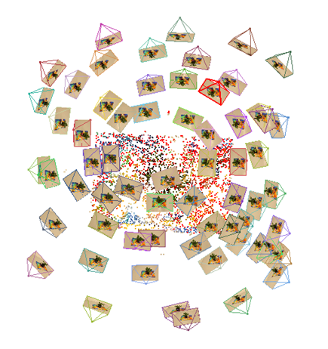
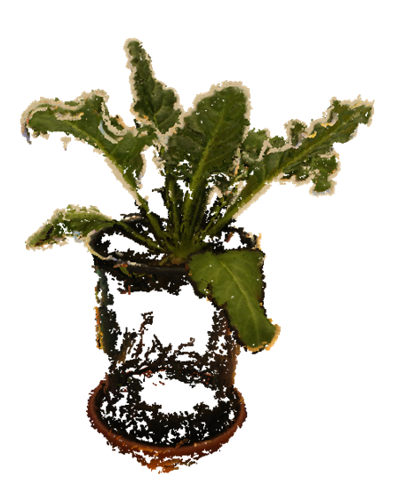
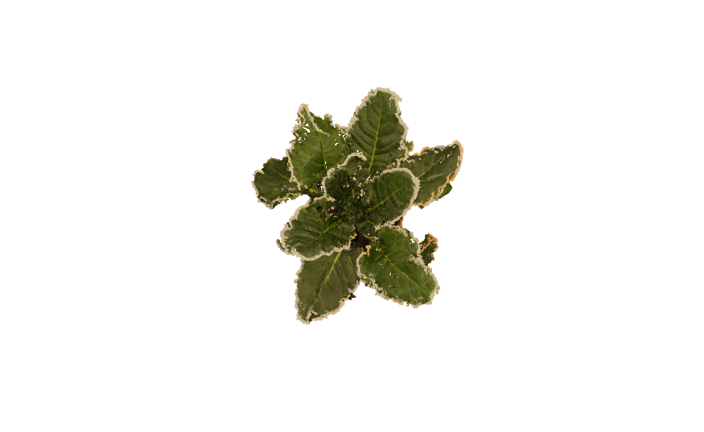
D)
C)
B)
A)
Figure 1. Process of 3D canopy modelling. A) Plant placed on a target. B) Series of images taken around the plant. C+D) Images stitched together to give a 3D plant.

Outcomes/achievements
- Developed a method to measure petiole and leaf angle between contrasting varieties.
- Assessed canopy development and expansion between and within these varieties.
- Compared the amount of biomass in the leaves, petioles and roots between varieties with different canopy architectures.
- 3D canopy imaged and modelled two contrasting canopies.

Key messages for growers and industry
The key differences in canopy architecture have been evidenced in the research undertaken in controlled environment rooms and the glasshouse. This is currently being scaled up in a field trial with the varieties used in the glasshouse. Canopy growth, radiation interception and biomass accumulated across the season will be measured and used to calculate the radiation use efficiency (RUE) of each variety. Latter phases of the project will consider whether management practices should be adapted according to differences in canopy architecture.

Other project objectives
- Does the optimum leaf area index differ between sugar beet varieties with contrasting canopy architectures?
- Is there a non-destructive proxy for biomass accumulation using NDVI and other spectral indices?
- Do we need to reconsider management practices to suit canopy types?

Milestones for current period
Milestones | Comments + Any Action required | Status R/A/G
1.1 | Literature review completed and hypotheses developed. | G
1.2 | First growth room experiment developing methods and protocol to look at canopy characteristics. | G
1.3 | Glass house experiment looking at more varieties measuring canopy traits. | G
1.4 | First field experiment established | G

Status
RED | “Major concern - escalate to the next level"  Slippage greater than 10% of remaining time or budget, or quality severely compromised. Corrective Action not in place, or not effective. Unlikely to deliver on time to budget or quality requirements.
AMBER | "Minor concern – being actively managed”  Slippage less than 10% of remaining time or budget, or quality impact is minor. Remedial plan in place.
GREEN | "Normal level of attention"  No material slippage. No additional attention needed

Method development to measure sugar beet canopy traits in a controlled environment room and glasshouse.
Research question: To what extent do the canopy characteristics (leaf angle, area and phyllochron) differ between sugar beet varieties with contrasting canopy architectures?
Controlled environment room experiment
The purpose of this experiment was to develop methods to measure and quantify the differences in canopy architecture between contrasting varieties.
Design
Two sugar beet varieties with visibly contrasting canopy architectures were grown in 5 litre pots in Kettering loam soil and given adequate nutrition in a randomised complete block design of four reps. When the 5th leaf of the majority of plants started to appear the leaf area, petiole angle and leaf angle was measured weekly.
Leaf and petiole angle method development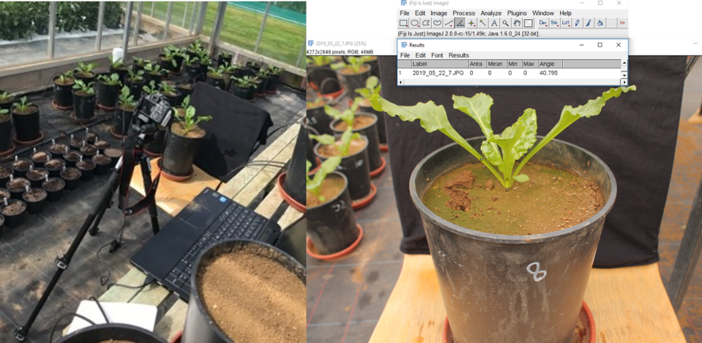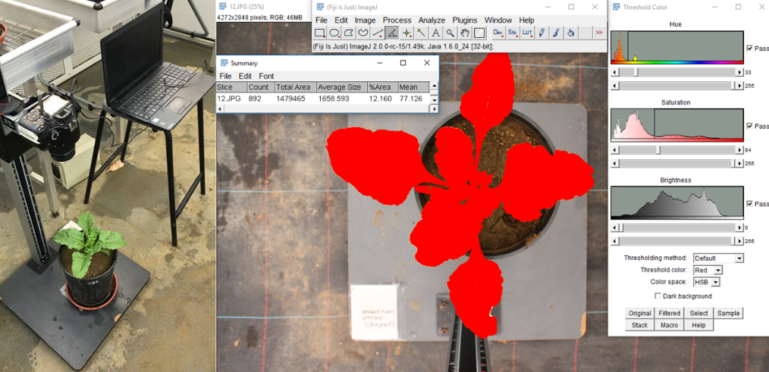
b)
a)

Fig 1. The method developed to measure a) leaf area and b) petiole and leaf angle. Once the plants reached 5th leaf stage the leaf area was measured using aerial images and a thresholding method, the petiole and leaf angle was measured by taking images of the plants from the side and using an angle tool from image analysis software (Rasband, W.S., ImageJ, U. S. National Institutes of Health, Bethesda, Maryland, USA).

a)

a)
b)

Fig 2. The petiole (a) and leaf angle (b) of an upright and prostrate sugar beet variety taken over a 3 week period in a controlled environment room, measured with a developed method using image analysis. DAS (Days after sowing). Error bars show LSD^{5%}.

Fig 3. The leaf area of an upright and prostrate sugar beet variety taken over a 3 week period in a controlled environment room, measured with a developed method using image analysis. DAS (Days after sowing). Error bars show LSD^{5%}.
Results
The prostrate variety had a consistently flatter leaf and petiole angle than the upright variety overtime (P<0.002). However, by 43 DAS the magnitude of the differences had disappeared and the differences in leaf angle were no longer significant (P=0.527; Fig 2).
The prostrate variety and upright variety showed no difference in leaf area (P>0.05; Fig 3).

Glasshouse experiment
The purpose of this experiment was to further develop the methods used in the controlled environment experiment to measure canopy architecture and development between four contrasting varieties in natural light conditions of the glasshouse.
Design
Four sugar beet varieties with visibly contrasting canopy architectures were selected, an upright and prostrate variety used in the controlled environment experiment and two median varieties M1 and M2. These varieties were grown in 5 litre pots of Kettering loam soil given with adequate nutrition in a randomised complete block design of five reps.
The number of leaves on each plant were counted once the plants developed two true leaves. When the fifth leaf of the majority of plants started to appear the petiole angle and leaf angle was measured over two weeks.
The phyllochron is defined as the thermal time interval that separates the emergence of successive leaves, each corresponding to a phytomer (the two cotyledons forming the first phytomer). The leaf was considered emerged when its length was above 10mm. The thermal time (⁰Cd) was calculated using as the sum of mean temperature for each day minus base temperature post emergence. The base temperature for sugar beet germination and leaf expansion is 3⁰C (Milford et al., 1985a; Gummerson, 1986).
At 62 days after sowing the plants were harvested and the fresh weights of leaves and petioles as well as roots measured before being dried and the biomass recorded. The total leaf area of each plant was also measured using a leaf area meter (Li-3100C Area Meter., Lincoln NE, USA).
A)

B)
Fig 4. The petiole (a) and leaf angle (b) of an upright and prostrate sugar beet variety taken over 2 weeks, measured with a developed method using image analysis. DAS (Days after sowing). Error bars show LSD^{5%}

Fig 5. Average phyllochron of each variety (leaf 2 to 12). Calculated as the thermal time interval between successive leaf emergences. (P=0.977) Error bars show LSD^{5%}

Table 1. Harvested fresh and dry weight (g/plant) for each variety 62 DAS.
 | Harvest data (per plant)
 |  | M1 | Prostrate | M2 | Upright | P value | LSD^{5%}
Dry weight (g)
 | Leaf | 15.64 | 14.36 | 15.36 | 16.47 | 0.02 | 1.25
 | Petiole | 13.32 | 13.32 | 13.28 | 13.94 | 0.83 | 1.79
 | Root | 17.72 | 14.48 | 16.82 | 16.12 | 0.04 | 2.17
 | Shoot:Root | 17.83 | 16.21 | 17.33 | 18.64 | 0.07 | 1.41
Leaf area (cm²) |  | 3859 | 3488 | 3811 | 3679 | 0.16 | 359.1

Results
The petiole angle of the upright and M1 was steeper at 42 DAS than 34 DAS, whereas the prostrate and M2 variety remained at consistent angles at both measurement points. At 42 DAS the upright variety had a significantly steeper petiole angle than M1, M2 and Prostrate variety (P<0.01; Fig.4A). The leaf angle followed a similar trend to petiole angle where the upright varieties petiole was steeper than the prostrate. However, at 34 DAS there was no significant difference in leaf angle between varieties (P=0.09). Differences began to appear by 42 DAS where the upright variety had a significantly steeper leaf angle than the other varieties (P<0.01; Fig. 4B).
Overall, no differences were seen between the phyllochron of each variety with values ranging from 35 to 40◦Cd/leaf (P=0.977; Fig. 5).
M2 fresh leaf weight was significantly greater than all other varieties however, this was not consistent with leaf dry weight as the upright variety was seen to have significantly higher leaf dry weight than the prostrate variety (P=0.02; Table 1).
There were no differences were seen in petiole fresh and dry weight between the varieties (P>0.05; Table 1).
M1 had a significantly higher fresh root weight than all over varieties although this was not seen in dry weight where no differences were seen between the M1, M2 and the upright varieties and the prostrate variety had a significantly lower dry root weight than all three. (P=0.016; Table 1).
The shoot to root ratio differed significantly between varieties with the prostrate variety having significantly lower shoot:root than M1 and the upright variety. However, no differences were found in total leaf area per plant (Table 1).

Discussion
Overall, in both experiments the prostrate variety had flatter petiole and leaf angles than the upright variety. However, the lack of significant difference at the end of the controlled environment room (C.E) experiment maybe caused by the technical fault in the C.E where above average temperatures may have led to wilting and thus atypical leaf angles. No difference was seen in leaf area between the upright and prostrate varieties in the C.E, this was also seen in the varieties used in the glasshouse where at harvest in the glasshouse the leaf area of the plant was measured using a leaf area meter and no differences were found. This could be caused by the singular plant pot growth where canopy interactions were not present the same as in the field.
The glasshouse experiment investigated canopy traits further by measuring the thermal time interval between leaf developments, termed phyllochron. This showed the rate at which the canopy develops and can potentially decipher whether canopy architectural differences seen are in part caused by developmental differences. Overall between leaves 2 to 12 no difference was seen in the phyllochron between all four varieties with the values ranging from 35 to 40◦Cd/leaf. A large error bar was associated with this data naturally so a more detailed experiment looking at leaf development and expansion maybe required to determine whether developmental differences are present between the canopy types. It has also been shown that later on in the season (after leaf 20) leaf appearance is slower (66.7°Cdays against 34.4°Cdays) (Milford et al., 1985b). At this point differences may exist between the varieties in maintaining canopy size and vigour which will require a longer term experiment to measure this.
The harvest data from the glasshouse experiment showed that, in general, the prostrate variety had a much lower leaf and root weight than the other varieties. This could be unrelated to canopy and growth traits but caused by its poor growth in the pots throughout the experiment and it may thrive being in field conditions within a canopy. The differences in fresh weight was often not carried through into dry weight biomass data this may be due to excess water being held in the canopy and roots which may not necessarily be biomass.
These observations are currently being followed up in a field experiment across the season where the theory that a more upright sugar beet canopy has higher radiation use efficiency (RUE) than a prostrate canopy is being tested. The field experiment at Sutton Bonington is taking regular assessments of canopy cover, alongside sequential biomass harvests in the field which will be used to calculate the RUE of contrasting varieties.

References
Gummerson, R. (1986) The Effect of Constant Temperatures and Osmotic Potentials on the Germination of Sugar Beet. Journal of Experimental Botany, 37(179), pp. 729–741.
Milford GFJ, Pocock TO, Riley J (1985a) An analysis of leaf growth in sugar-beet. I. Leaf appearance and expansion in relation to temperature under controlled conditions. Ann. Appl. Biol. 106:163–172.
Milford GFJ, Pocock TO, Riley J (1985b) An analysis of leaf growth in sugar beet. II. Leaf appearance in field crops. Ann. Appl. Biol. 106:173–185.

