BBRO PROJECT REPORT FORM
Please note the details on page 2 will be used to formulate our Annual Report.
Project Title: Mitigating new threats from virus yellows: monitoring aphid populations and insecticide resistance to maintain control.

BBRO project no: | 13/01
Project sponsor: | BBRO
Interim report / Final report (delete as appropriate)

Project lead or student name: | PI: James Bell (formerly Richard Harrington)  Co-PI Lin Field
Project mentor or supervisors: | None
Report Date: | X April 2017
Reporting period covered:  (e.g. 1/1/16 - 31/12/16) | 1st April 2013 - 31st March 2017
Timeline (e.g. Year 1 of 4) | Year 4
BBRO use only | Date assessed:
Assessors comments
Action required

Project summary (no more than 300 words)
The objective of this project was to optimise the use of insecticides on sugar beet by providing forecasts and up-to-date information on the timing and abundance of aphids, their virus content and the precise insecticide resistance mechanisms present. The project aimed to build on successful previous projects using the Rothamsted Insect Survey’s aphid monitoring network of suction traps, with two new key components: i) Molecular protocols were used to detect two new insecticide resistance mechanisms (super-kdr, conferring strong resistance to pyrethroids, and nicR, conferring resistance to neonicotinoids) ii) Resistance testing of aphids, collected from the Broom’s Barn network of yellow water pan traps, was employed to add information on local variability in sugar beet crops in East Anglia. The project also developed a new PCR-based assay for detecting individual M. persicae infected with the major beet yellowing virus, BMYV, that could be used alongside the resistance testing assays and replace the less effective ELISA test method.

Main Objectives
1) To monitor (on a regional basis using suction traps) winged aphid vectors of sugar beet viruses throughout the UK (daily March to November each year, weekly at other times).
2) To provide forecasts of the phenology and abundance of aphid vectors and the consequential potential levels of virus infections with and without control measures (March each year).
3) To assess the status of four currently relevant insecticide resistance mechanisms: MACE (to pirimicarb), kdr and new super-kdr (to pyrethroids) and nicR (to neonicotinoids) in individual Myzus persicae from suction trap and yellow water pan trap (YWT) samples (April to July each year and then as a batch for August to November samples).
4) To assess Myzus persicae from suction traps for Beet mild yellowing virus (April to July each year and then as a batch for August to November samples).
5) To disseminate information to growers in a timely manner to aid decisions on aphid control (March to July each year) and to conduct a grower survey on usage of the information (Year 2).

Insert picture/graph  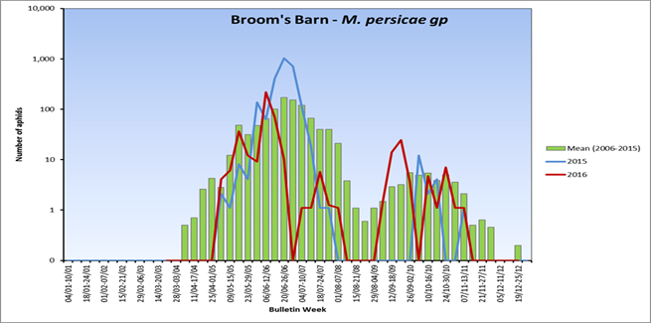 | Insert picture/graph  Myzus persicae  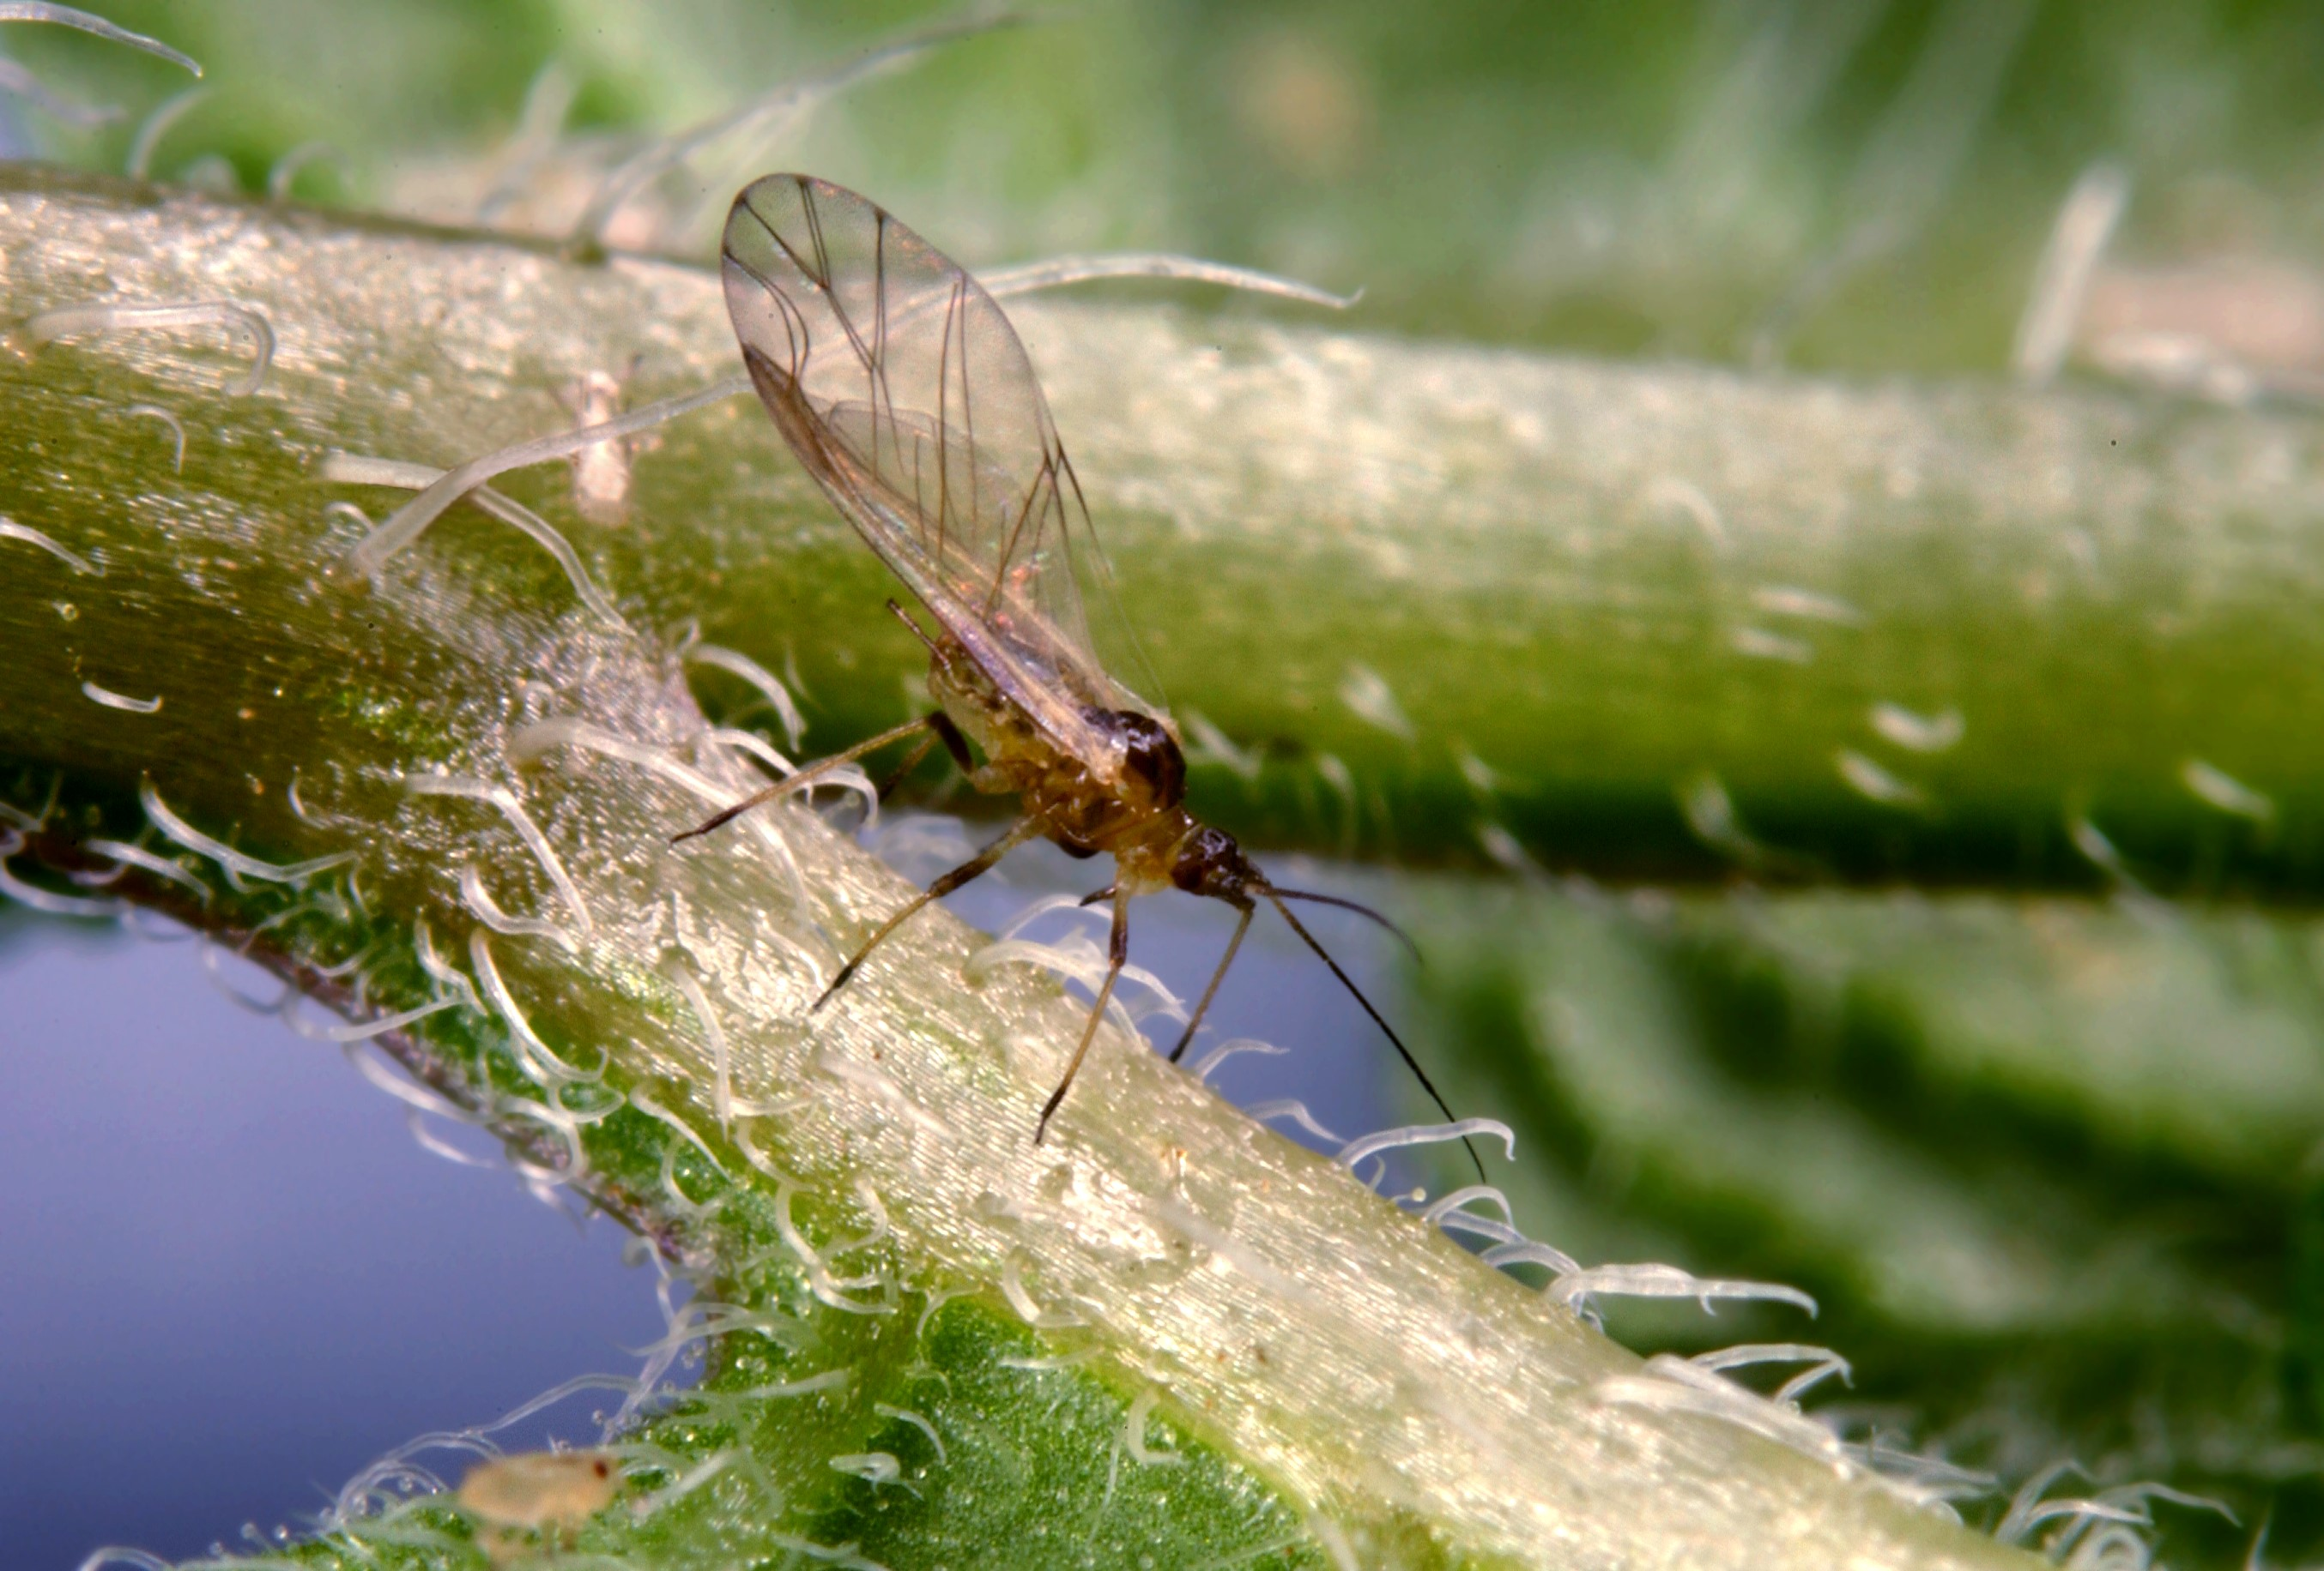
Main outcomes and achievements
- 22 objectives related to monitoring and forecasting aphid vector migration, the viruses that are carried by these vectors, their resistance to insecticides as well as project management targets were completed on time and within budget.
- A grower survey on usage of data from project was conducted which showed that the sugar beet industry found the BBRO Advisory Bulletins 'extremely valuable'.
- Four annual virus yellows and aphid forecasts showed that whilst migrating aphids were able to exploit warmer winters, the sugar beet crop was exceptionally well protected by the addition of neonicotinoid treated seed. Should seed treatment be withdrawn then the incidence of beet yellows would exceed 50% of the crop.
- Engagement activities included lecturing and aphid ID for the Advanced Sugar Beet Course, attendance at BBRO events including grower talks and publications in trade journals and the scientific literature.
- An RT-PCR molecular protocol was developed to replace ELISA techniques to rapidly test for virus yellows alongside the resistance mechanisms MACE (affecting pirimicarb), new super-kdr and kdr (pyrethroids) and nicR (neonicotinoids).
- A total of 2070 Myzus persicae from suction traps and 577 from water traps were tested for insecticide resistance mechanisms over the four years of the project. All the traps were in close proximity to sugar beet growing areas. The results from both suction and water traps confirmed extremely high levels of MACE (85-96%) and new super-kdr (88-94%) within the general M. persicae population. The level of kdr has continued to decline and was only found in 3-7% of the population. The nicR mutation, conferring strong resistance to neonicotinoids, was not found in any of the aphids tested (>700).
- A sub-sample of 1135 M. persicae were tested for infection with beet mild yellows virus, BMYV (by ELISA in 2013 and by the new RT-PCR method in 2015 and 2016). No aphids scored positive for this virus in any of the three years, providing further evidence of the low incidence of this important virus in recent years.

Key messages for growers and industry
- Infection with beet yellowing viruses has been shown to cause sugar beet yields to fall by 50% in outbreak years. Large scale infections are now rare largely due to the effectiveness of neonicotinoid insecticides that control the main aphid vector, Myzus persicae.
- In the UK M. persicae is currently susceptible to neonicotinoids but target site resistance (nicR) has been observed in Southern Europe and is expected to spread. Resistance evolution and the predicted loss of the once common UK clones suggest that there is additional uncertainty as to the future effectiveness of neonicotinoids generally.
- In both the UK and abroad a blanket ban of neonicotinoids in the near future looks increasingly likely. Should neonicotinoids be withdrawn or prove ineffective due to resistance, virus yellows could return to a situation not unlike the 1970s in which there were large-scale infections and consequently low yields.
- Monitoring and surveillance of the aphid vectors, the diseases they carry and the resistance mechanisms that they use to overcome control are key monitoring activities that help growers and the industry plan management strategies as demonstrated by this project. Such activities reduce the prophylactic use of insecticides through the provision of pest forecasts and bulletins to growers, which in turn slow down resistance evolution when the appropriate action is taken, such as crop inspection to assess risk.

Section 1: To be completed by Project Lead:
Other project objectives (not listed on previous page)

N/A

Milestones for current period
Note: mentors will be asked to comment on the status of this project (yellow column) using the scoring system shown below

Please note that all 23 objectives overleaf were completed on time and within budget, except 04/02 'virus testing in 2014' because of a lack of products for the old ELISA protocol.

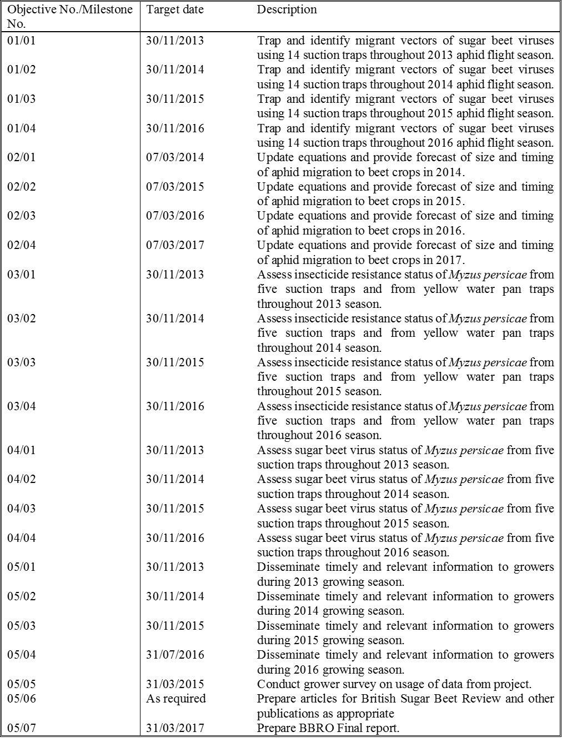

Status - Mentor’s scoring system for interim reports.
RED | “Major concern - escalate to the next level"  Slippage greater than 10% of remaining time or budget, or quality severely compromised. Corrective Action not in place, or not effective. Unlikely to deliver on time to budget or quality requirements.
AMBER | "Minor concern – being actively managed”  Slippage less than 10% of remaining time or budget, or quality impact is minor. Remedial plan in place.
GREEN | "Normal level of attention"  No material slippage. No additional attention needed
Milestones | Comments + Any Action required | Status R/A/G
01/01
01/02
01/03
01/04
02/01
02/02
02/03
02/04
03/01
03/02
03/03
03/04
04/01
04/02
04/03
04/04
05/01
05/02
05/03
05/04
05/05
05/06
05/07

Summary of results (including figures and tables)
Annual report: please provide a 2 page summary of key findings from the reporting year.
Final report: please provide a summary of project findings and outcomes with relevant supporting data.
1) To monitor (on a regional basis using suction traps) winged aphid vectors of sugar beet viruses throughout the UK (daily March to November each year, weekly at other times).

We produced weekly BBRO aphid news sheets (between 16-18 annually) highlighting numbers of Myzus persicae, Macrosiphum euphorbiae and Aphis fabae grp between April to end of November in each year (2013-2016). Data concerning the resistance status of a sample of aphids tested for MACE, skdr, kdr were included within the new sheets (see Objective 3). Alongside the BBRO news sheets (Fig. 1), Aphid Bulletins (approx. 30-35) were supplemented with that publication to provide a more complete picture of aphids across the UK.

Fig. 1: The last of the BBRO Aphid News publications in the 2016 series

Generally, after growth stage 12, aphids become less of an issue as mature plant resistance takes over sometime in mid-June depending on drilling date and weather. Driving the changes in the population dynamics between years was a very strong, but variable temperature signal (Fig. 2).

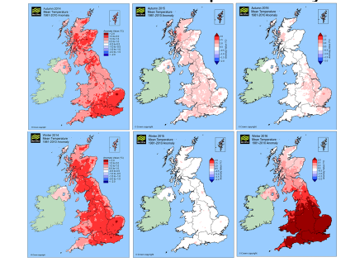

Fig. 2: Average autumn and winter temperatures over 2014-2016 clearly showing exceptional, changing conditions between years. Darker reds indicate increasingly warmer temperatures whilst whites indicate that temperatures were no different from a mean anomaly of around zero (i.e. the expected long term average). © Crown Copyright.

All three aphids occurred at all sites in all years. Aphis fabae grp, Myzus persicae and Macrosiphum euphorbiae often showed two summer flight periods, depending on latitude. The first peak represented those aphids moving from winter hosts into beet in spring and early summer. Later, summer populations leaving a range of hosts represented the second peak and were in response to crowding and a change in host plant nutrition. M. euphorbiae often flew a little before M. persicae and is thought to be responsible for small primary virus infections in beet crops. The later influx of M. persicae is responsible for more significant secondary spread. The black bean aphid, Aphis fabae grp., although not a good virus vector can cause direct feeding damage later in the summer, usually not flying in earnest until July.
In 2013 the migration of M. persicae and M. euphorbiae were forecast to be considerably later based on January/February temperatures. The cold winter was compounded by the coldest spring since 1962. As result the UK had the slowest start to an aphid year in 50 years, with most first flights not recorded until mid-June. In this year M. euphorbiae flew about 2 weeks before M. persicae, but generally it was a season in which numbers were low for both species.
In 2014 the migration of M. persicae and M. euphorbiae were forecast to be considerably earlier than average. M. persicae was recorded early and occurred in large number with migrations all the way from mid-May right through to June. M. euphorbiae also flew early but numbers were below 10 year means.
In 2015 the migration of M. persicae and M. euphorbiae were forecast to be about average and this was realised in most cases. After an early flush of M. euphorbiae, M. persicae started flying in the 2nd week of May. The main M. persicae flight was well above the 10 year mean through much of the second half of June.
In 2016 we expected a repeat of 2014 with a considerably early set of first flights forecast but a cool and wet spring somewhat moderated aphid flights generally. Migrations of both species in early June and with particularly high numbers at our trap at Wellesbourne. Numbers of M. euphorbiae were below average.
After average numbers in 2013 and 2014, there was the explosion of A. fabae grp in 2015 which provoked calls to both the Rothamsted Insect Survey and the BBRO. As notable as the explosion was in 2015, the following year the UK experienced a very late arrival and near absence of A. fabae. We are unable to provide a possible mechanism(s) that would explain the exceptional performance A. fabae in 2015 but it is clear that it cannot be explained by climate alone.

All information was completed on time and as contracted.

2) To provide forecasts of the phenology and abundance of aphid vectors and the consequential potential levels of virus infections with and without control measures (March each year).

The annual aphid forecasts were produced on time in March of each year for distribution and dissemination to the growers (Fig. 3). Generally, the forecasts showed that aphids were strongly linked to winter conditions, particularly temperature, in support of the many studies that have shown this formally using statistical models (see Bell et al. 2015 and references therein).

Fig. 3: The 2017 Sugar beet aphid forecast delivered in early March showing the predicted phenologies for Myzus before the season begins.

Examining the forecasts over time using Myzus as an example, there was some variability in the response between first flights (first record) and numbers to 17th June. The range of first record dates across all years of trap operation spans around three months across the network. In 2013, after a cold winter and spring, M. persicae was, on average across the five sugar beet area suction-traps (RT,BB,K,WR & H), 17 days later than forecast, and M. euphorbiae 13 days later. In 2014 first flights were expected to be considerably earlier, and M. persicae turned up on average about a day earlier than forecast and M. euphorbiae 10 days earlier. In 2015 after an unremarkable winter, average first flight were expected and largely realised with both species about 8 days earlier than forecast. In 2016 first flight predictions were again a good estimate of the observed first flights in the traps (Fig. 4). In summary, any further fine tuning of models related to first flight prediction would not necessarily make any difference to grower management strategies.
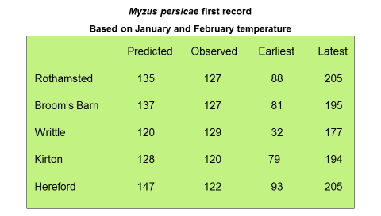
Fig. 4: Predicted and observed migration forecasts for the first flights of Myzus at key sites in 2016. The figure shows that the models that were produced in March predicted well the likely first record of this aphid species, although there was a difference observed at Hereford
Predictions of numbers up to June 17th was poor, particularly in the last season (Fig. 5). This may be due to the fact that the 17th June is now too far into the year and includes a second migration not as closely related to the first flights. Errors can appear large because of aphid’s potential for exponential rates of reproduction and perhaps numbers are best considered in terms of their logarithm rather than actual numbers. The problem may be compounded by the ban of neonicotinoids on winter OSR which may have increased the overwintering aphid reservoir, particularly in cover crops which are largely seeded with brassicas. We are now examining whether machine-learning algorithms can better estimate numbers compared with linear models.

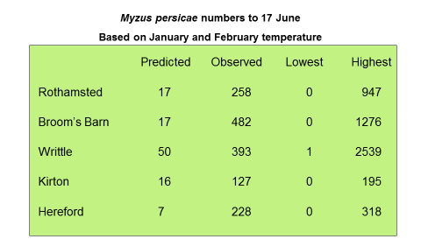
Fig. 5 : Predicted and observed migration forecasts for the numbers of Myzus at key sites in 2016. The models produced in March before the season began do not estimate well the numbers observed. This has been an on-going issue since 2010 caused by the unprecedented variability in winter conditions. We are testing a new set of models, based on machine-learning, to see if the difference between predicted and observed counts can be reduced.

The RIS also produces predictions to estimate potential levels of virus infections with and without control measures (i.e. treated seed). The virus yellows forecast showed that given the widespread use of neonicotinoid seed treatment, the predicted incidence of virus yellows was extremely low at the regional level and between 0.18-1.03% (Fig. 6).

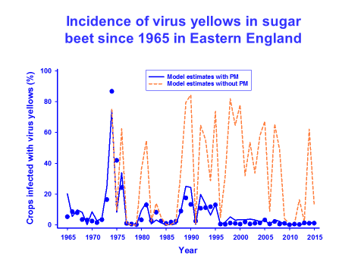
Fig. 6 : Predicted incidence of virus yellows vectored by Myzus with and without neonicitinoid treated seed over time since 1965. Treated seed trends stabilised after 1995 whereas untreated seed was highly variable in time reaching levels close to zero to over 80% infection rates.

Seven and a half million tonnes of sugar beet are grown in the UK each year at a gross value of £150+ million per annum according to 2016/2017 prices. Assuming that virus yellows reverted to 1970s outbreak conditions, if resistance took hold or if neonicotinoids were withdrawn with no viable replacement, then roughly 40-50% of the tonnage would be lost on average.

3) To assess the status of four currently relevant insecticide resistance mechanisms: MACE (to pirimicarb), kdr and new super-kdr (to pyrethroids) and nicR (to neonicotinoids) in individual Myzus persicae from suction trap and yellow water pan trap (YWT) samples (April to July each year and then as a batch for August to November samples).

The insecticide resistance status of M. persicae was tested from five suction traps in 2013 – 2015 (Rothamsted - RT, Brooms Barn - BB, Kirton – K, Writtle – Wr and Hereford – H) and from the same five traps plus York (Y) in 2016, see Fig. 7. All aphids were tested for MACE (S431F mutation in acetylcholinesterase conferring strong resistance to pirimicarb) and new super-kdr (M918L mutation in the voltage-gated sodium channel conferring strong resistance to pyrethroids). Aphids scoring SS (susceptible) for these mutations were further tested for kdr (mutation L1014F in the voltage-gated sodium channel conferring moderate resistance to pyrethroids) and nicR (mutation R81T in the nicotinic acetylcholine receptor conferring strong resistance to neonicotinoids).

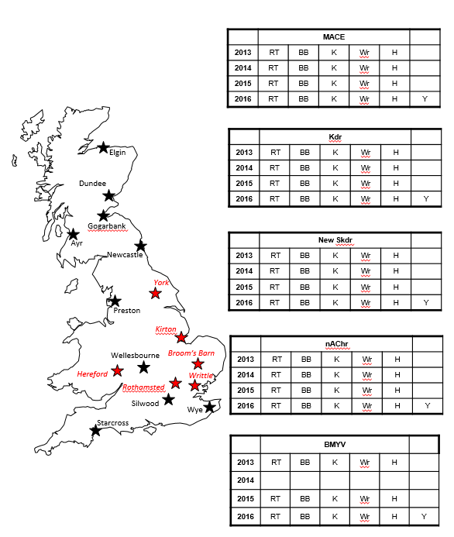

Fig. 7: The distribution of the Rothamsted Insect Survey 12.2 m high suction traps. Those traps used in this programme are labelled in red italics. The tables indicate the suction trap sites and years for which different resistance mechanisms and viruses were monitored.

The results of MACE and new super-kdr testing are shown in Tables 1 and 2 respectively. These tables show how these two mechanisms now dominate within the UK Myzus persicae populations. Both mutations were found at very high frequency in all traps for all four years from 2013 to 2016. Overall frequencies of 94-96% were recorded for both mutations in 2013 and 2014, and these fell only slightly to 85-89% for 2015 and 2016. This almost certainly reflects the dominance of the so-called ‘O’ and ‘P’ clonal types within the largely asexual M. persicae UK population that are known to carry the MACE + new super-kdr mutation combination. The dramatic rise of these genotypes is shown in Fig 8, that charts the overall frequency of MACE in suction trap samples we have tested over the past 22 years (1995-2016). Following initial identification in 1996, this mutation appeared to die out between 1997 and 2001, only to reappear in 2002 and then increased rapidly to the high (>80%) levels noted in the last report (BBRO Final Report 2012) and which have clearly continued here. In contrast, Fig 9 shows how the frequency of kdr has declined over the same period and has now been largely replaced by the new super-kdr mutation. Comprehensive testing for new super-kdr only began in 2013 as part of this project so detailed data is not available prior to this year. However, preliminary testing of archived samples has shown that it was present at lower frequency before 2005 (our unpublished results) and this would be consistent with co-selection with MACE to the levels now seen.

Previous studies have shown that the older kdr mutation (L1014F) is not found in new super-kdr (M918L) genotypes, and for this reason we restricted testing for kdr to those aphids that scored SS for new super-kdr. This resulted in total scores for kdr across all five traps of 17 in 2013, 22 in 2014, 21 in 2015 and 38 in 2016. These values represented 4.0%, 3.2%, 4.3% and 7.8% of the total number of aphids tested in 2013-2016 (Fig. 9). It seems likely that kdr has been replaced by new super-kdr on account of the much higher resistance to pyrethroids afforded by the new skdr (S Foster, personal communication). We also tested a selection of aphids from all traps (approximately 180 each year) for the nicR mutation (R81T) that confers strong resistance to neonicotinoids in parts of Southern Europe (Bass et al 2011). No individuals from any of the traps were found to carry this mutation.

Our main conclusion from the suction trap testing is that MACE and new super-kdr remain at extremely high levels in M. persicae populations from the main sugar beet growing areas, and any attempts to control them with pirimicarb or pyrethroids are therefore very unlikely to be successful. On a more positive note, we did not find any evidence for the nicR (R81T) mutation in the UK trap samples, and this is consistent with grower observations that neonicotinoids continue to offer very effective control at present.

Table 1: Numbers of M. persicae from suction traps showing MACE resistance 2013 - 2016.

Number MACE / Number tested
 | 2013 | 2014 | 2015 | 2016
Broom’s Barn | 99/104 | 162/172 | 92/110 | 57/68
Writtle | 78/81 | 136/145 | 79/90 | 93/113
Kirton | 83/89 | 103/114 | 110/133 | 84/95
Rothamsted | 74/74 | 136/142 | 83/88 | 75/82
Hereford | 66/68 | 79/85 | 67/74 | 62/69
York |  |  |  | 37/44
Total tested  (% MACE) | 400/416 (96) | 616/658 (94) | 431/495 (85) | 408/471 (87)

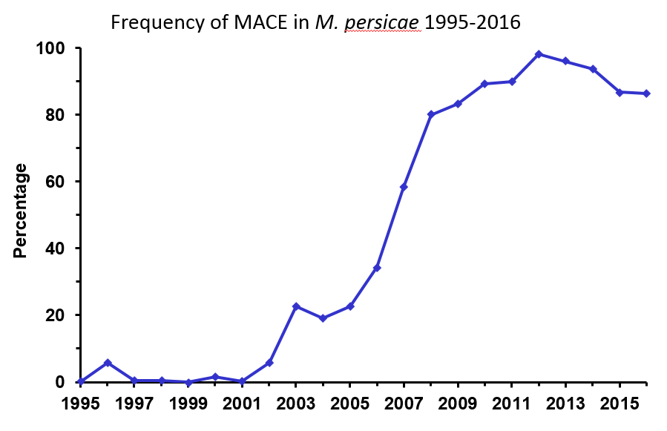
Fig. 8 The percentage of M. persicae carrying the MACE mutation in UK suction traps 1995-2016.

Table 2: Numbers of M. persicae from suction traps showing new super-kdr resistance 2013 - 2016.

Number new skdr / Number tested
 | 2013 | 2014 | 2015 | 2016
Broom’s Barn | 102/109 | 160/173 | 95/110 | 66/78
Writtle | 79/84 | 139/146 | 80/91 | 98/113
Kirton | 83/89* | 104/116 | 112/134 | 88/94
Rothamsted | 70/74 | 136/141 | 83/88 | 74/81
Hereford | 64/68 | 82/85 | 68/74 | 66/72
York |  |  |  | 37/44
Total tested  (% new skdr) | 398/424 (94) | 621/661 (94) | 438/497 (88) | 429/482 (89)

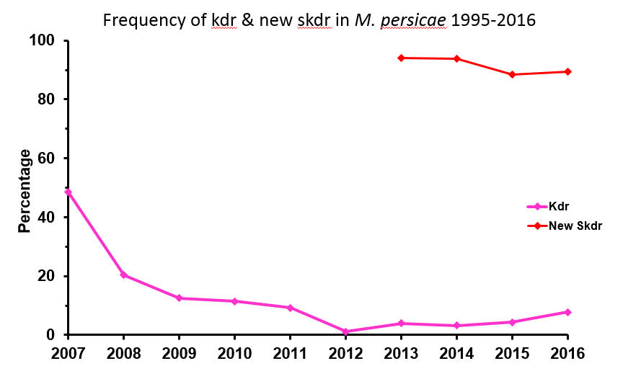
Fig. 9 The percentage of M. persicae carrying kdr and new super-kdr in UK suction traps 1995-2016.

Testing of yellow water trap samples in 2013-2016 gave broadly similar results to those described above for the suction trap samples. Overall numbers were lower than those for suction traps, mainly because of the closure of Brooms Barn research station. However, a sub-sample of water trap aphids was provided by Dr Mark Stevens each year. These were also tested initially for MACE and new super-kdr, and results are given in Table 3. A total of 577 aphids were tested over the four years, and 517 were scored as MACE and new super-kdr. This gives a very similar overall frequency of 88% for the MACE/super-kdr genotype to that of the suction trap samples. Aphids scoring SS for MACE/super-kdr were routinely retested for the nicR mutation, however all were found to be negative. Conclusions drawn from the water trap testing are therefore identical to those stated above for the suction trap samples.

Table 3: The frequencies of MACE and new skdr mutations in water trap M. persicae 2013-2016.
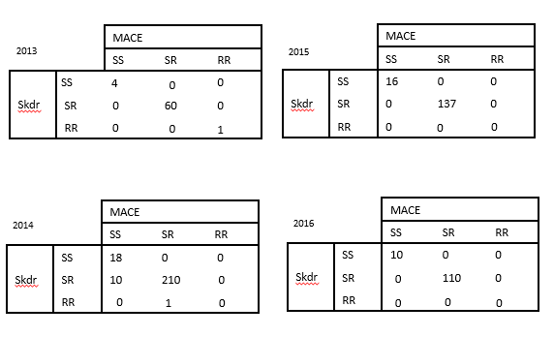

4) To assess Myzus persicae from suction traps for Beet mild yellowing virus (April to July each year and then as a batch for August to November samples).

The virus content of the vector Myzus persicae was tested from the five main suction traps (Rothamsted, Brooms Barn, Kirton, Writtle and Hereford) for 2013, 2015 and 2016. The re-opened York trap was also tested in 2016. Virus testing in 2013 was carried out using an ELISA assay as previously described (BBRO Final Report 2012). No testing was done in 2014 because a fresh batch of antibodies could not be obtained. To overcome this problem a new assay was developed (based on RT-PCR) and this was subsequently used in 2015 and 2016.

A brief outline of the RT-PCR assay is as follows:
Individual aphids were placed in the wells of a 96 well immunoplate along with 50ul sucrose buffer solution (0.3M sucrose, 0.3M NaCl, 60mM Tris.Cl pH 8) and gently ground using a multi-homogeniser (Burkard Scientific, UK). The plate was heated to 96C for 10 min and 2ul aliquots of each aphid homogenate transferred to the wells of a 96 well PCR plate for the reverse transcription reaction. 8ul reaction mix, containing 50ng primer Virus_R1 (table X), 0.5mM dNTP and 100U Revertaid reverse transcriptase (ThermoFisher, UK) was added to each 2ul homogenate and incubated at 50C for 1 hour. RT reactions were then tested for the presence of BMYV & TuYV by TaqMan assay, using fluorescent dye labelled oligonucleotide probes for allele-selective amplification and detection of the virus sequences in a modified real-time PCR assay. Primer and probe sequences for the assay were designed using Primer Express software v.2.0 and purchased from Life Technologies (see Table 4). Primers 1F and 1R are standard oligonucleotides with no modification. The TuYV_M probe is labelled with 6-FAM at the 5’ end for the detection of TuYV fragments, and the BMYV_V probe is labelled with VIC for detection of BMYV fragments. Each probe also has a 3' non-fluorescent quencher and a minor groove binder at the 3' end. PCR assay reactions (15μL) contained 1.5μL each RT reaction, 7.5 μL of SensiMix Probe mix (Bioline Reagents Ltd), 800 nM of each primer and 200 nM of each probe. Reactions were run on an ABI 7900HT (Applied Biosystems) using temperature cycling conditions of 10 min at 95 °C, followed by 40 cycles of 95°C for 10 s and 62°C for 45 s. The increase in VIC and 6-FAM fluorescence was monitored in real time by acquiring each cycle on the yellow channel (530 nm excitation and 555 nm emission) and green channel (470 nm excitation and 510 emission) of the 7900HT, respectively. An example output of the assay is shown in Fig. 10. The first two rows contain control aphids from cultures known to be infected with BMYV and TuYV respectively. The third row contains uninfected aphid controls and the next two rows contain suction trap samples. All control aphids have scored correctly, with the suction trap samples showing a 50% level of infection with TuYV (8 of 16 have scored positive).

__________________________________________________________
Name Sequence
________________________________________________________

Virus_R1 GAACCATTGCCTTTGTAGAGG
primer_1F TCGGACAACACAACGCCG
primer_1R GGAACTTCCCGCGAGATTGTC
TuYV_M probe 6FAM-CGAGACATTTGTTTTC

BMYV_V probe VIC-CGAGACATTCATTTTC

_____________________________________________________________________
Table 4. Oligonucleotide primer and probe sequences.

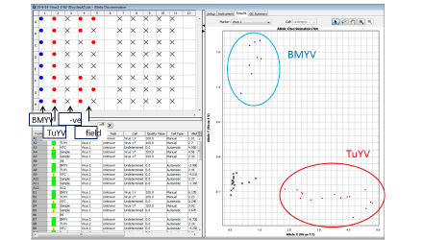

Fig 10: Results of the RT_PCR TuYV / BMYV assay on individual M. persicae. Row 1 contains aphids from a culture infected with BMYV, row 2 has aphids infected with TuYV, row 3 are uninfected controls and rows 4 and 5 are suction trap samples.

The results of testing are shown in table 5. In 2013, 374 M. persicae were tested for BMYV and TuYV by ELISA. No aphids were identified as carrying BMYV, and a low proportion (5% overall) carried TuYV. A further 447 aphids were tested by the newly developed RT-PCR assay in 2015, and 314 in 2016. Once again, no aphids were identified in any of the suction trap samples that scored positive for BMYV.

A much higher frequency of TuYV-infected aphids was however observed for all traps in 2015 and 2016, with overall levels of 80% (2015) and 64% (2016). This virus was formerly known as beet western yellows virus (BWYV), but was renamed turnip yellows virus (TuYV) because it is no longer considered an important virus of sugar beet. The RT-PCR assay was developed to detect both TuYV and BMYV mainly because the assay is also being used in another project for detection of TuYV in M. persicae on Brassica crops (a BBSRC ‘HAPI’ project involving John Walsh at Warwick and Martin Williamson at Rothamsted). Nevertheless, the co-detection of TuYV infected aphids in the current project is also useful as positive control for virus detection, particularly given the null score for BMYV. The reason for the discrepancy in TuYV infection levels between 2013 (5%) and 2015/2016 (60-80%) results from an underscore by the ELISA in 2013 when the antibodies were old and not detecting the virus effectively, combined with the fact the RT-PCR method is far more sensitive than the ELISA and capable of scoring aphids that carry considerably lower virus titers (Table 5).

The failure to detect any aphids carrying BMYV by either method is further evidence of the declining incidence of this important beet virus in recent years. A parallel study of over 3600 yellow water trap aphids in 2015 and 2016 (organised by Mark Stevens and carried out by BBRO staff at Rothamsted), and also using the new PCR assay method, confirmed this low incidence with only 2 aphids (from ~2000) scoring positive in 2015, and no positives from over 1600 aphids tested for the 2016 samples.

M.persicae 2013 (ELISA)
Site | Total | BMYV Pos | % BMYV | TUYV Pos | % TUYV
RT | 71 | 0 | 0 | 1 | 1
BB | 99 | 0 | 0 | 6 | 6
Wr | 78 | 0 | 0 | 6 | 8
H | 54 | 0 | 0 | 3 | 6
K | 72 | 0 | 0 | 1 | 1
Total | 374 | 0 | 0 | 17 | 5
M.persicae tested 2015 (PCR)
Site | Total | BMYV Pos | % BMYV | TUYV Pos | % TUYV
RT | 81 | 0 | 0 | 69 | 85
BB | 102 | 0 | 0 | 92 | 90
Wr | 81 | 0 | 0 | 69 | 85
H | 65 | 0 | 0 | 44 | 68
K | 118 | 0 | 0 | 82 | 70
Total | 447 | 0 | 0 | 356 | 80
M.persicae tested 2016 (PCR)
Site | Total | BMYV Pos | % BMYV | TUYV Pos | % TUYV
RT | 50 | 0 | 0 | 30 | 60
BB | 39 | 0 | 0 | 26 | 67
Wr | 81 | 0 | 0 | 65 | 80
H | 22 | 0 | 0 | 16 | 73
K | 103 | 0 | 0 | 54 | 52
Y | 19 | 0 | 0 | 11 | 58
Total | 314 | 0 | 0 | 202 | 64

Table 5. Virus infection levels according to ELISA and PCR methodologies

5) To disseminate information to growers in a timely manner to aid decisions on aphid control (March to July each year) and to conduct a grower survey on usage of the information (Year 2).

The RIS prepared 65 (i.e. 2013(15),2014(16),2015(16),2016(18)) BBRO Aphid News Sheets and 134 (i.e. 2013(29),2014(34),2015(33),2016(38)) Bulletins over the course of the project that were sent out to growers each Friday during the aphid season. We also ran a yearly BBRO Annual Review meeting reporting on previous year’s aphid numbers, levels of resistance and levels of viruses as recorded by the suction traps which was very successful and included 8-10 Rothamsted staff keen to discuss the previous year's activities. Richard Harrington, later accompanied by James Bell from 2014 onwards, gave a lecture and aphid ID training as part of the Advanced Sugar Beet Course ran at BBRO HQ in November of each year. Field visits to BBRO events were made to advise growers on aphids, as requested as well as advice over the phone to crop consultants and growers. Several media articles were published during the project, particularly in Farmers Weekly, relating to Myzus persicae although these tended to arise as a result of the AHDB Aphid Alerts project. A large number of conference presentations and talks were given in which a link to either sugar beet or the vectors or both were acknowledged (see Publications section).

A grower survey was carried out in 2015, with the help of the BBRO and British Sugar, to examine the use and application of the BBRO Aphid News Sheets*. In summary, most of the 80 respondents were agronomists or crop consultants who generally advised on neonicotinoid seed in the four sugar beet factory regions, the majority of whom found the BBRO Aphid News Sheets extremely valuable (Fig. 11). The majority of respondents wanted a simple traffic light system to advise them quickly as to whether aphids are an issue posing an increasingly level of concern if the size of the migration was red. This is technically challenging because a different times of the year the numbers of aphids caught in the traps is not consistently related to a field threshold. There was concern when discussed that this might promote the prophylactic use of insecticides and the issue was not considered further.

* Note the some of the graphs produced by British Sugar to not sum to the number of respondents. James Bell explored this with British Sugar but they did not comment further.

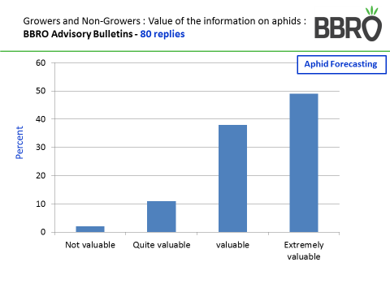

Fig 11: Grower survey examining the value of the BBRO Aphid News Sheets to the Sugar Beet industry.

Annual report: Key issues to be addressed next year:

n/a

Publication of results to date/planned publications:
Papers

Bell, J.R. , et al. & Harrington, R. (2015) Long-term phenological trends, species accumulation rates and climate: five decades of change in migrating aphids. Journal of Animal Ecology 84: 21–34

Bell, J.R., Pierre, J.-S. & Dedryver, C.-A. (2017) Aphid Population Dynamics: From Fields to Landscapes. Chapter 13. van Emden, H.F. and Harrington, R. (Eds). Aphids as Crop Pests. 2nd Ed. CAB International (in press)

Harrington, R. (2013) Ten amazing facts about aphids (that you would probably rather not know). British Sugar Beet Review 81(1), 19-21.

Harrington, R. (2014) The Rothamsted Insect Survey strikes gold. Antenna 38, 158-166.

Malloch, G., Pickup, J., Highet, F., Foster, S., Williamson, M. & Fenton, B. (2016) Assessment of the spread of pyrethroid resistant Sitobion avenae in the UK and an update on changes in the population structure of Myzus persicae in Scotland. Proceedings Crop Protection in Northern Britain, 223-228.

Harrington, R. and Hullé, M. (2017) Monitoring and Forecasting. Chapter 20 in: van Emden, H.F. and Harrington, R. (Eds). Aphids as Crop Pests. 2nd Ed. CAB International (in press)

Holloway, P., Bell, J.R., Dore, J. & Kudenko, D. (2017) Data representation in ecological phenomena: A machine learning approach to better identify the drivers of aphid flight patterns. (submitted)

Sheppard, L., Bell, J., Harrington, R. and Reuman, C. (2016) Changes in large-scale climate cause changes in the spatial synchrony of aphid pests. Nature Climate Change 6, 610-613.

van Emden, H.F. and Harrington, R. (Eds) (2017) Aphids as Crop Pests (Second Edition). (in press)

Zhang, H., Breeze, T., Bailey, A., Garthwaite, D., Harrington, R. and Potts, S.G. (2017) Arthropod pest control for UK oilseed rape – comparing insecticide efficacies, side effects and alternatives. PLOS ONE | DOI:10.1371/journal.pone.0169475 January 11, 2017, 22pp

Presentations

Bell, J. R., Harrington, R. Taylor, M.S. and Verrier, P. (2013) Population metrics for migrating aphids. NJF Report 9 (7): 39-40.

Bell, J.R. 'Wings of Change', ZSL, London 14th July 2015

Bell, J.R. Monitoring and Forecasting Pests: The Rothamsted Insect Survey. British Herbs. 22nd October 2015. Rothamsted Research

Bell, J.R., Hemming, D., Henrys, P.A., Thackeray, S.J. and Harrington, R. (2015) Climate change impacts on aphid migration. UK–French Joint Meeting on Aphids (BAPOA + RES Aphid SIG), Paris, France, 5th – 6th November 2015.

Bell, J.R. (2016) Climate change impacts pest and beneficial insects over the last half century: Insights from the UK. Symposium: Climate Change Impacts and Insect Population Dynamics, XXV International Congress of Entomology, 25-30 Sept 2016, Orlando, Florida.

Bell, J.R. (2017) BBRO Stakeholder Board on Wednesday 8th February 2017, Congham Hall, Kings Lynn

Bell, J.R. (2017) Monitoring and Forecasting Pests: The Rothamsted Insect Survey. Berry Gardens. 20th February. Rothamsted Research

Harrington, R., Taylor, M.S., Shortall, C.R., Alderson, L.J. and Verrier, P.J. (2013) The Rothamsted Insect Survey: A potential goldmine for aphids genomics studies. 8th International Aphids Genomics Consortium Workshop, Rothamsted, 17th – 18th January 2013.

Harrington, R. (2013) Climate change and insects: a double whammy. NIAB Innovation Farm Key Challenge Event: Growing Whatever the Weather. NIAB, Cambridge, 26 June 2013.

Harrington, R., Taylor, M.S., Alderson, L., Shortall, C., Kruger, T., Izera, D., Verrier, P.J and Pickup, J. (2013) The Rothamsted Insect Survey: Gold standard aphid monitoring. NJF Report 9 (7):7-12. (NJF Seminar 468: Suction traps in studying distribution and occurrence of insects and forecasting pests and vector borne viruses; Kristianstad, Sweden, 30 October 2013).

Harrington, R., Taylor, M.S., Alderson, L.J., Shortall, C.R., Kruger, T., Izera, D., Parker, S.J. and Verrier, P.J. (2013) The Rothamsted Insect Survey: Gold standard insect monitoring. Myerscough Research Conference, Myerscough College, Preston, 8 October 2013.

Harrington, R. (2013) Climate change and insect crop pests: an overview. Entomological Society Annual Meeting (Entomology 2013), Austin, Texas, 12 October 2013.

Harrington, R. (2013) Insects and climate change: traps, trends and traits. Entomological Society Annual Meeting (Entomology 2013), Austin, Texas, 12 October 2013.

Harrington, R. (2014) Aphid monitoring and insecticide resistance. Potato Council Crop Protection Treater Group. York.

Harrington, R., Cox, D., Foster, S.P., Taylor, M.S. and Williamson, M.S. (2014) The resistance trap: growing aphid threats. Aspects of Applied Biology 127, 287-294. Crop Protection in Southern Britain. 27-28 November 2014.

Harrington, R. (2014) (talk, invited) The Rothamsted Insect Survey: Golden years of aphid monitoring. Royal Entomological Society Aphid Special Interest Group, 3rd September 2014, Harper Adams Agricultural University.

Harrington, R. (2014) (talk, invited) HGCA Agronomists’ Conference, 9th November 2014.

Field, L. and Foster, S. (2013) Insecticide resistance. The Alpha Group. Rothamsted Research. November 2013

Field, L. (2016) NFU presentations at Watford 10/2/15, St Albans 23/2/16, Tring 7/3/16 and Ware 22/3/16

Field, L. (2017) Insecticide resistance. AICC Annual Conference, Towcester, January 2017.

Foster, S. (2013) Update on insecticide resistance in Myzus persicae and Sitobion avenae. Royal Entomological Society Aphid Special Interest Group Meeting. Leamington Spa. September 2013

Foster, S., Cox, D., Oliphant, L. and Williamson, M. (2013) Monitoring resistance to aphicides in the peach-potato aphid, Myzus persicae. AHDB Research Conference. September 2013

Foster, S. (2013) Managing insecticide resistance: the good, the bad and the ugly. HGCA Agronomists’ Conference. Peterborough. December 2013

Foster, S. (2014) Insecticide resistance in grain aphids. National Tillage Conference. Kilkenny. January 2014

Foster, S. (2014) Insecticide resistance in aphids. European Congress of Entomology. York. August 2015

Foster, S. (2015) Update on resistance in UK pests. Velcourt Farm Managers Meeting. Oxford. January 2015

Foster, S. (2015) Insecticide resistance in UK pests: growing problems. Frontier Agriculture Meeting, Wansford, December 2015.

Foster, S. (2015) Resistance in aphids, beetles and weevils in the UK: growing problems. Rothamsted Research Association Winter Meeting. Rothamsted Research, Harpenden, December 2015.

Foster, S. (2015) Insecticide resistance in key UK pests: growing problems. Vegetable Consultants Association, Stilton, November 2015.

Foster, S. (2015) G Malloch, B Fenton & M Williamson. Insecticide resistance: the attack of the clones. Aphid Special Interest Group, Paris, November 2015.

Foster, S. (2015) Insecticide resistance in UK pests: growing problems. Frontier Agriculture Norfolk Team Autumn Farmers Meeting, Norwich, October 2015.

Foster, S. (2015) Combating resistance to aphicides in UK aphid pests. IRAG-UK, Dunmow, October 2015.

Foster, S. (2015) IRAG-UK. IRAC Meeting, Rothamsted Research, Harpenden, September 2015.

Foster, S. (2015) Insecticide resistance in Peach-potato aphids: the good news and the bad news. IIRB Seminar: Resistance Management, Vienna, September 2015

Foster, S. (2015) Insecticide resistance in UK pests: growing problems. AHDB Crop Protection Group, Stoneleigh, Warwickshire, August 2015.

Foster, S. (2015) Update on resistant pests in cereals and oilseed rape. Bayer Commercial Technical Managers Meeting, Huntingdon, March 2015.

Foster, S. (2016) Insecticide resistance in cabbage stem flea beetles and aphids. OSR Value Chain Conference, Stoneleigh, November 2016.

Foster, S. (2016) Update on insecticide resistance in UK pests. Frontier Winter Meeting, Nassington, November 2016.

Foster, S & Williamson, M. (2017) Challenges with controlling insecticide resistant pests. Rothamsted Research Association Meeting, Rothamsted Research, Harpenden, February 2017.

Sheppard, L.W., Reuman, D.C., Bell, J.R. and Harrington, R. (2014) Causes of spatial synchrony in UK aphids. Xth European Congress of Entomology, 3-8 August 2014, University of York, S19.2 p.31.

Zhang, H., Harrington, R., Breeze, T., Bailey, A. and Potts, S. (2015) The influence of climate on autumn UK abundance of Rhopalosiphum padi. UK–French Joint Meeting on Aphids (BAPOA + RES Aphid SIG), Paris, France, 5th – 6th November 2015.

Section 2: To be completed by project mentor
Is the project on track to meet the stated objectives? (please comment in relation to milestones and the status score awarded in section 1).

Please comment on any proposed changes to milestones.
Are conclusions scientifically robust? (please comment on data analysis/interpretation)
For final reports only:
How would you rate the project against the following criteria (please give a score out of 10, with 10 being highest)
1 ) The project met its original objectives:

2) Contribution to scientific knowledge:

3) Direct relevance to growers:

