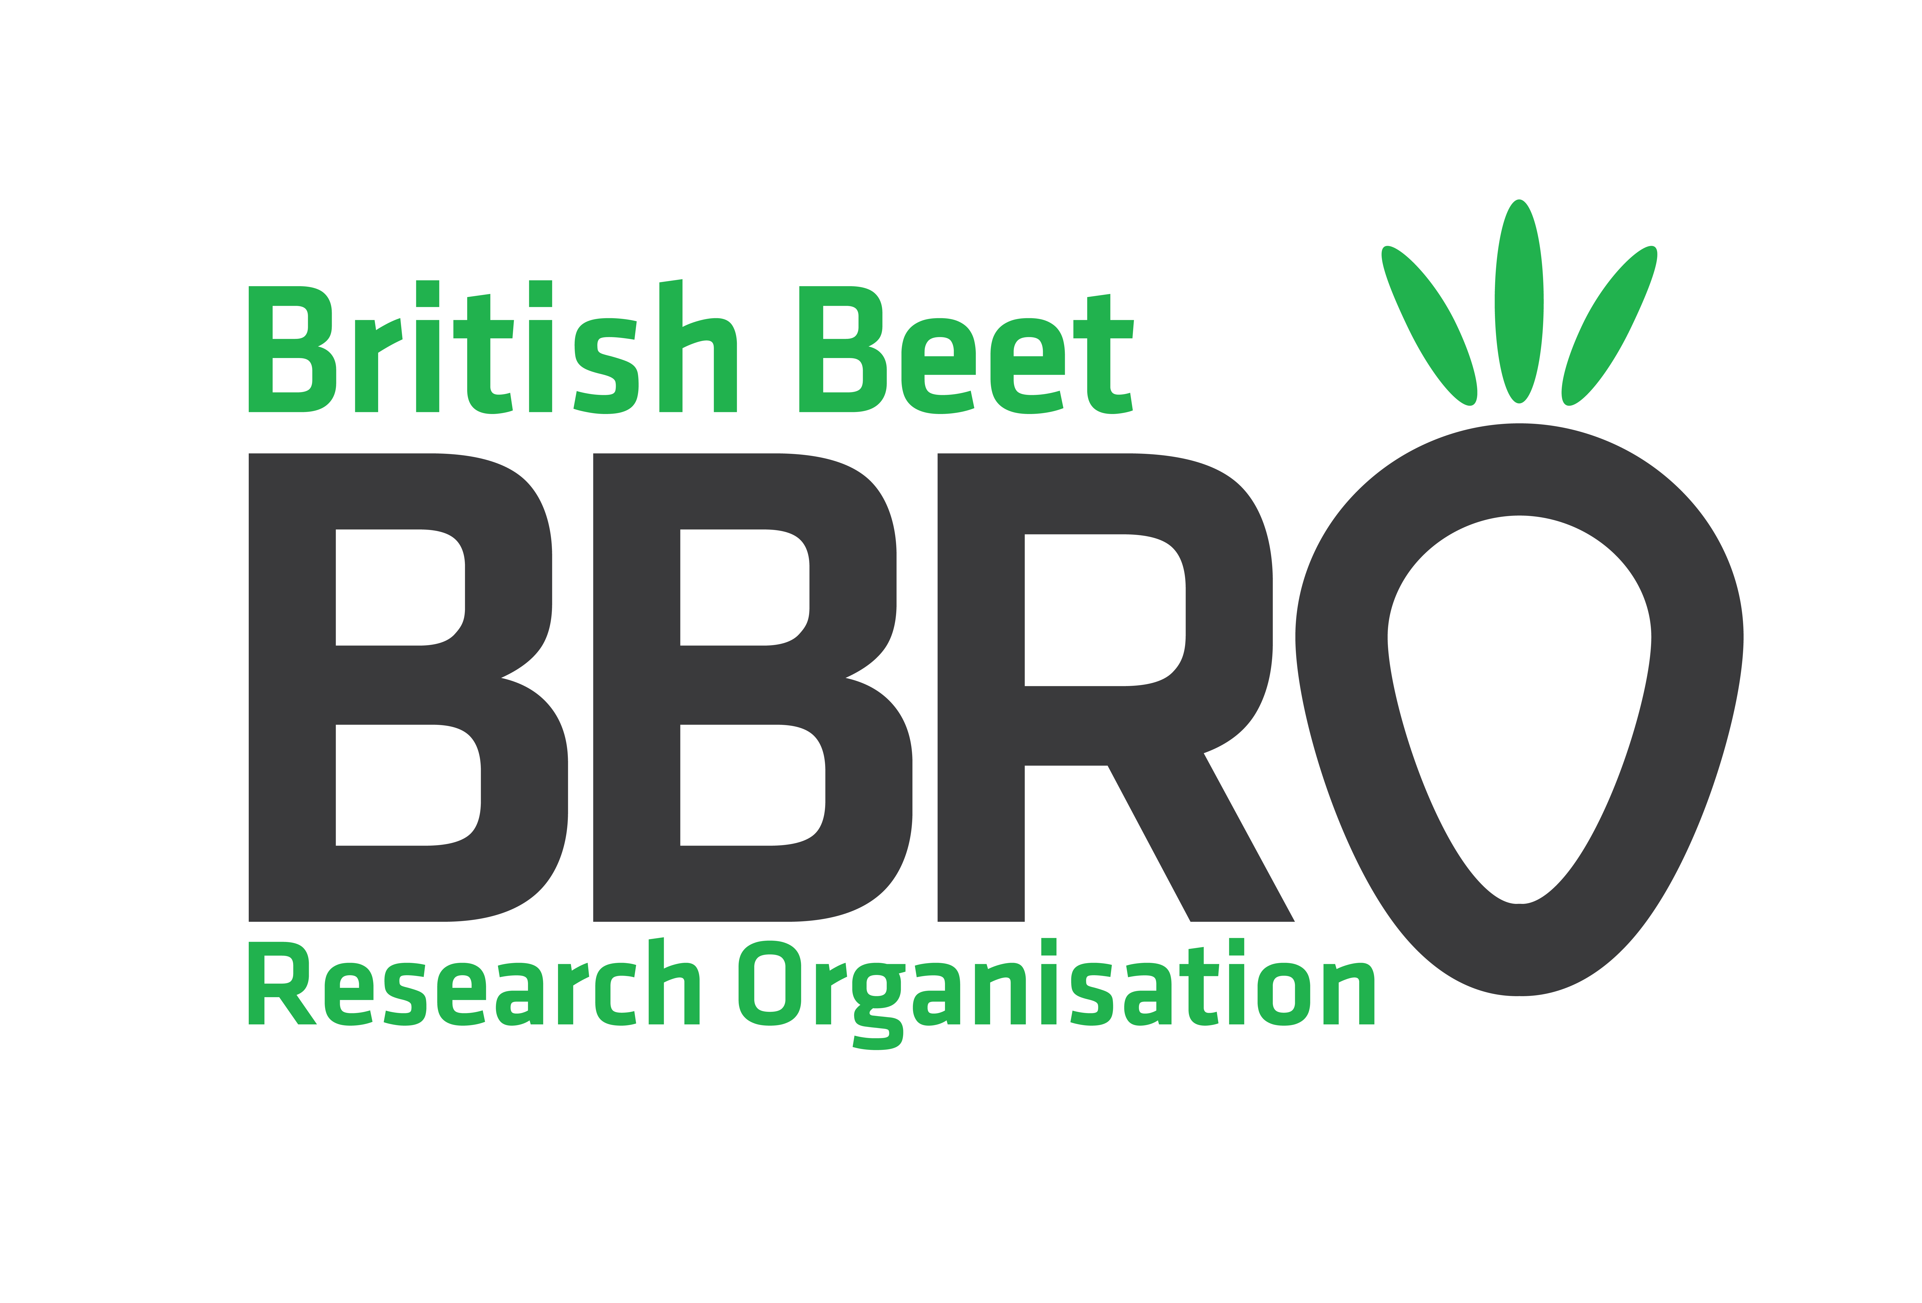
BBRO, Centrum, Norwich Research Park, Colney Lane, Norwich, Norfolk NR4 7UG. Website: www.bbro.co.uk Email:info@bbro.co.uk

BBRO is a not for profit company providing support to UK sugar beet growers
and wider industry.

Job Title | Crop Pathologist
Reports to: | Head of Crop Protection
Operational Responsibilities | Horticulture: Manage the day-to-day function of BBRO’s horticulture department and oversee plant growing activities. Schedule facility uses to meet demands of internal and external experiments and customers.  Pathogen Culture Management:  Keep cultures of important pathogens (Virus Yellows, aphids and Beet Moth) so they can be used for research at BBRO or for supply to third parties.  Field Assessments:  Schedule and undertake measurements of BBRO field trials, using existing protocols or development of new methods, for susceptibility to pests and diseases (e.g. virus, foliar diseases and insects). Liaise with BBRO colleagues and third parties to provide support as required and as each season dictates.  Protocol and Data Management:  Keep relevant SOPs up-to-date, prepare trial protocols and collate data for analysis.  Laboratory Support:  Help other BBRO team members where required and be trained in important lab protocols e.g. ELISA, qPCR and bioassays
Research Duties | Integrated Pest Management:  Support BBRO’s internal and external research projects and Work with the Head of Crop Protection to devise experiments and carry-out field studies to develop new control methods to achieve integrated solutions for existing threats to the UK’s sugar beet crops:  Virus Yellows (e.g. camouflage, endophytes, repellents)  Beet Moth  Aphid & disease resistance  Phenotyping:  Use BBRO’s phenotyping tools and techniques to assess varietal responses to virus yellows, nematodes, foliar diseases and insects in controlled environments and field experiments.  Pathogen monitoring and assessments:  Support BBRO’s CropWatch network and research projects with development of new methodologies to provide tools and technologies to detect and respond to existing and emerging pathogens. (e.g. Virus Yellows, soil-borne diseases, Beet Moth and SBR/RTD)  Knowledge Exchange:  Represent BBRO at suitable industry panels/events when required and share latest findings to growers and other industry stakeholders
Personal Specification | Essential:  Degree in Agriculture or related subject or  A track record of laboratory research  Full Driving License  Great attention to detail  Good IT skills  Proven communication, organisation, and problem-solving abilities  Ability to work independently as well as part of a wider team  Willingness to undertake physical, hands-on work in the field  Desirable:  Postgraduate qualification in Agriculture or a closely related subject  Previous experience in the culturing of plants, diseases and insects  PA1 and PA6  Experience working in agricultural trials  Understanding of the UK Sugar Beet sector  BASIS and FACTS qualifications
Term | 24-month fixed term contract

To apply please send CV and covering letter to alistair.wright@bbro.co.uk

