BBRO PROJECT REPORT FORM
Please note the details on page 2 will be used to formulate the BBRO printed Annual Report.
Project Title:
Understanding soil plant interactions to improve sugar beet productivity
BBRO project no: | 14/100
Project sponsor: | BBRO
Final report

Project lead or student name: | Prof. Debbie Sparkes
Project mentor or supervisors: | Tim Hess
Report Date: | 2020
Reporting period covered:  (e.g. 1/1/16 - 31/12/16) | 2014-2020
Timeline (e.g. Year 1 of 4) | Final report (year 5 of 5)
BBRO use only | Date assessed:
Assessors comments
Action required

Project summary (no more than 300 words)
Sugar beet roots have been studied to identify if certain rooting traits are linked to enhanced nitrogen uptake, with an aim to improve yield through selecting these beneficial rooting traits during breeding. Five UK sugar beet breeders provided breeding lines for this project, which were screened using a ‘pouch and wick’ phenotyping technique. After three weeks roots were photographed and image analysis was used to calculate root length and number of branches for each of the 172 varieties tested. The pouch and wick system is designed to be high throughput, so over 60 seeds were grown and imaged for each variety, to help overcome the problems of high variability in the lines.

Plants were also grown in pots with soil, in a glasshouse to a size similar to full canopy expansion in the field. Commercially available plants were also grown under field trial conditions, and harvested at canopy expansion, and then again at final harvest. Leaves were analysed for nitrogen content, and the root traits measured in the pouch and wick system were compared to the nitrogen uptake of the varieties grown in pots and the field.

When using commercially available varieties, there was a strong relationship between lateral root number and nitrogen uptake of plants grown in the pot trial. However, when the phenotyping was extended to look at all 172 breeding lines, this relationship was not seen. Field trials of the commercial varieties also showed a significant relationship between root branching, canopy size and yield but only during one season, when growing conditions were poor. In a further two years with more favourable growing conditions no relationship was seen, suggesting that increased root branching only had a significant impact on N uptake in challenging growing conditions.

Short summary of key objectives
To identify rooting traits for optimal nutrient uptake by sugar beet
Main outcomes and achievements
- A high throughput method was developed to measure early rooting traits in sugar beet.
- Relationships between nutrient uptake and lateral rooting number was found in commercial varieties
- Root phenotyping was then expanded to evaluate the rooting traits of 172 breeding lines, from five sugar beet breeding companies. The same lines were also grown in a large scale pot experiment in a polytunnel, when N uptake was measured
- The relationship between lateral root number and N uptake, seen in the commercial varieties, was not seen in the breeding lines: likely due to the additional background variation in these lines.
- Field trials using commercial varieties found links between final canopy size and root branching, but only during a difficult growing season, suggesting that only when conditions are really challenging do differences in root architecture become important for N uptake.

Key messages for growers and industry
- There is a clear relationship between root architecture and nutrient uptake, which has been demonstrated in sugar beet for the first time in this project
- The phenotyping screen developed has proved useful and, for commercial varieties of sugar beet there was a link between lateral root number (root branching) and N uptake in pots.
- In our first field experiment, we also found a link between root architecture and N uptake leading to more rapid canopy closure and increased yield. This was not evident in later experiments, when conditions were more favourable, suggesting that the rooting traits are most valuable when N availability is limited (e.g. due to environmental factors)

Section 1: To be completed by Project Lead:
Other project objectives (not listed on previous page)

Milestones for current period
Objective No./Milestone No. | Target date | Description
2.1/01  2.2/01  2.3/01  2.3/02  2.3/03  2.3/04  2.3/05  2.4/01  2.4/02  2.4/03  2.4/04  2.4/05 | 04/2015  04/2016  02/2016  04/2016  04/2017  04/2018  12/2018  12/2015  01/2016  04/2016  04/2017  04/2018 | Genetic diversity within sugar beet germplasm characterised.  Controlled environment experiments completed.  Design of field experiments on nutrient uptake finalised.  First field experiments on nutrient uptake established.  Second field experiments on nutrient uptake established.  Final field experiments on nutrient uptake established.  Recommendations for growers published.  Review of previous and current work on nutrient placement  Design of experiments on timing and placement of nutrients finalised.  First field experiments on timing and placement of nutrients established.  Second field experiments on timing and placement of nutrients established.  Final field experiments on timing and placement of nutrients established.

Summary of results (including figures and tables)
For Project Annual Report: please provide a 2 page summary of key findings from the reporting year.
For Project Final Report: please provide a summary of project findings and outcomes with relevant supporting data.
The aim of this work package was to develop a high-throughput phenotyping method to identify the genetic diversity of rooting traits within UK breeding lines of sugar beet. A further aim was to look for a relationship between rooting traits and nitrogen uptake and, if possible, to develop a phenotyping method which can be help breeders with early detection of beneficial rooting traits.

In the initial stages of this work package, commercially available sugar beet varieties were used to optimise the root phenotyping and imaging techniques for sugar beet seedlings. A ‘pouch and wick’ method was used to create a high throughput screen for early rooting traits of sugar beet seedlings. The method used blotting paper covered in black plastic as the ‘pouch’ which was able to wick up nutrient solution, allowing the seeds to emerge and grow. After three weeks the black plastic was removed, the seedling roots were photographed and image analysis was used to measure root length, lateral root number and lateral root length (Fig 1). Commercial varieties were also grown in a glasshouse for 10 weeks, until they were at a size comparable to canopy closure in the field. The glasshouse plants were analysed for nitrogen uptake, and showed a clear relationship between nitrogen uptake, and lateral root number measured during root phenotyping (Fig 2).

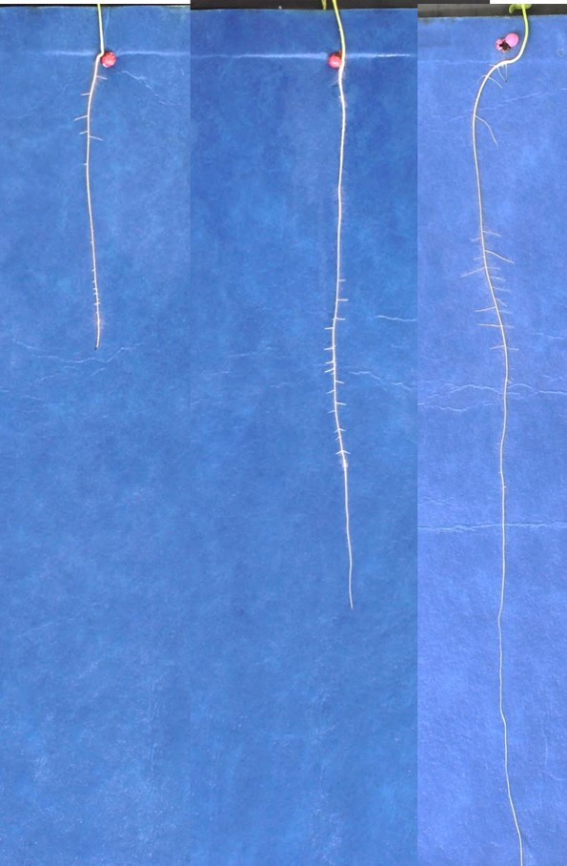
Figure 1: Images from the root phenotyping screen used to identify rooting traits in sugar beet seedlings.

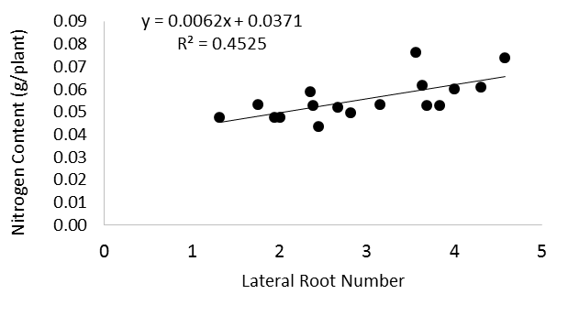
Figure 2: Relationship between lateral root number measured in commercial varieties using the root phenotyping technique, and nitrogen uptake, measured 8 weeks after sowing in glasshouse grown
plants.

The project was expanded to look at 172 breeding lines from five UK breeders. These were all screened using the root phenotyping technique. A large polytunnel experiment was set up, with 10 replicates of each 172 varieties grown until they reached a size equivalent of canopy closure (Fig 3). Despite the preliminary experiments on commercial varieties funding relationships between the root phenotyping data and nitrogen uptake, this was not seen in the polytunnel experiment using all the breeding lines. As the experiment was so large it had to be carried out in a polytunnel, which had less environmental control that the previous experiment using commercial lines in the glasshouse. Due to the discrepancy between the results of the polytunnel experiment, and the preliminary results, the experiment was repeated using a smaller subset of the breeding lines, in a more controlled glasshouse experiment. The experiment used 35 varieties picked from across all 5 UK breeders. Varieties were chosen to represent the full range of rooting traits from the original 172 breeding lines, but also have a high rate of successful emergence, as some breeding lines showed poor emergence in the original experiments. The results from this repeated breeding line experiment concluded that there was no relationship between nutrient uptake and rooting traits measured in the phenotyping trial. This is likely due to the wider variation present in breeding lines, which could then mask any differences in root architecture/N uptake.
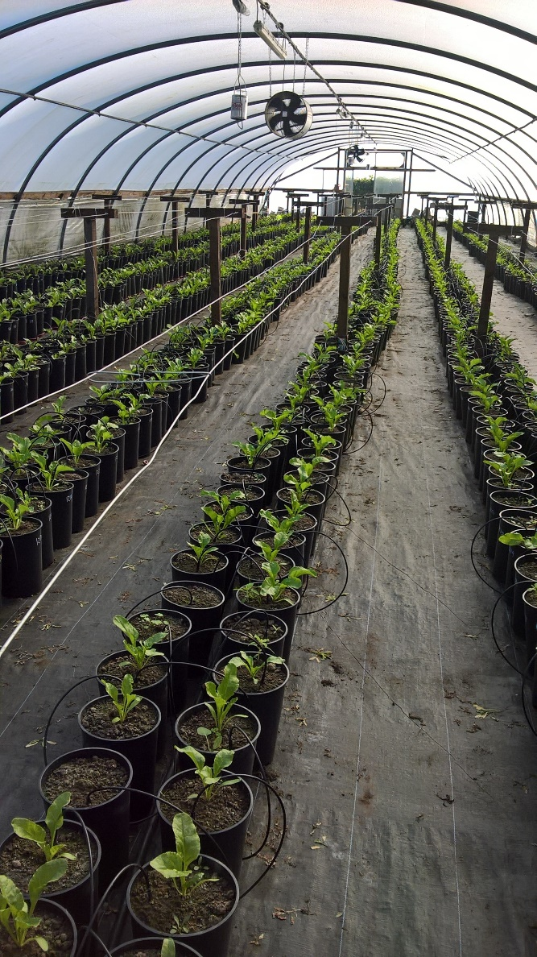
Figure 3: Polytunnel experiment using UK breeding lines.

The commercial varieties used in the preliminary experiments were also grown in field trials for three years. Samples were taken from the plots at canopy closure and at final harvest for nitrogen uptake analysis. In the first year of field trials a significant relationship was found between nitrogen uptake and rooting traits measured in the phenotyping trial; lateral root number (R²=0.3107), and lateral root length (R² = 0.2784) (fig 4). However further field trials in 2017 and 2018 using commercial varieties did not show a similar relationship between rooting traits and nitrogen uptake.
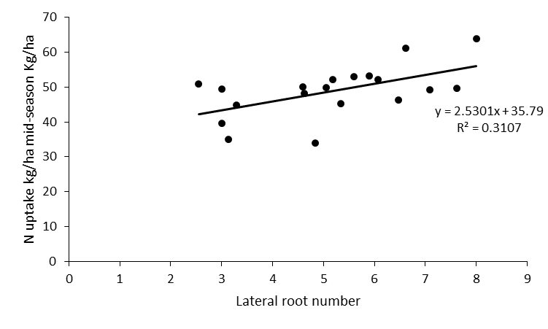
Figure 4: relationship between lateral root number measured in the root phenotyping study, and nitrogen uptake measured from the mid-season harvest of the 2016 field trial.

In addition to nitrogen uptake, image analysis of canopy photographs was used to model canopy expansion in the three years of field experiments (Fig 6). Canopy expansion curves were calculated for the different varieties, and these were used to calculate the canopy inflection points for each variety, which the midpoint of the exponential phase of the curve (Fig 7), and indicates how quickly a canopy is expanding. An estimate of the ‘upper limit’ for the curves was also calculated, which gave an estimate for the maximum size the canopy each variety would reach. Significant differences in canopy expansion between the varieties was measured in all years of field experiments. In the 2016 field trial, the upper limit score had a significant relationship with the lateral root count measured in the phenotyping trial. However, this was not seen in the 2017 or 2018 field trial. When comparing the results, it was clear that 2016 was a difficult year for sugar beet growth; weather data shows that there was a colder start to the growing season in 2016, which could be the reason the 2016 crop did not reach the same maximum canopy size as seen in 2017 and 2018 (Fig 5). Figure 8 shows a comparison between 2016 and 2017 field trials; the estimated maximum canopy size in 2016 was between 70 and 90%, showing a large range, between varieties, in 2017 the estimated canopy size reached nearly 100% for all varieties showing a very small range. The canopy expansion curves were also used to estimate how many days after sowing (DAS) the crop took to reach maximum canopy expansion, and in 2016 this was over 10 days slower than in the 2017 crop, showing a less favourable start to the growing season. Data from the 2018 field trial showed similar canopy cover: close to 100 % with a small range. Based on the differences between seasons, we concluded that a relationship between rooting traits and canopy size will only be evident when N uptake is constrained by other factors. Any further work to link root architecture with N uptake should therefore be conducted under non-optimal conditions (e.g. water limitation).

In conclusion, a high throughput method to identify early rooting traits in sugar beet was successfully developed. A relationship between rooting traits and nitrogen uptake was demonstrated in the glasshouse and the field, but only when using commercial varieties. This relationship showed an increase in N uptake with increased lateral root number. The benefits of more lateral roots only appeared in the field when the crop was grown in a stressful season, which accentuated the differences between the varieties, seen in the poor canopy cover.

The above report summarises all the N uptake work carried out at the University of Nottingham. The nutrient placement work (milestone 2.4) was always planned to be carried out by BBRO and was subsequently conducted as part of a separate project.

Figure 5: Graph showing thermal time for first 100 days for each of the three years of field trials. 2016 had the lowest thermal time at the start of the experiment, resulting in a smaller overall canopy at the end of the field season.

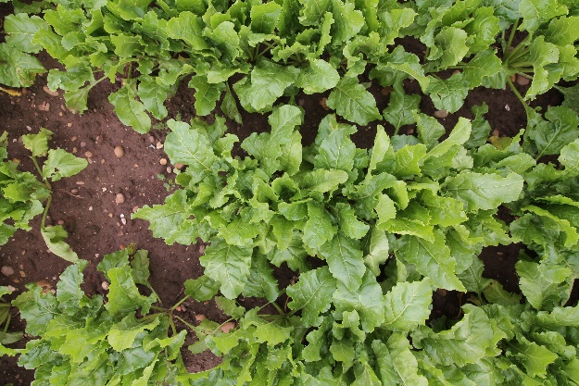

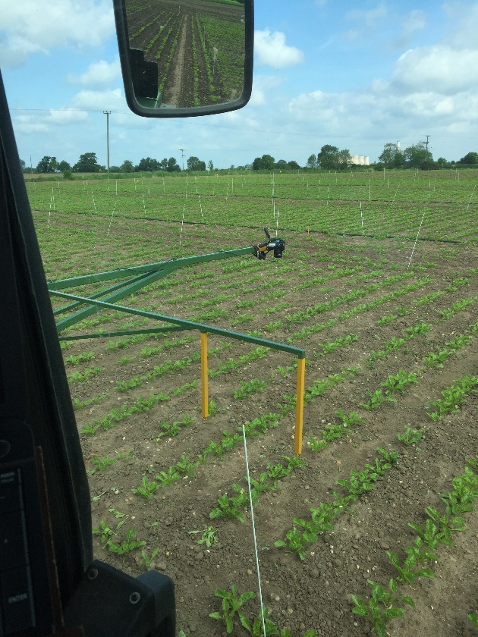
Figure 6: A tractor mounted camera was used to take plot images. Image J was used to calculate green area.
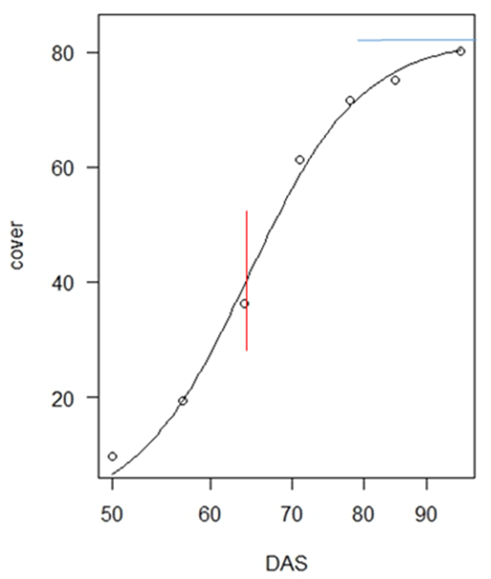
Figure 7: Example of canopy expansion curve used to calculate canopy inflection points (red line), which is the mid-point along the exponential phase of the curve; upper limit (blue line), which is the estimated maximum expansion of the canopy. DAS= days after sowing.

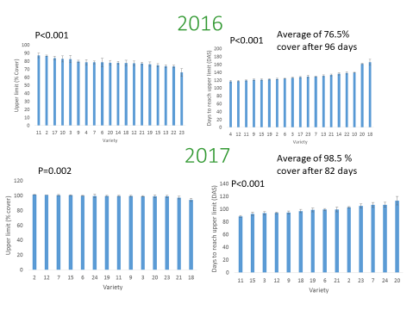
Figure 8: comparison between 2016 and 2017 field trials. On the left, showing variety range between upper limit, and on the right showing number of days to reach upper limit.

Annual report: Key issues to be addressed next year:

FINAL REPORT

Publication of results to date/planned publications:
A poster on this work was presented at the 2017 BBRO open day
A journal paper is planned focussing on the relationship between rooting traits and nitrogen uptake seen in commercial varieties in the field trial

Section 2: To be completed by project mentor
Status - Mentor’s scoring system for interim reports.
Red | “Major concern - escalate to the next level"  Slippage greater than 10% of remaining time or budget, or quality severely compromised. Corrective Action not in place, or not effective. Unlikely to deliver on time to budget or quality requirements.
Amber | "Minor concern – being actively managed”  Slippage less than 10% of remaining time or budget, or quality impact is minor. Remedial plan in place
Green | "Normal level of attention"  No material slippage. No additional attention needed
Milestone | Comments + action required | Status  R/A/G
Is the project on track to meet the stated objectives? (please comment in relation to milestones and the status score awarded in section 1).

Are conclusions scientifically robust? (please comment on data analysis/interpretation)
For final reports only:
How would you rate the project against the following criteria (please give a score out of 10, with 10 being highest)
1 ) The project met its original objectives:

2) Contribution to scientific knowledge:

3) Direct relevance to growers:

