BBRO PROJECT REPORT FORM
Please note the details on page 2 will be used to formulate the BBRO printed Annual Report.
Project Title: SporeID

BBRO project no:
Project sponsor: | Innovate UK
Interim report / Final report (delete as appropriate)

Project lead or student name:

Project mentor or supervisors:

Report Date:
Reporting period covered:
(e.g. 1/1/16 - 31/12/16)
Timeline (e.g. Year 1 of 4) | Year
BBRO use only | Date assessed:
Assessors comments
Action required

Project summary for BBRO Publication (no more than 300 words)
SporeID is a project designed to minimise the impact of foliar diseases on the yield of the UK sugar beet crop including powdery mildew, rust and other potential threats. The aim of this project is to develop unique disease monitoring system that would be fast, robust and cost effective. We are bringing together novel diagnostic tools, crop disease modelling and yield forecasting to underpin grower decision making, and investigate the potential impact of emerging disease on the crop.
Current advances in technology allow us to use the novel solutions, including robots, weather stations, machines and GPS for the better crop management and SporeID involves a fully automated device performing molecular diagnostics straight from the spores in the field on a real time basis and a support modelling tool, to predict the possibility of disease development in terms of environmental factors such as, temperature and humidity.
The three-year project is led by the BBRO; it also involves British Sugar plc, AB Sugar, the University of Nottingham, Rothamsted Research and Burkard Manufacturing Company Ltd.

Short summary of key objectives
► To exploit novel diagnostic tools and monitoring systems, crop disease modelling and yield forecasting to improve foliar disease control in sugar beet.
► To provide a new platform that integrates the collection of met data, aphids, mildew and rust spores with rapid DNA-based diagnostics, providing real-time information on disease pressure.

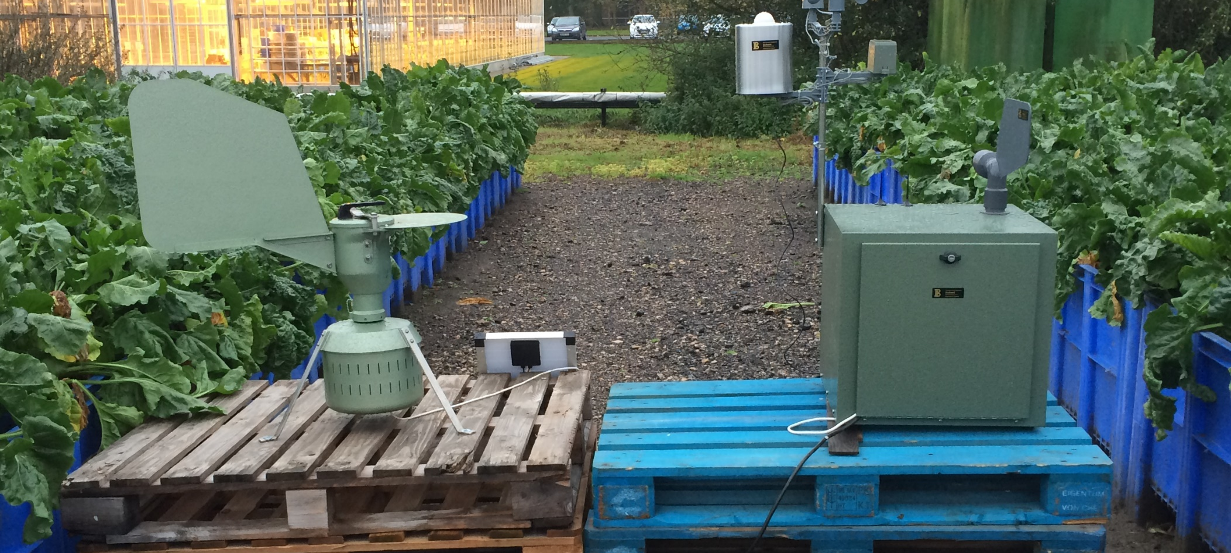  Prototype of the automated spore trap alongside the conventional Hirst trap while comparing. | 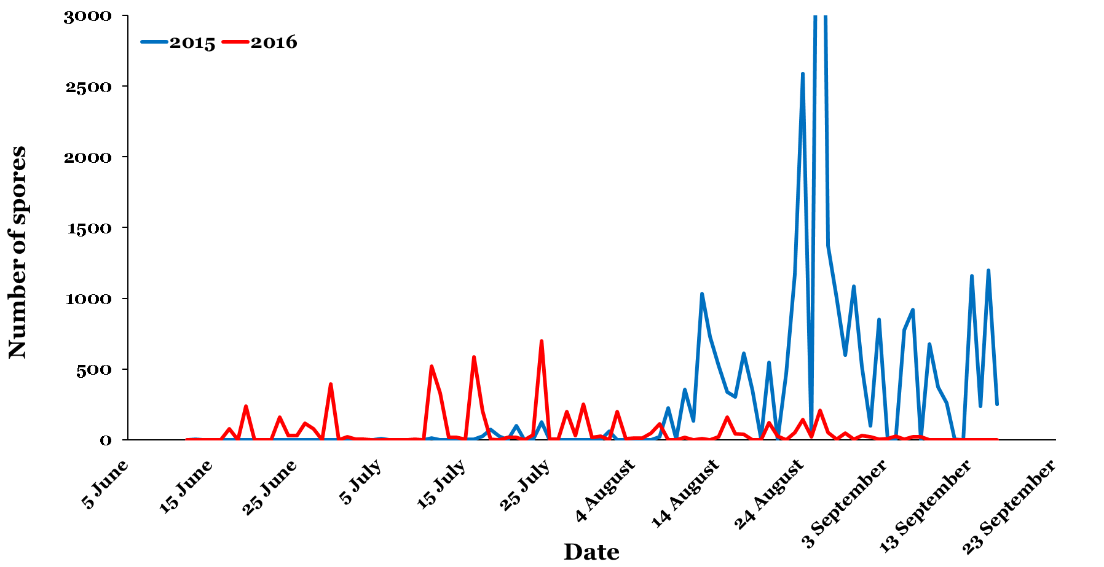  Estimation of the amount of spores per day in air samples form a field trial site in alternate 2015 and 2016 seasons.
Outcomes/Key messages for growers and industry
- Samples collected from in-field spore traps were analysed and provided data of the inoculum presence in 2015, 2016 and 2017.
- Currently, the prototype of automated spore trap is being validated at Burkard Ltd with UoN and Rothamsted researchers.
- BeetGro model has been incorporated with the parameters describing disease development.
- Work on website and interface is still ongoing.

Ultimately this project will lead to a new user interface for disease monitoring and prediction and for a more robust approach for the application and benefit of fungicides for the UK crop.

Section 1: To be completed by Project Lead:
Other project objectives (not listed on previous page)

Milestones for current period
Note: mentors will be asked to comment on the status of this project (yellow column) using the scoring system in section 2.

Summary of results (including figures and tables)
For Project Annual Report: please provide a 2 page summary of key findings from the reporting year.
For Project Final Report: please provide a summary of project findings and outcomes with relevant supporting data.
Annual report: Key issues to be addressed next year:

Publication of results to date/planned publications:

Section 2: To be completed by project mentor
Status - Mentor’s scoring system for interim reports.
Red | “Major concern - escalate to the next level"  Slippage greater than 10% of remaining time or budget, or quality severely compromised. Corrective Action not in place, or not effective. Unlikely to deliver on time to budget or quality requirements.
Amber | "Minor concern – being actively managed”  Slippage less than 10% of remaining time or budget, or quality impact is minor. Remedial plan in place
Green | "Normal level of attention"  No material slippage. No additional attention needed
Milestone | Comments + action required | Status  R/A/G
Is the project on track to meet the stated objectives? (please comment in relation to milestones and the status score awarded in section 1).

Are conclusions scientifically robust? (please comment on data analysis/interpretation)
For final reports only:
How would you rate the project against the following criteria (please give a score out of 10, with 10 being highest)
1 ) The project met its original objectives:

2) Contribution to scientific knowledge:

3) Direct relevance to growers:

